[In-Progress] Fleet Signup Flow v3.0.0
Redesigning Fleet web signup to onboard faster w/ less friction

Team | Fleet |  | Status | In Progress
DRI | ahmad.saffi@ |  | QA Date | 10/16/2019
Version | Fleet Signup Flow v3.0.0 |  | Ship Date | 10/21/2019

What | Who
Feature Folder | Product
Github Project | Product / Engineering
Figma Prototypes | Design
Impact Analysis | Analysis
Feature Monitoring | Analytics / Engineering

Team | Reviewer | Timestamp
Product | emmanuel.pozo@ | Reviewed and left comments 09.27.19. Mostly ready, small changes to consider in my comments.
Eng Mgmt | ulf.schwekendiek@ | Reviewed and left some last comments 09/27/19. Looks like we have more than enough to start working on this.
Web DRI | ryan.fitzpatrick@ | Reviewed on 9/30/19 - Ready to start work. Without a design for mobile it will be hard to make a 100% accurate estimate.
Backend DRI | david.shao@ | Reviewed and left comments 9/30/19 - Spec looks great. There’s a few clarifying questions, but we have work that we can start with.
Design | melissa.gamo@ | Reviewed and left some comments 9/30—Desktop is good, prioritizing some mobile screens for estimate, I did have designs from last week so they have been started
Analytics | mikaela.klein@ | Reviewed and left some comments on the success metric for the A/B test.

Overview

Background
Our current signup process for Fleet applicants on the web is in need of a revamp. 70% of our applicants are acquired via the web (mostly mobile web). We want to begin improving the signup experience starting with the web and eventually bring that into native clients. We want to reduce the amount of steps it takes to sign up as well as make it clear why we are requesting information from people at each step. Some specific things we’ll be addressing include moving up the referral entry code step to the beginning of the sign up flow, eliminating the need for people to select a signup market by automatically placing them in a market based on their home address, simplifying the vehicle selection step, and incentivizing the signup flow by reminding people about our starter guarantees.

The goal for this project is to increase our weekly activation fleet by improving our onboarding conversion.

Problem
As a Fleet applicant, I am less inclined to complete my signup process with Postmates because of all the onboarding steps and lack of clarity/transparency around the information I am giving.

What’s New
01. Referral code entry moved earlier in the onboarding funnel (from last step to the first during the account creation step)

02. Reduction of steps in the signup flow from 11 to 8

03. Removing the region selector step by instead assigning a market based on home address

04. Market-specific starter guarantee static on every page in the signup flow

05. Simplified vehicle selection step

06. Progress indicated on the navigation bar of every page in the signup flow

07. Rearranging of some steps for optimal signup experience as shown below.

08. A previous button that takes you to the prior screen

Not Doing
01. We will not be changing the web landing page itself in any way

02. We will not improve the driver’s license number capture & validation mechanism we have in place

03. We will not allow applicants to take a photo using their phone/computer’s camera; photo uploads only

04. We will not be removing the vehicle select option because of it not being vital to the signup

05. We will not have another referral field on the web dashboard as the user is waiting for their profile to activate
06. We will not redesign loading, log out or log in screens

Impact
Teams: Fleet, Fleet Support

Company OKRs:
- KR1: Weekly Delivery Volume
- KR2: Weekly Active Customers (Postmates)

Team OKRs:
- KR1: Weekly Active Growth

Success
Depending on whether you’re taking a conservative, moderate, or aggressive approach to the projected impact of this project, our Weekly Active Fleet 7d conversion can increase anywhere from 5K additional Postmates to 24K (as shown above or in my analysis).

Key Success Metric

Success Metric | Baseline* | Success | 7d Actual | 14d Actual
Increase of Weekly 7d Fleet Conversion (signup to activated) - Amongst Test & Control  % of applicants who convert to an active Postmate within 7 days of signup, when comparing the test and control groups in the experiment | 0% | 5% lift

Second-Order Metrics

Success Metric | Baseline* | Success | 7d Actual | 14d Actual
Increase Total Weekly Active Fleet  # of Postmates who do at least 1 job from Monday - Sunday | 141K | 148K
Decrease # of Weekly Unshippable Welcome Kits  # of weekly upshipped welcome kits due to invalid or incomplete addresses | 275 | 75
Decrease # of Weekly Background Check FS Tickets  # of support tickets written in to Fleet Support tagged with ‘background_check’ over a given week | 1,200 | 900
Decrease Weekly FS Contact Rate for Background Check Tickets  # of support tickets written in to Fleet Support tagged with ‘background_check’ divided by the number of completed jobs | 0.08% | 0.06%
* As of XX.XX.XX, date of launch

Known Issues
01. Our driver’s license validation library is outdated and unreliable
We are choosing to not update our Regex library and instead continue with this solution for v3.0. As a fast follow we will consider updating to a more sustainable library that takes newly mandated driver’s license numbers into account.

02. We are not providing any error messages around incorrect referral codes
While we do run validation logic on the server when capturing and storing the referral code information, since this is on the signup page when creating an account, we would rather not risk having a user stuck in this state trying to correct the referral code. Instead, we will proceed forward and show them the market-specific starter incentive.

03. We have spaghetti code for our existing onboarding funnel that needs to be refactored
The true question is whether we wish to solve for the long-term and refactor the entire codebase for our signup flow, or if we wish to only refactor as we need to and build off of what we have to save time.

Outstanding
01. Verify that the consolidation of legal disclosures are approved by Legal

02. Confirm with Saurabh & Kayla that we can consume the market-specific starter incentive data
→ This is confirmed, we can consume this information from Fleet Incentive Services (FIS)

03. Determine whether we will integrate with the USPS API’s Street Address Checker
→ This is confirmed, we will integrate with the USPS API, but need additional details on how to handle failures that may be caused by an outage, or any throttling to the API call they may have

04. Determine how we will do a clean A/B test where we have two concurrent onboarding funnels

05. Determine if we should refactor the codebase for the original signup flow

Requirements

Web

Implement web signup pages (ISSUE-###)
Component | Requirements | Asset
Navigation Bar | - Every page should capture a page_id in order for onboarding to continue from the same location regardless of which device it is continued on.  Log In Link  - If you are on any page of the signup flow  - Show only “Log In” at the top right  - Else  - Show Log In & Sign Up  Status Navigation Bar  - If you are on any page of the signup flow  - Show a navigation status bar at the top of the page  - Use visual increments via a black line denoting the progress in the flow (per design’s specification; see all rows on the right column)  - Else  - Do not show  Error States  - N/A | 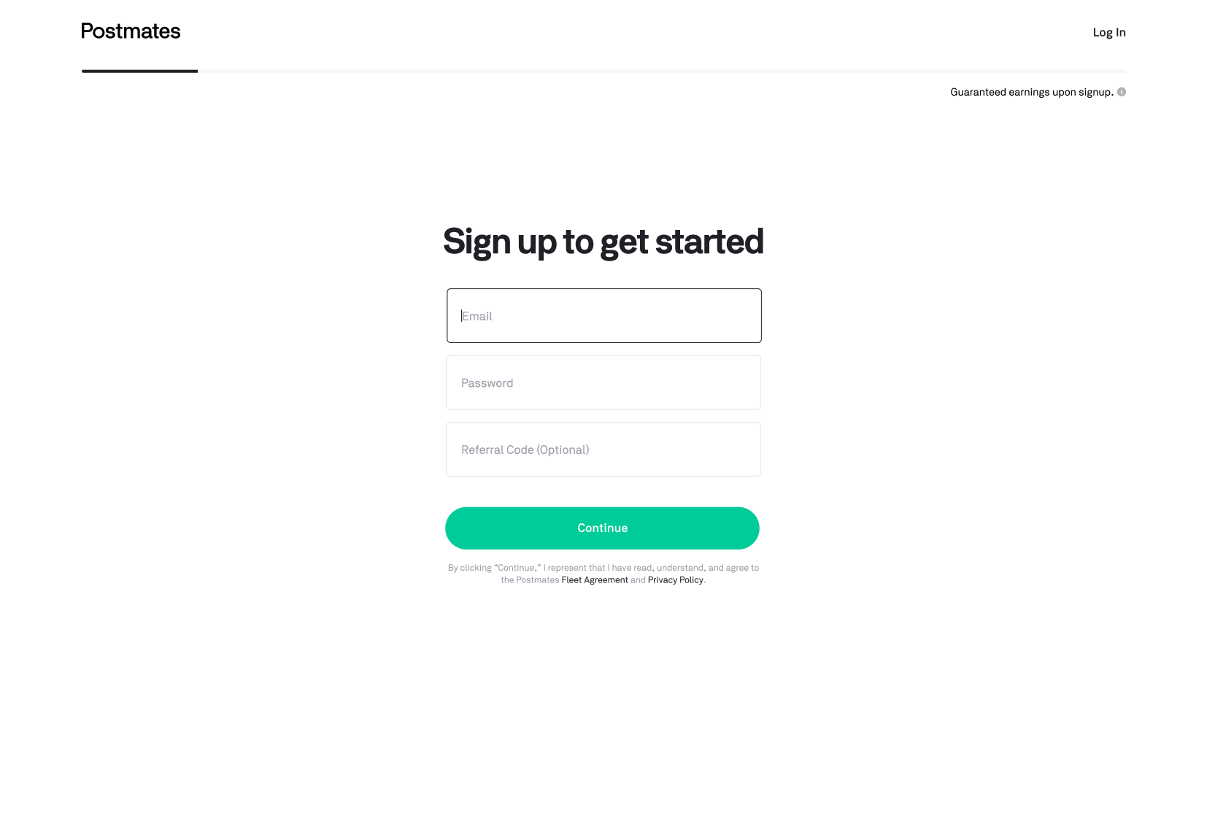
Forms | - For each page on desktop, first form is always activated (to enable typing write away)  - If I press continue without completing forms  - All invalid/error states will appear at the same time | 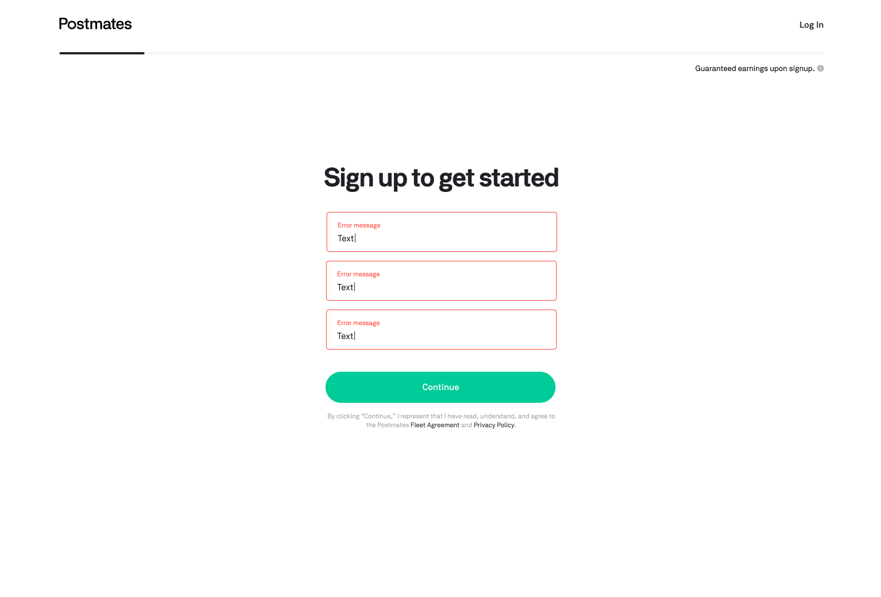
Market Incentive Reminder | Market Starter Incentive  - If you signed up on the general signup page (not market-specific)  - Show a written explanation of their incentive  - Incentive should be written in the following format: “Guaranteed earnings when you deliver.”  - If you are in a market with a starter incentive (having come from a market-specific landing page)  - Show a written explanation of their incentive  - Incentive should be written in the following format: Earn <sign_up_bonus> on your first <sign-up_incentive_threshold> deliveries.  - Sign up bonus amount in bold (Ex Earn $500 on your first 50 deliveries.”  - Information on the market incentive can be retrieved from FIS using a get available incentive endpoint  - Clicking on incentive opens modal  - If you enter a referral code in the “Referral Code” field and select “Continue”  - See “Referral Code” below  Market Incentive Modal + Glyph  - If you select the market incentive glyph  - Showcase a modal  - Has green dollar sign badge in top center  - Has max 2 rows for Earnings header  - 40 character limit in total  - If exceeded, do not truncate  - Has max 6 rows for body  - 160 character limit in total  - Truncation allowed if 6 row character limit exceeded  - If you select “Got It”  - The modal is dismissed and you will remain on the Signup Page  - If you select any region on the page other than the modal  - The modal is dismissed and you will remain on the Signup Page  - Else  - Do nothing  Error States  - If the market has no incentives, show nothing | 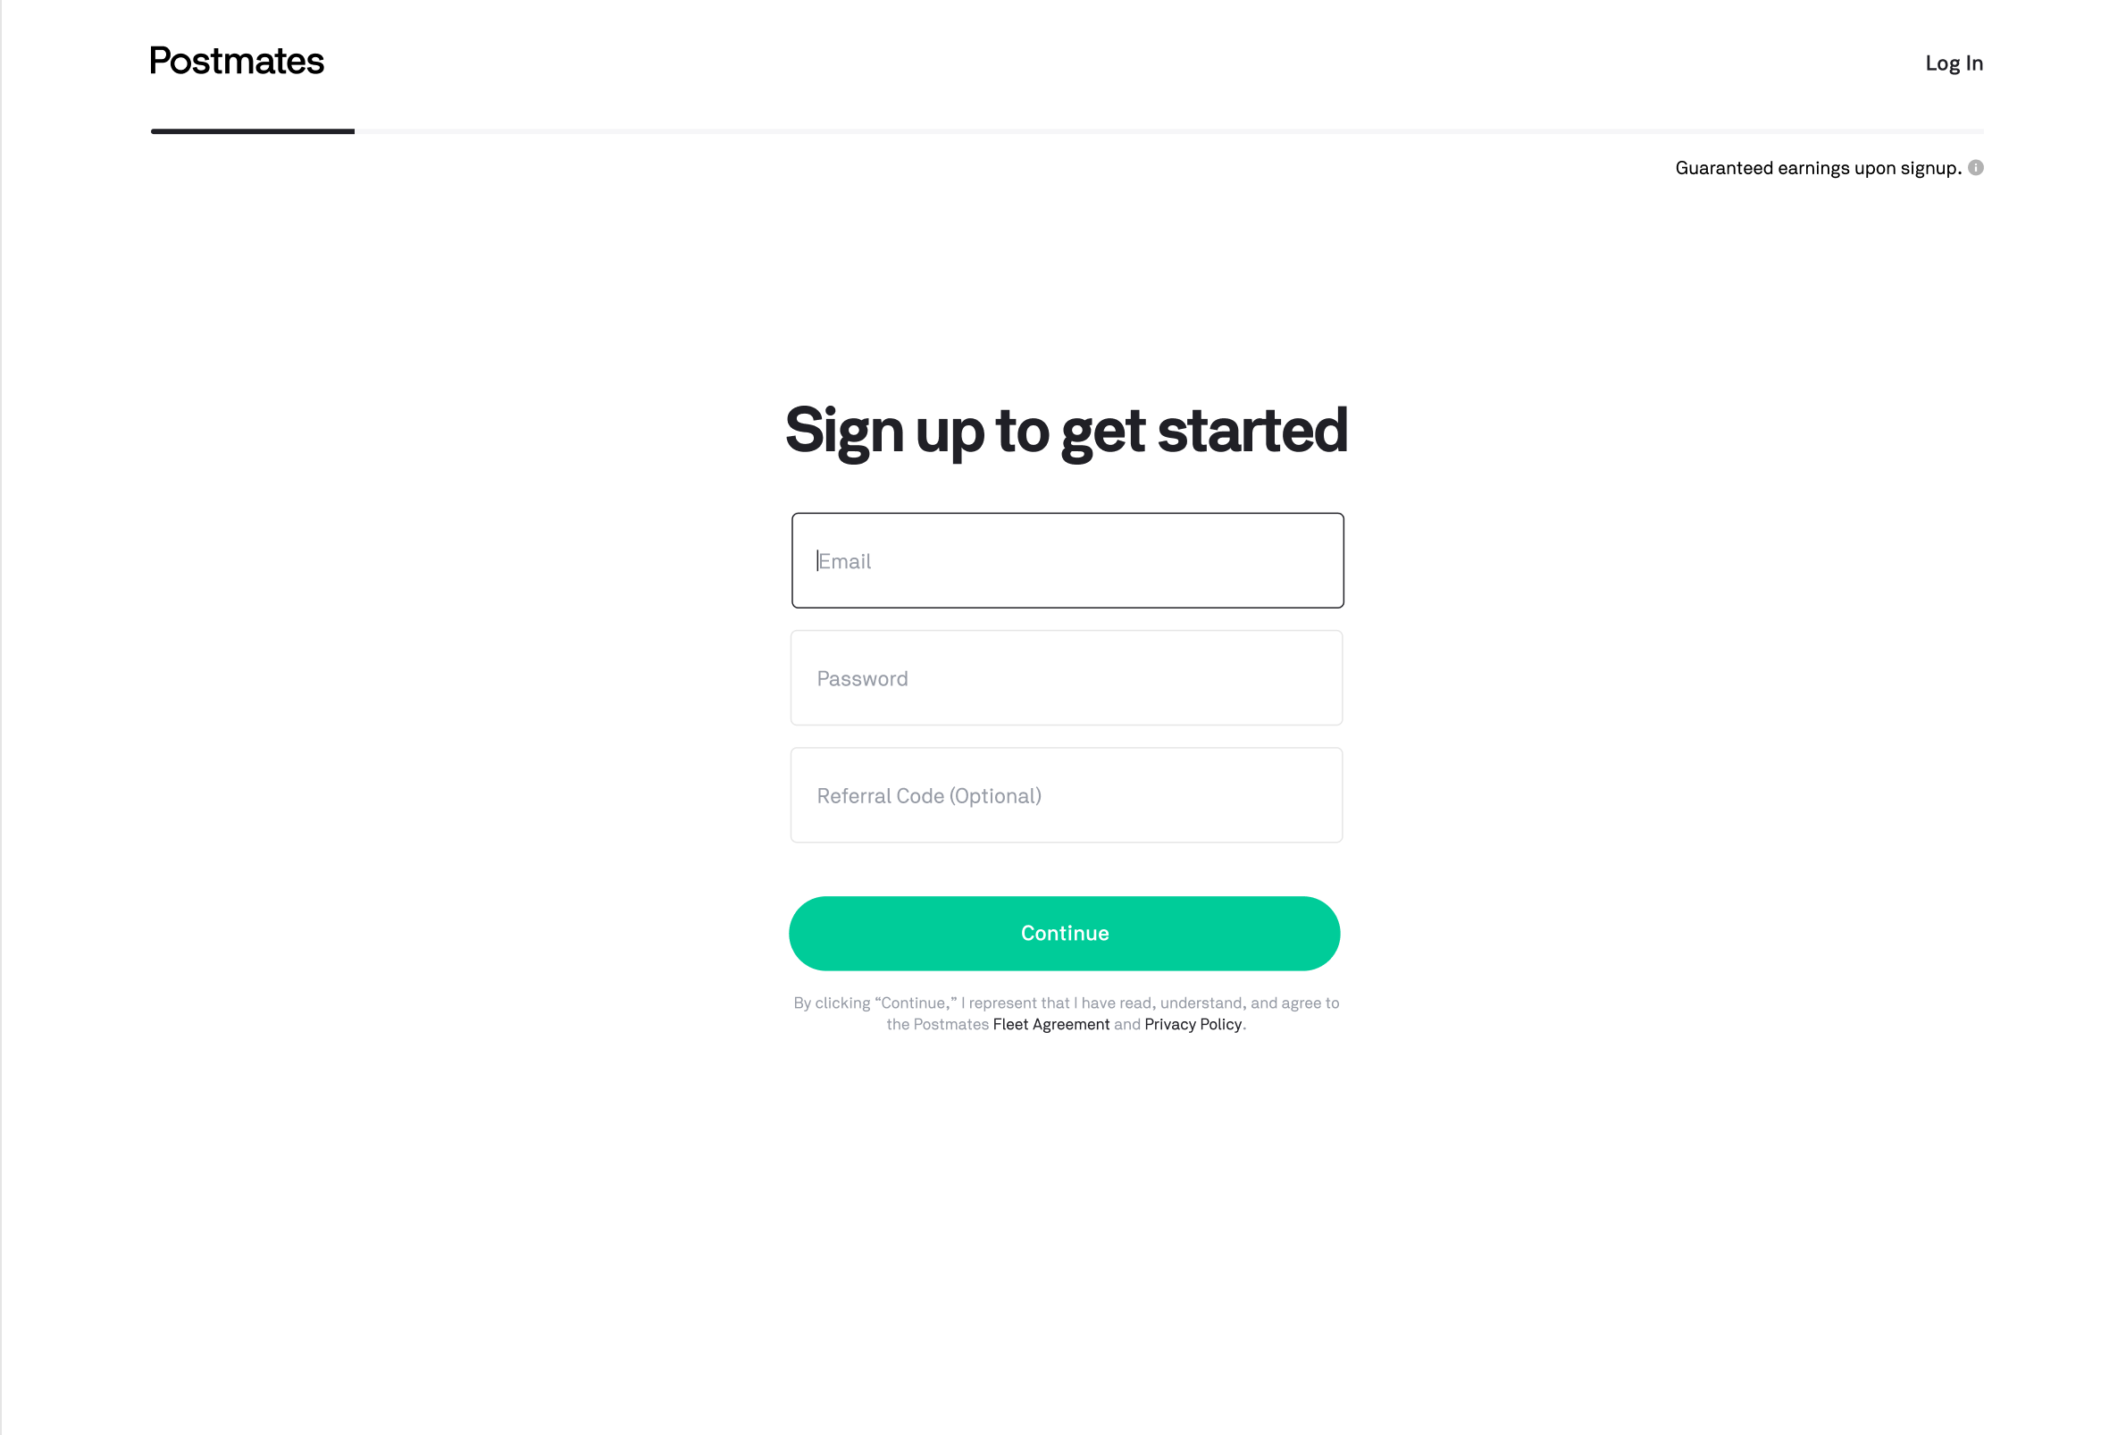  Generic  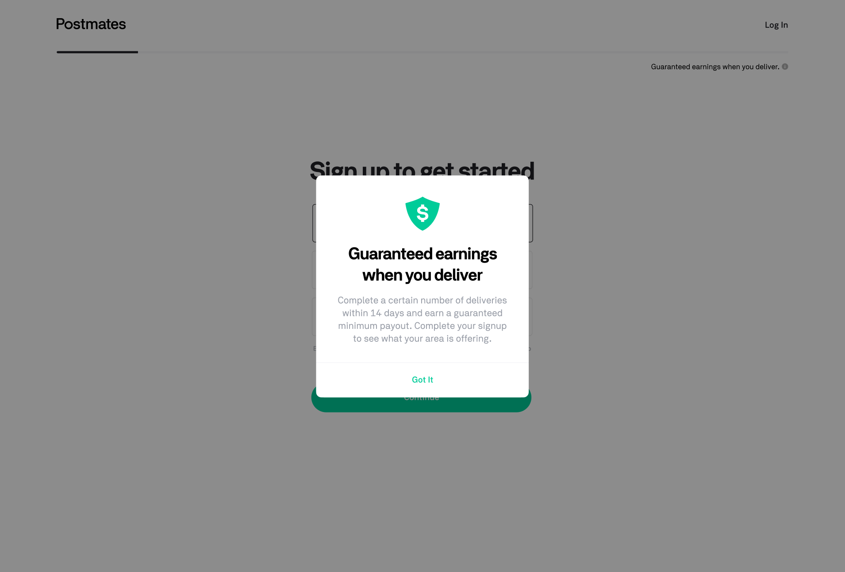  Market-specific  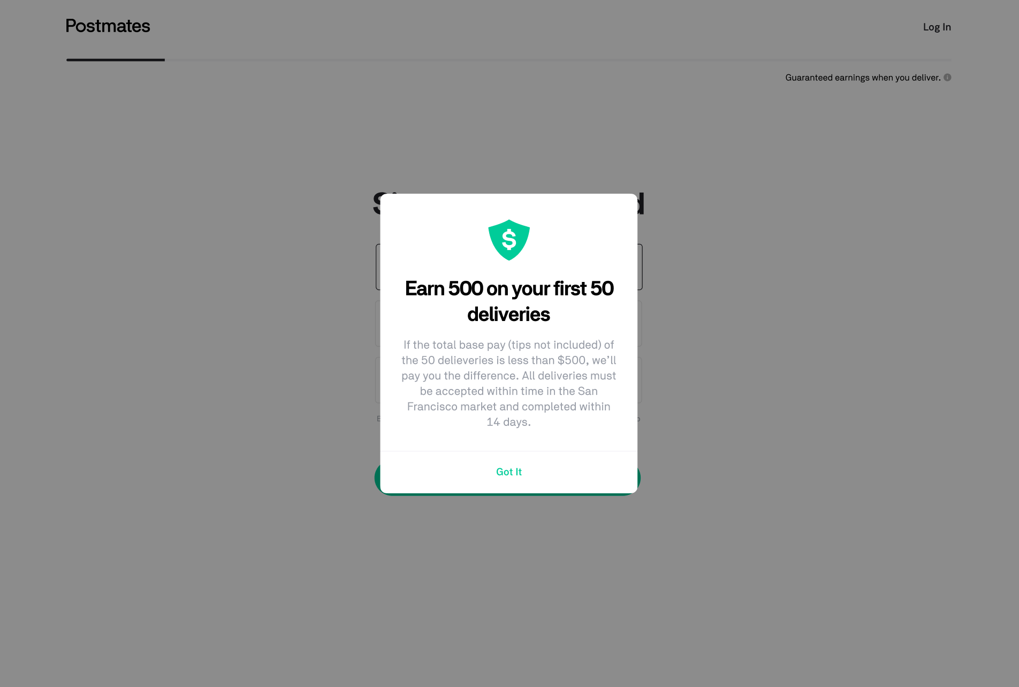
Signup Page | Referral Code  - When you are on the signup page  - If you have not yet signed up through the landing page  - Show a referral field beneath the email and password fields  - Have the referral field be optional  - Else if you signed up on the landing page  - Skip this screen and go to “Tell Us About Yourself” page that has the “referral code” field added  - When you enter in any amount of alphanumeric digits and select “Continue”  - Capture/store the information  - Trigger server-side logic to validate that the referral code exists  - If the referral code exists  - All following pages in the signup process should have the following copy in place of the generic earnings text: “You’ll receive a <referral_bonus_amount> after completing <referral_delivery_threshold> in <referral_timeline_threshold>.”  - Redirect to the next page “Tell Us About Yourself”  - Else  - Proceed forward with the Market-Specific Incentive, not acknowledging the referral offer  - If you are accessing a signup page that was shared by a referrer (unique code appended to the URL)  - The referral code field should have the code pre-filled  Error States  - If email blank when trying to submit form, show “Enter your email”  - If invalid email (such as no @ ) then show “Invalid email”  - If repeat email, show “Email already exists”  - If password blank, show “Create a password”  - If password is too short, “Minimum 6 characters”  - Referral code: If values that are not alpha-numeric are entered, show a warning beneath the Referral field that says “Please enter alpha-numeric values only.”
Tell Us About Yourself | Back Button  - If you are on any page of the signup process except the first  - Show a previous button  - When selected, it should take you to the prior page  - If you select the browser back button  - It should take you to the prior page  - If there is partially entered content in any of the form fields  - Surface a browser-level warning message that asks if you wish to go to the previous page, losing your unsaved changes  - Changes should not be cached nor saved, proceeding to the prior page  - If a user goes back a page or several pages and then proceeds forward to the next page  Form Fields  - If you are entering a name in the “First Name” and “Last Name” field  - Validate the fields adhering to Checkr’s Regex  - If you are entering a phone number in the US  - If you type in “1” as the first digit in your phone number  - Proceed to the next number, while not displaying the number 1 → Ex. I type in (15106930064) it should just take as (510-693-0064)  - Allow entry of 8 numbers if the first number is “1”  - Allow entry of 7 numbers (but the first number cannot be a 1)  - All digits must be numerical and not alphabetical or special characters  - If you are entering a phone number in Mexico  - If you type in “52” as the first 2 digits in your phone number  - Proceed to the next number, while not displaying the number 52 → Ex. I type in (52-22-0693-0064) it should just take as (22-0693-0064)  - Allow entry of 12 numbers if the first 2 numbers are “52”  - Allow entry of 10 numbers minimum  - All digits must be numerical and not alphabetical or special characters  Error States  - If any numbers or characters are added for the first or last name, show an error message that says “Invalid first name” and “Invalid last name”  - If blank, “Enter your first name” and “Enter your last name”  - If user enters 8 numbers and the first is NOT “1” AND if user enters 7 numbers and the first is a “1” AND if a user enters any number of digits other than 7 or 8, show an error that says “Invalid mobile number”  - If blank, “Enter your mobile number” | If you came from the “Sign Up” page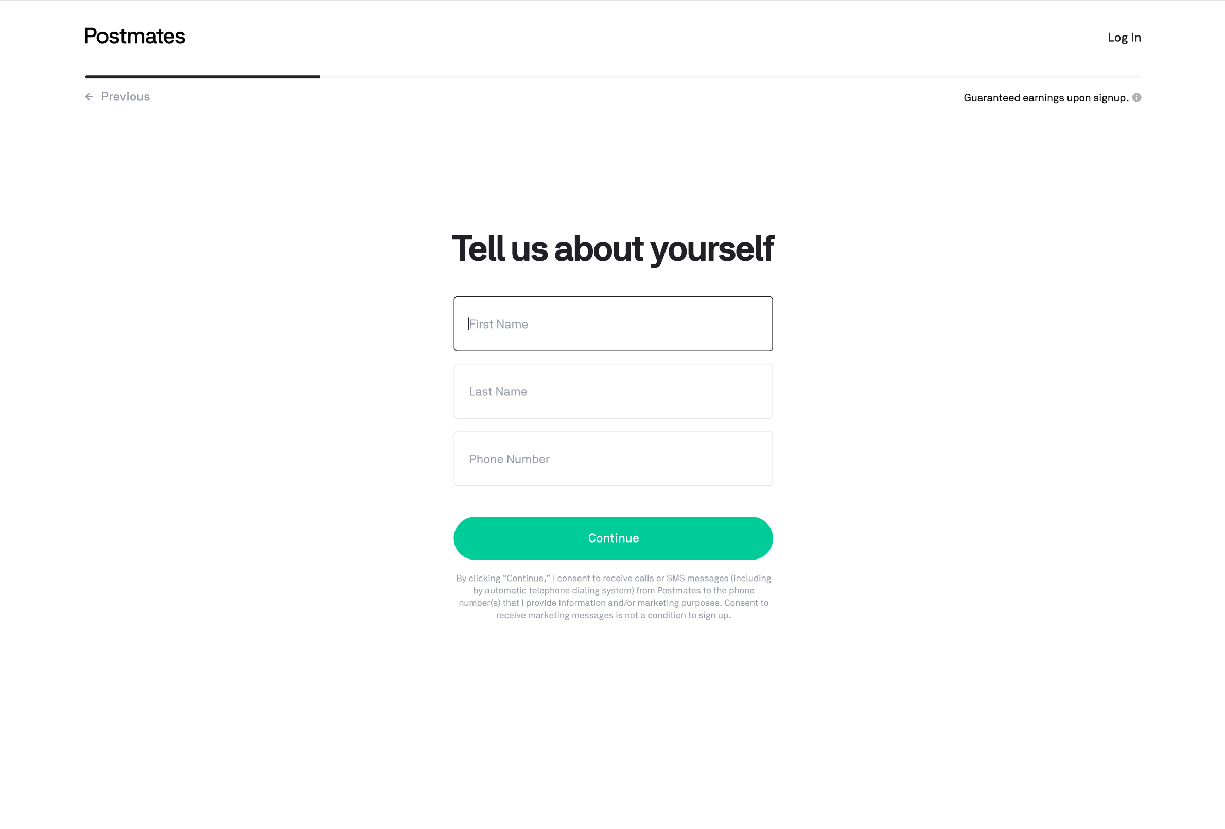  If you came from the landing page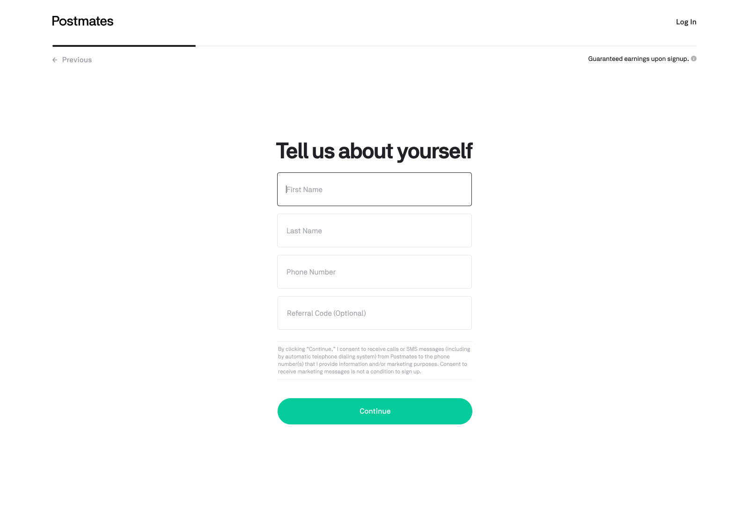
Mailing Address | Mailing Address  - If you are on the mailing address page  - As soon as a user types into the address field  - A dropdown should appear with dynamic search results  - These search results should be calling the Google Maps API to populate results  - A user must select one of the addresses in the dropdown for the results to be stored/accepted in the field  - If a user selects one of the address options from the dropdown, these additional form fields should appear, pre-populated with information in the right field.  - “Apt / Suite Number”: Text field with no form field validation  - “City”: Text field with alphabetical digits form field validation  - “State”: Dropdown menu with a list of US states in “XX” format  - “Zip Code”: Text field with field validation for 5 alphanumeric digits.  - If a user does not select one of the addresses, but types in an address that is not part of the dropdown, once they select elsewhere on the page, these additional form fields should appear without their content pre-populated  - Apt / Suite Number  - City  - State  - Zip Code  - If you select “My address is not showing up” in the dropdown menu  - The dropdown menu collapses and 4 additional fields are added:  - Apt / Suite Number  - City  - State  - Zip Code  - When the user continues to type in their Street Address, the dropdown in this instance should NOT expand  - Clicking on Info glyph opens modal  - If you select “Continue”  - A call is made to the USPS API to validate the street address information provided  - If the API validates the street address  - Your results are captured/stored and advance to the next screen: “Confirm Where You Will Deliver”  - If the API does NOT validate or if the call fails for the street address information provided  - An error message occurs as indicated below  - This validation should only occur once; on the second try we do not call the USPS API, but accept whatever entries we are given  - Show “Please correct” within the field that USPS has returned as being incorrect  - If you select “Previous”  - Your results will not be captured and a browser-level warning message will appear about advancing without saving changes. If confirmed, you will go to the “Tell Us About Yourself” screen  Mailing Address Glyph  - When you select the glyph next to the word “tote bag”  - A modal appears overlayed on the screen discussing our welcome kit  - If you select outside the modal  - Dismiss modal  - If you select “Got it”  - Dismiss modal  Assigning A Market  - Once the Mailing Address is stored  - Use the location of the mailing address to assign a region to the Postmate  USPS API Street Address Checker  - Integrate w/ the USPS API to validate the Street Address during our type-ahead search  Error States  - If you enter an invalid US street address that is not a part of the search API, then display an error that says “Please enter a valid US street address“  - If you enter an address that is not a valid US address, display an error message that says “Please select a valid US address” | 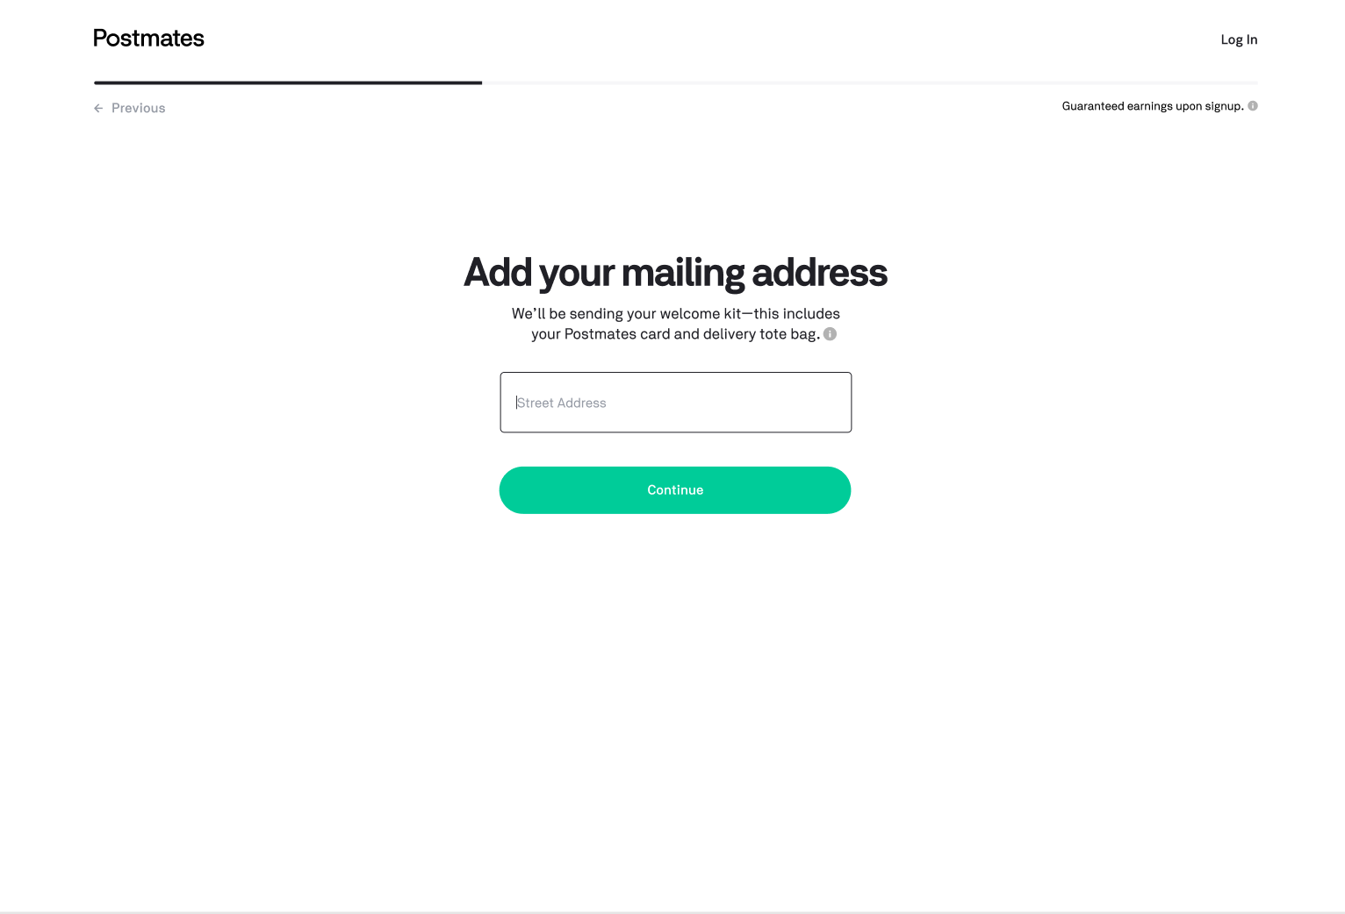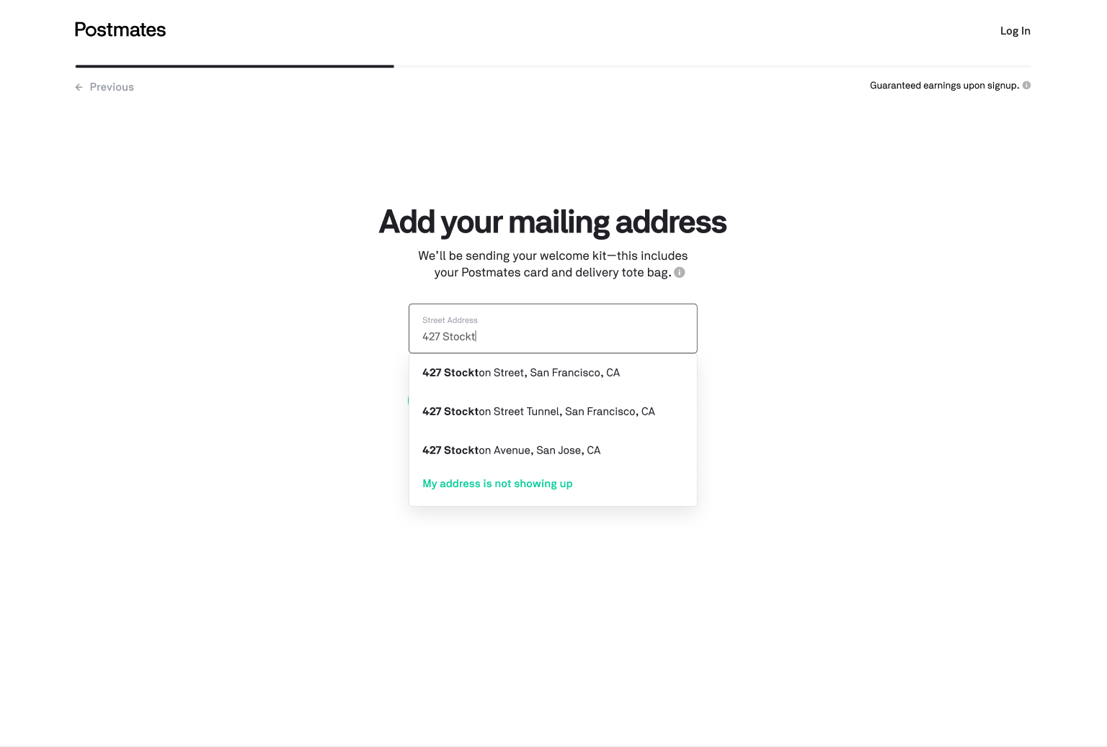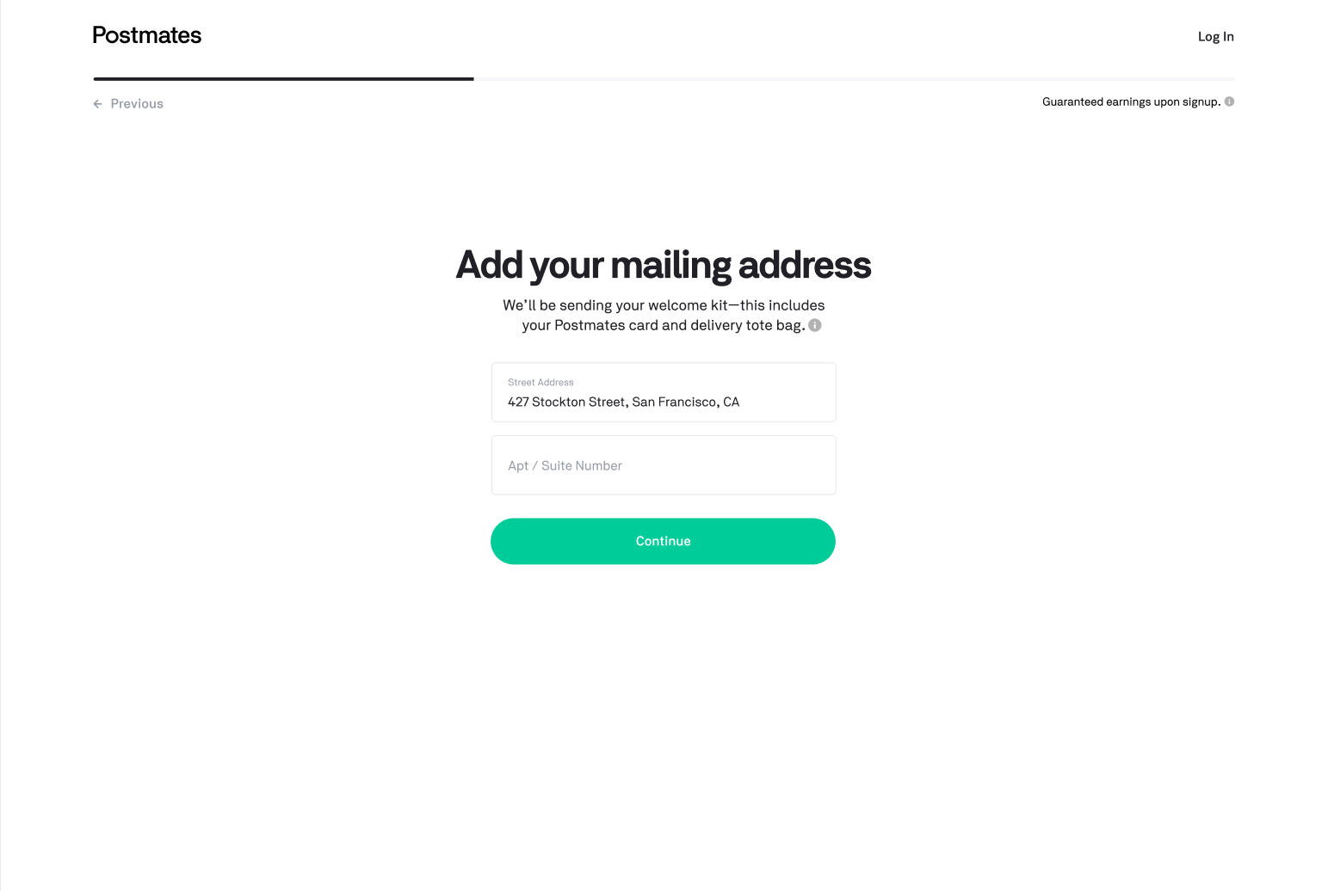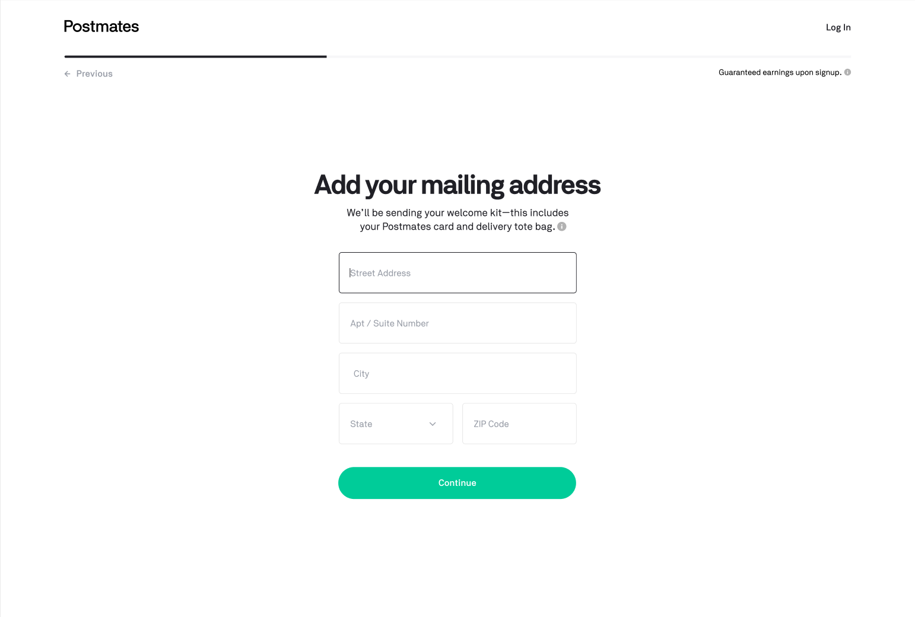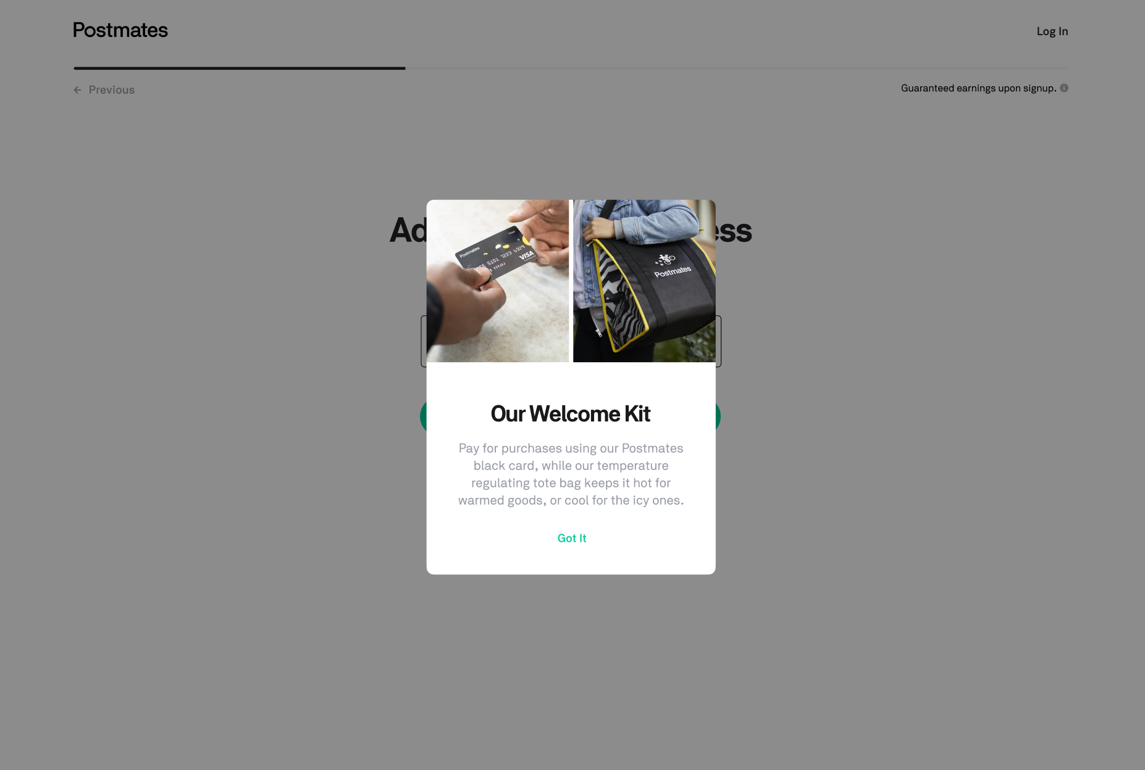
Confirm Where You Will Deliver | Confirm Where You Will Deliver  - If you are on this page  - You should see a city pre-indicated on the dropdown (pulled from mailing address)  - If a market was not attributed to the applicant’s mailing city on the backend during the mailing address entry  - Display the entry in the “City” field of their mailing address  - The server should conduct a radial search of cities (that are attributed to a market) within a 250 mile radius of the mailing city  - The dropdown will list all cities within a 250 mile radius of the mailing city in alphabetical order  - If you select any area on the form field (the text area or the carrot)  - The dropdown should expand  - The dropdown will list the city pre-selected with a check mark to the right  - If you select the text field of the dropdown, a cursor appears  - If you press any key with the cursor present, the city name should disappear  - With the text field cleared out, the dropdown should have an alphabetical list of the cities visible  - If you select “Continue”  - Your results are captured/stored and advance to the next screen: “Verify Your Identity”  - If you select “Previous”  - Your results will not be captured and a browser-level warning message will appear about advancing without saving changes. If confirmed, you will go to the “Tell Us How You WIll Deliver” or “Add Your Driver’s License” (depending on where you came from)  Error States  - If you have no city selected or if you manually write in a city that is not part of the dropdown, then an error state will appear that says “Choose a city Postmates operates in.”  - If you type in and try to hit “Continue” on an unavailable market, an error state will appear that says “Location Unavailable” | Market (Ideal-city matches existing market)  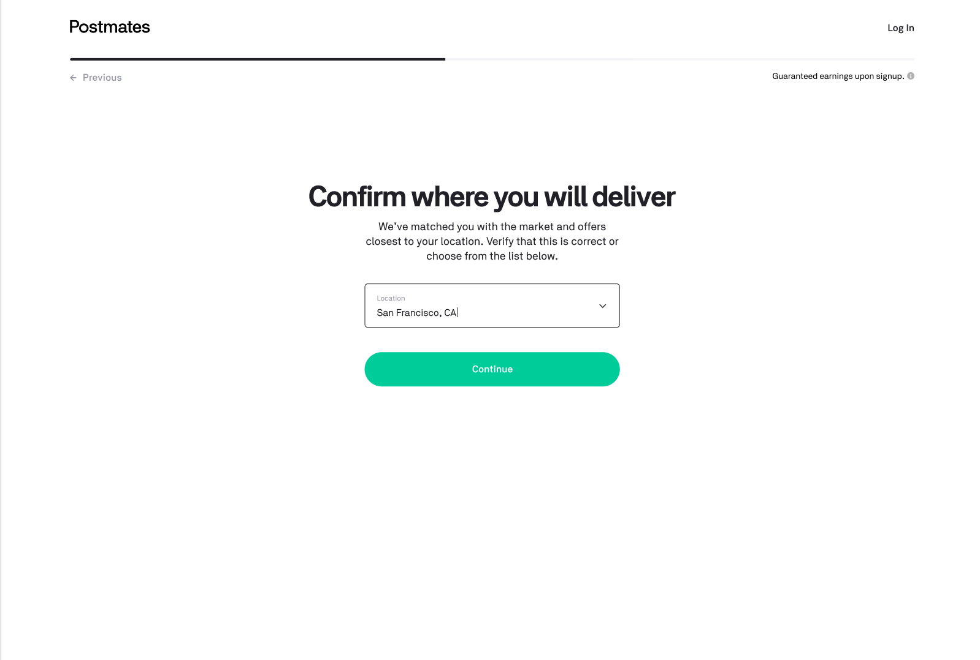  Market Error (Pre-filled city does not match existing markets)  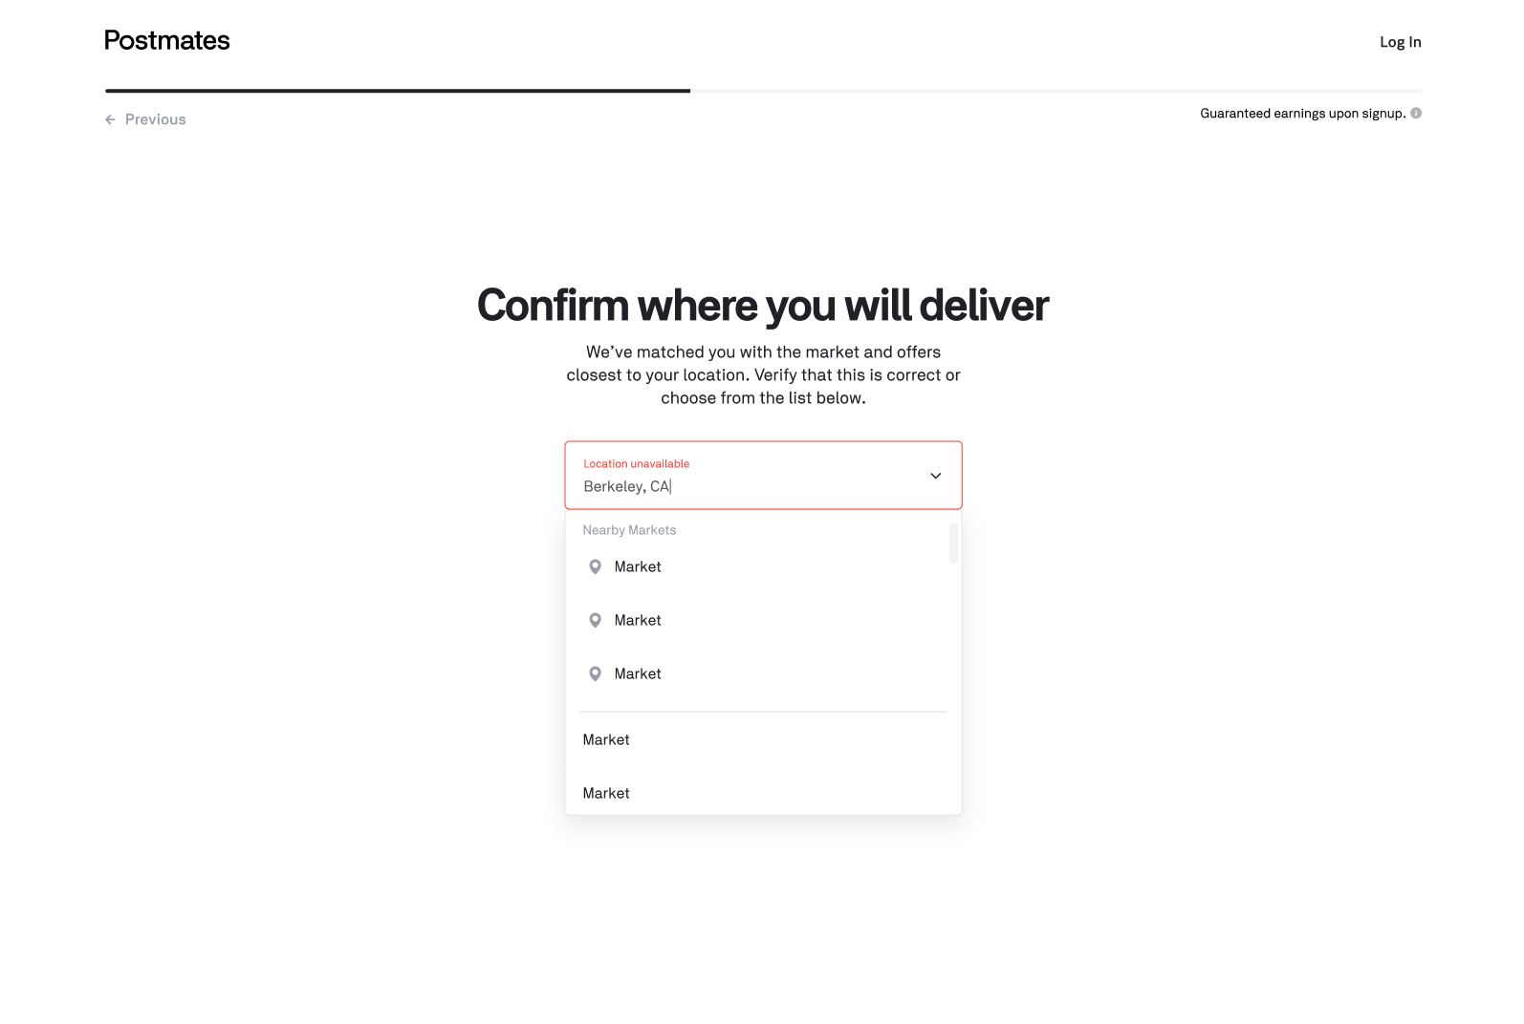  Behavior: Clicking carrot exposes menu  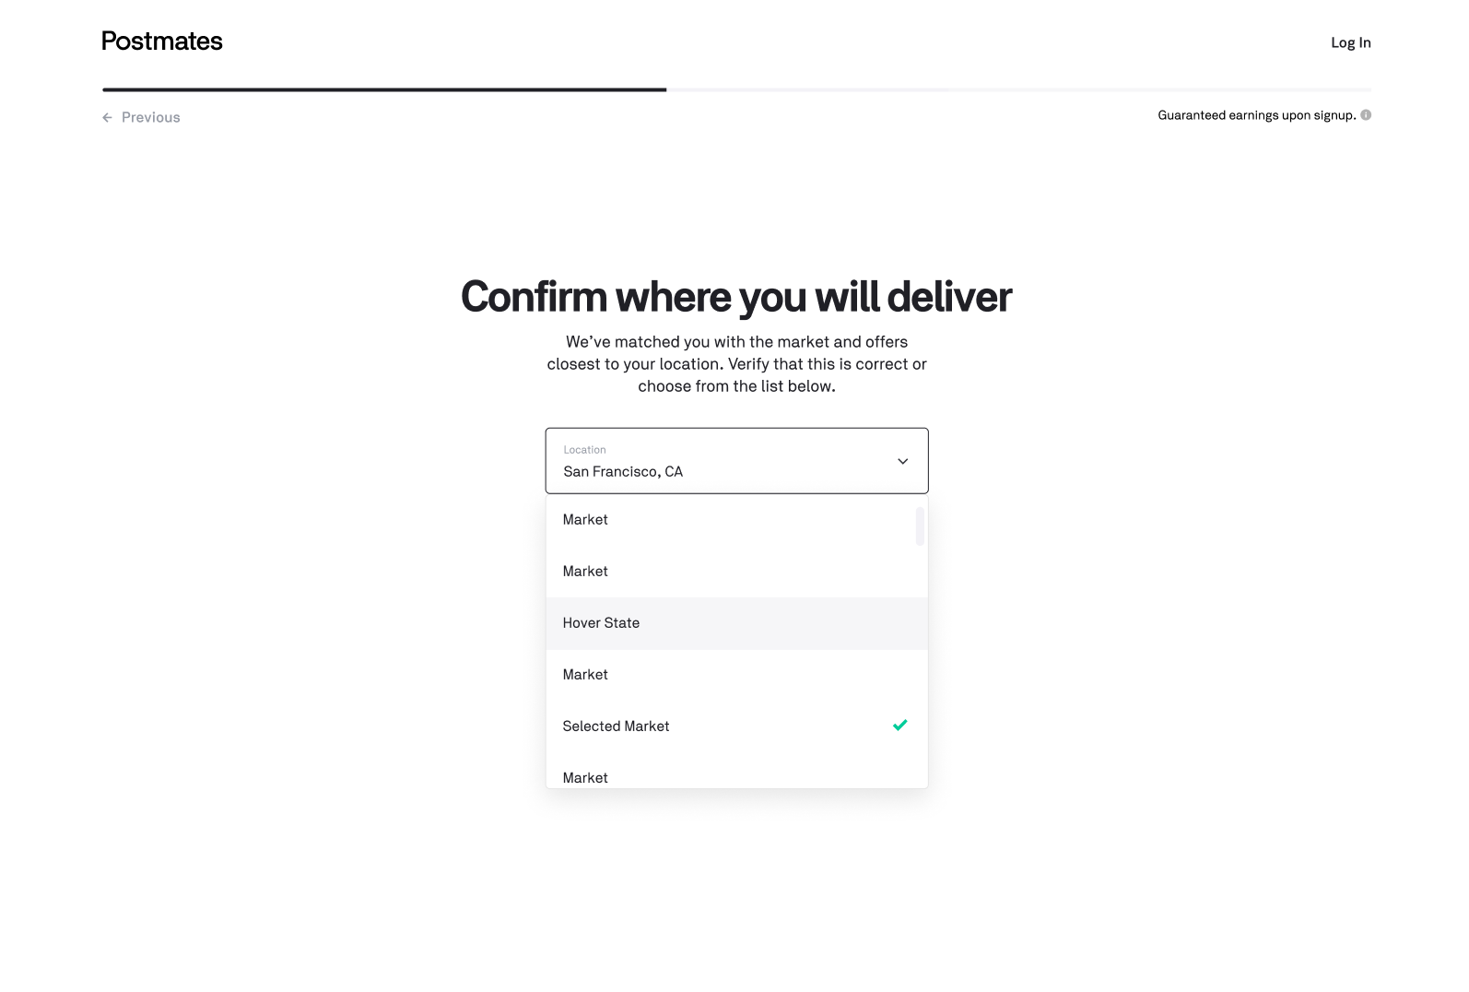  Clicking to type clears out pre-filled, and exposes menu  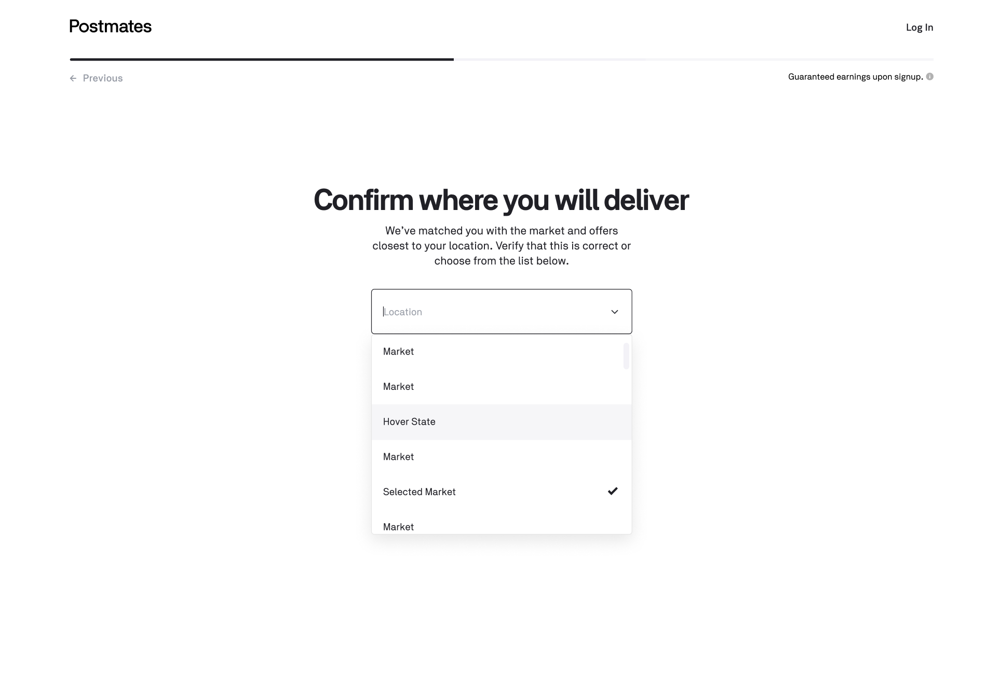  Typing shows matched relevant results  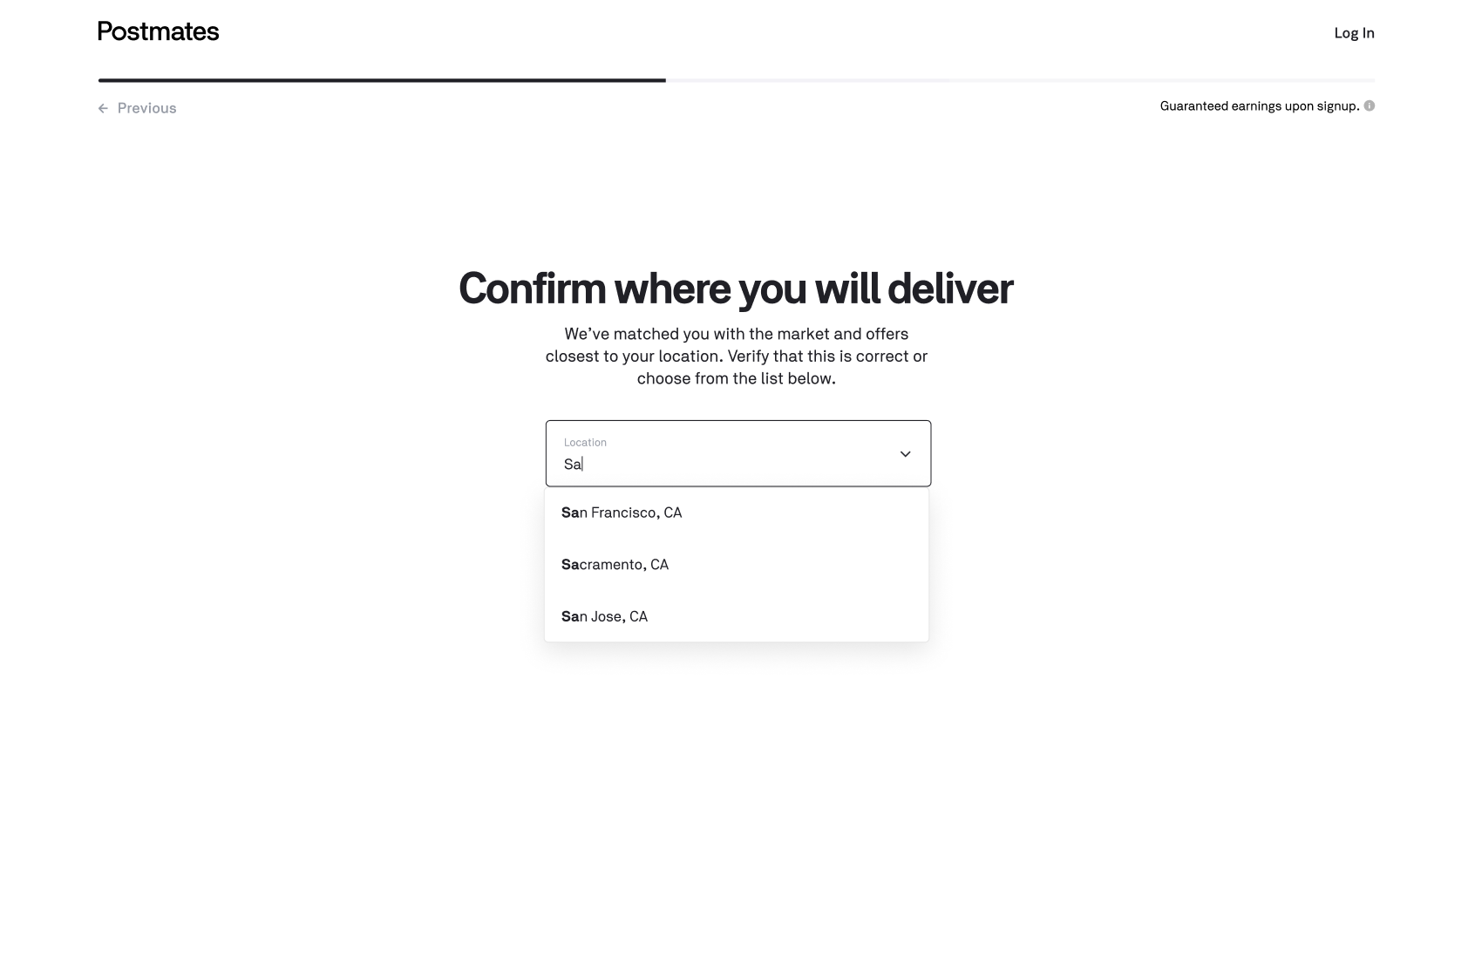  Continued typing with no matches show no error state  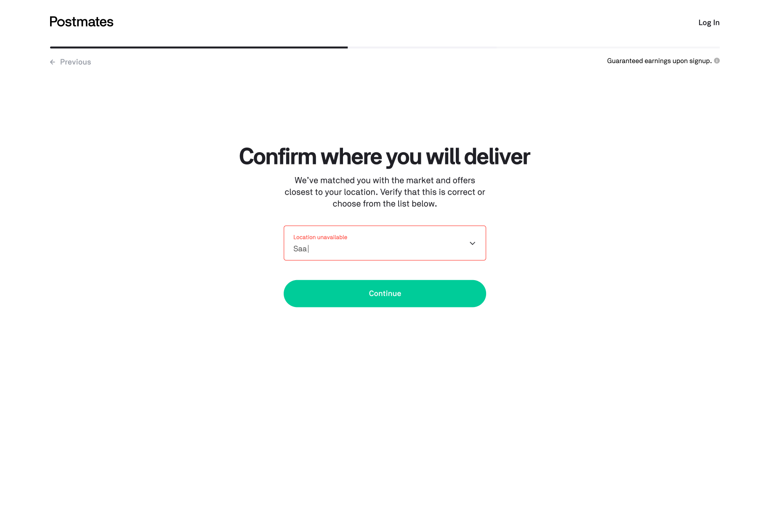
Driver’s License | Add Your Driver’s License  - If you are on the driver’s license screen  - If you enter data into the driver’s license number field  - It should only be alpha-numeric numbers  - It should call our Regex to validate the state-specific driver’s license format  - If you enter data into the State field  - It should be type-ahead  - Values should be of “XX” alphabetical format  - If you enter data into the “Exp Date” field  - It should be 4 numbers only  - As you type the 3rd digit, there should be a forward slash after the second digit so the complete output is in the following format “XX/XX”  - If you select “I will not be driving”  - Your results will not be captured/saved and you will be directed to the “Tell us how you will deliver” screen  - If you are in a market that only has a car as an option  - Do not show “I will not be driving”  - If you select “Continue”  - Your results are captured/stored and advance to the next screen: “Confirm where you will deliver”  - You will also be tagged as having a “car” as the default vehicle option  - If you select “Previous”  - Your results will not be captured and a browser-level warning message will appear about advancing without saving changes. If confirmed, you will go to the “Tell Us About Yourself” screen  Error States  - If you enter a driver’s license number that does not follow the syntax specific to the indicated state:  → “Invalid license number”  - If blank, “Enter your license number”  - If state not selected “Select state”  - If you enter an expiration date that is not 4 numbers, display an error message that says “Invalid expiration”  - If blank, “Enter expiration” | 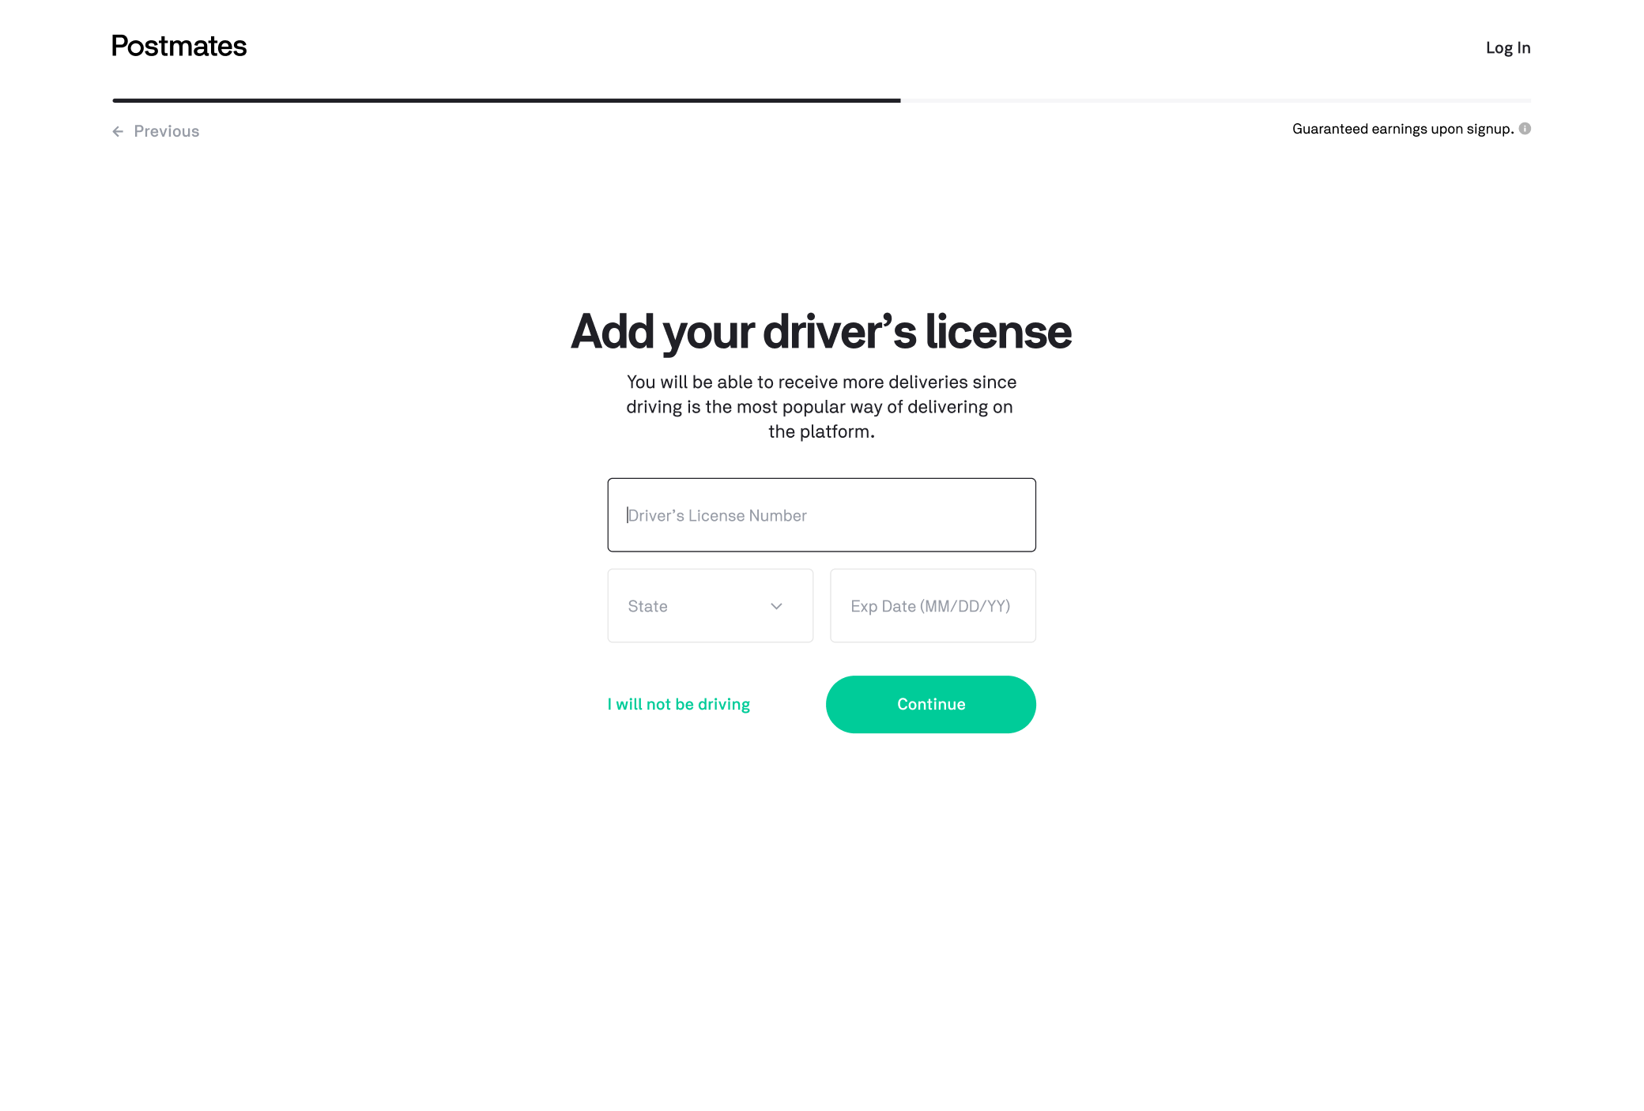
Tell Us How You Will Deliver | Vehicle Selection  - If you are on the vehicle selection screen  - If you hover over one of the 3 vehicle options  - The vehicle icon should levitate a little higher up from its original position and have a dropshadow  - If you select one of the 3 vehicle options  - The vehicle icon should levitate a little higher up from its original position and have a dropshadow  - Selected state reverts back to original position and has specific black color border  - If you select another vehicle option after having already selected one  - The same logic applies to the new selection, while the prior selection reverts  - If you select “I will be driving”  - Your results will not save and you will be redirected to the “Add your driver’s license” screen  - If you select “Continue”  - Your results are captured/stored and advance to the next screen: “Confirm where you will deliver”  - If you select “Previous”  - Your results will not be captured and a browser-level warning message will appear about advancing without saving changes. If confirmed, you will go to the “Add your driver’s license” screen  Error States  - If you select no vehicle option, selecting continue should prompt an error message that says “*Select how you will deliver” right below the headline | Default:  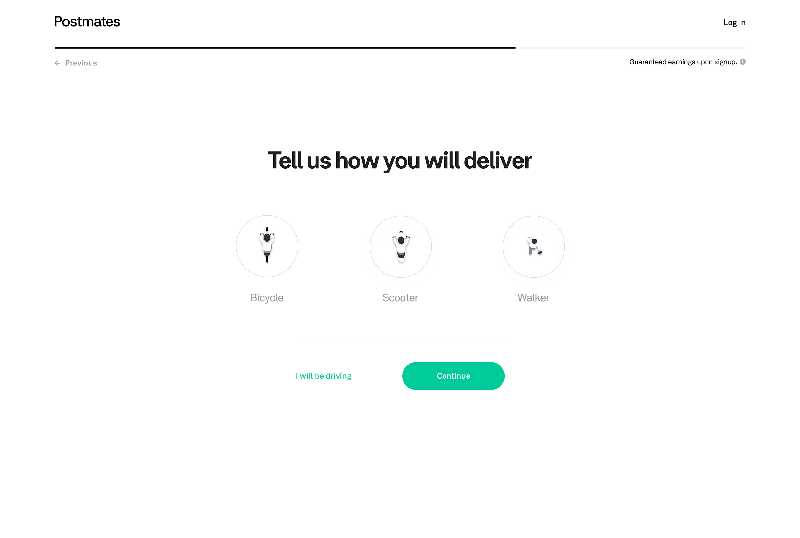  Hover: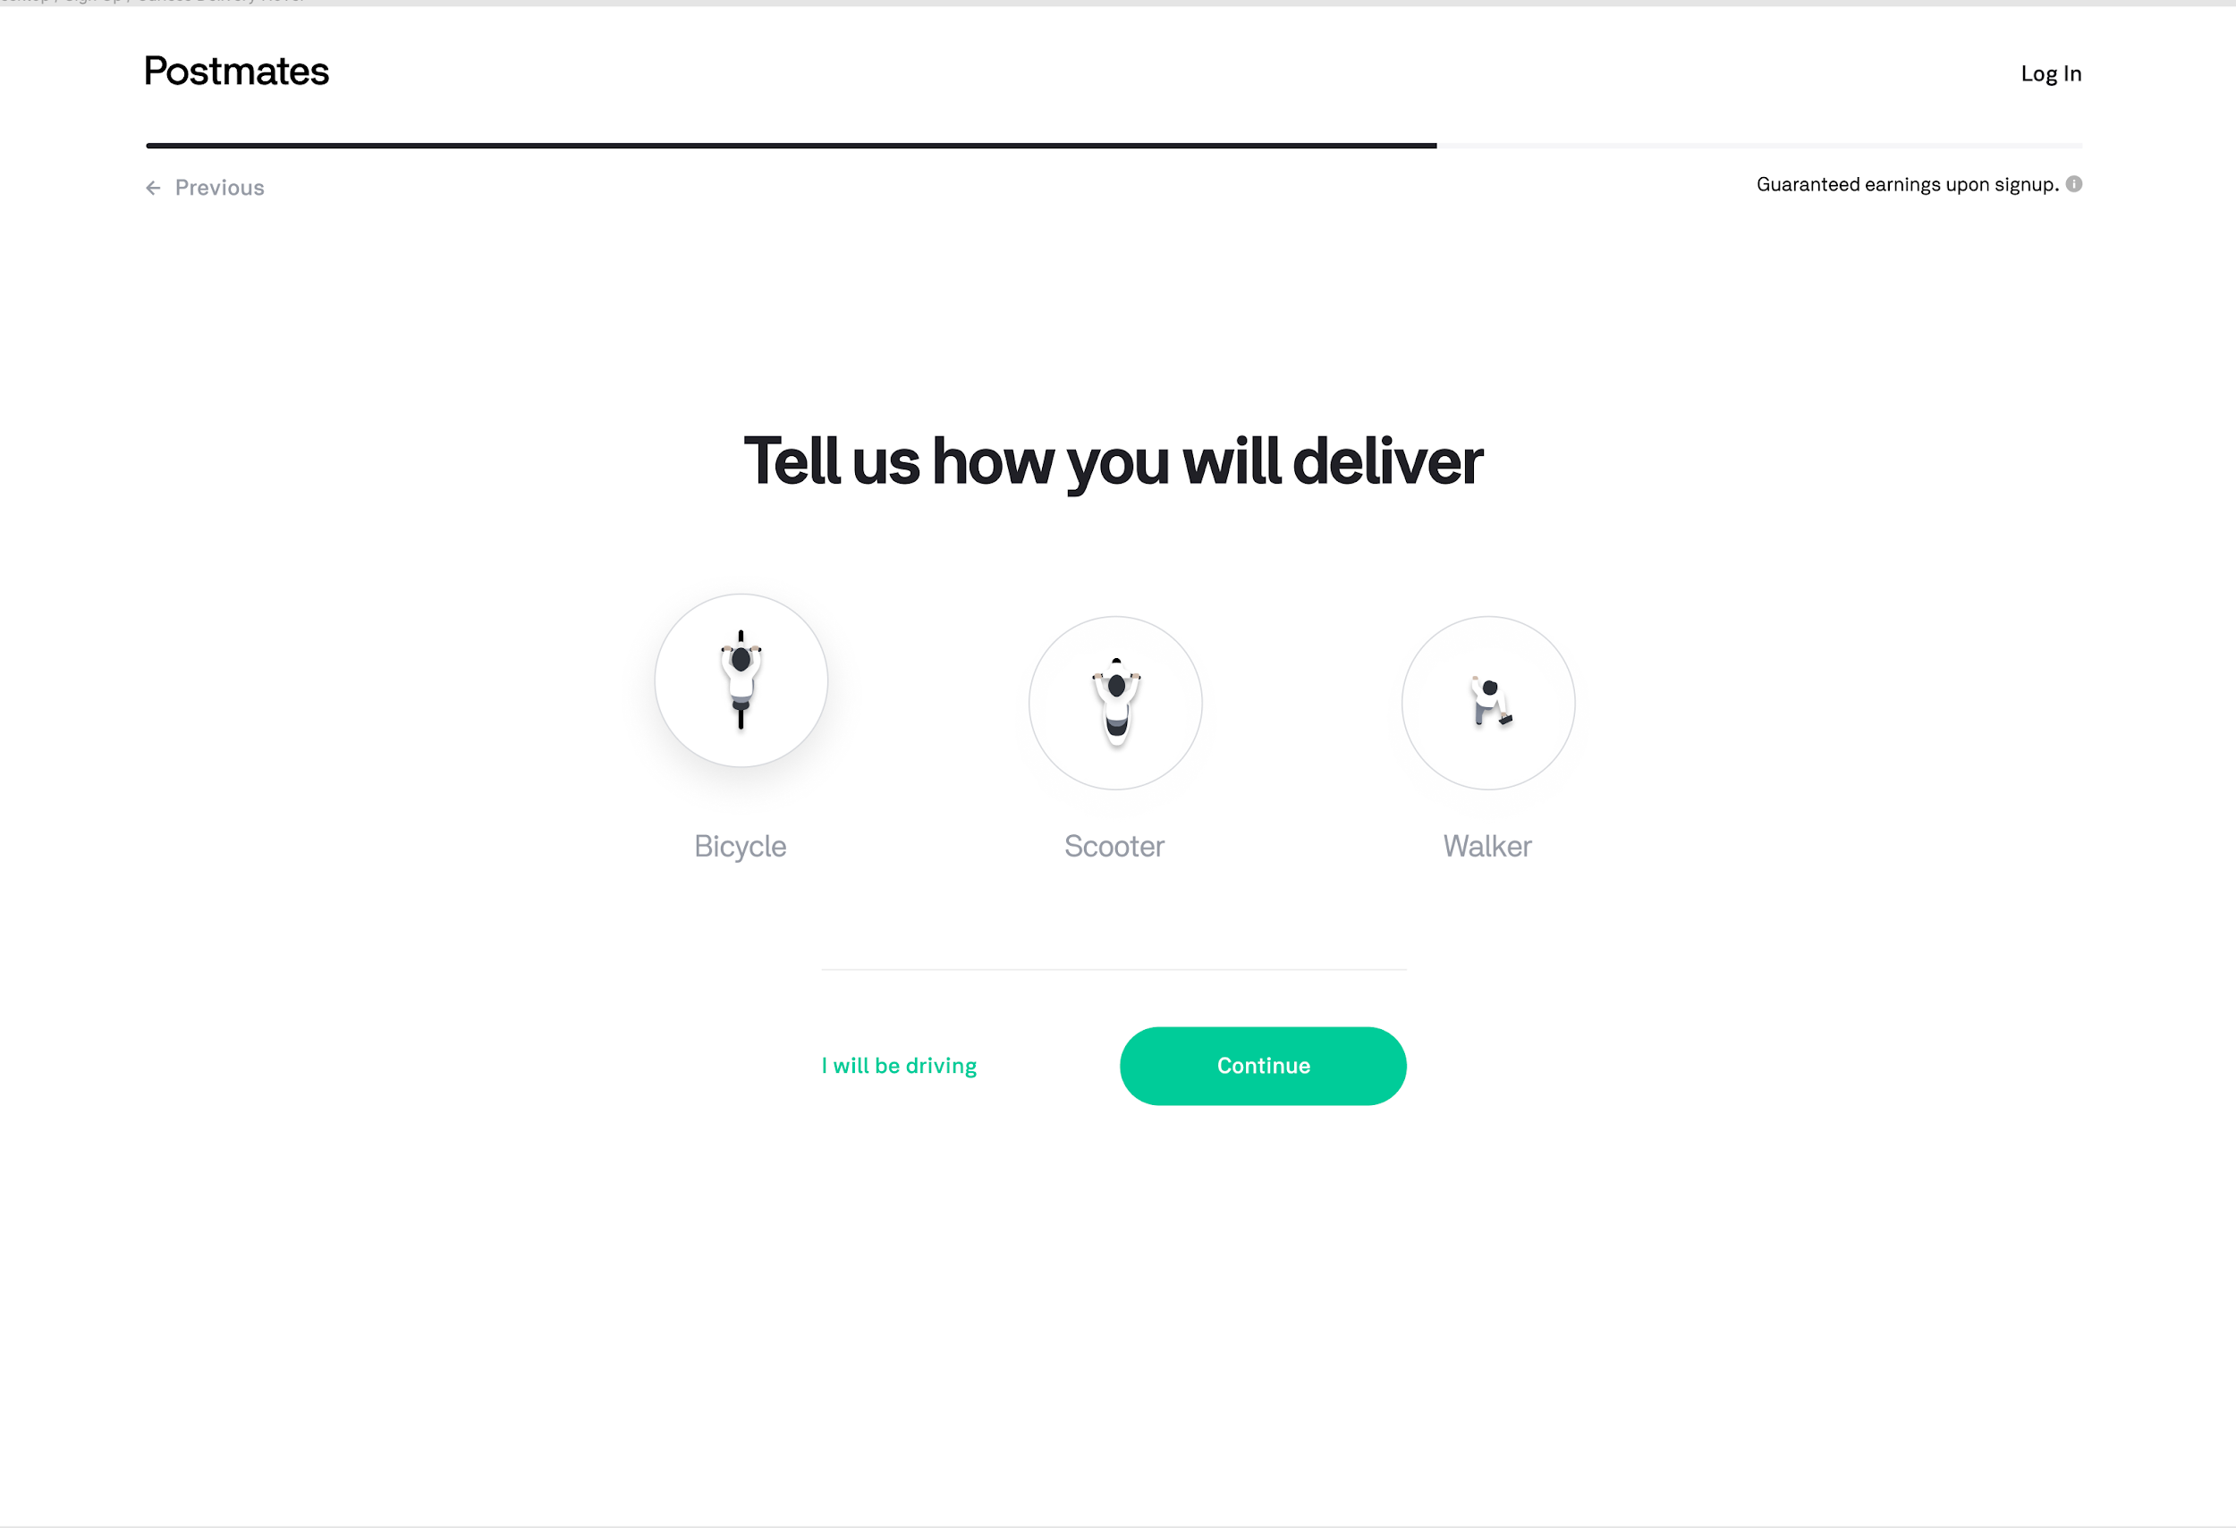  Selected: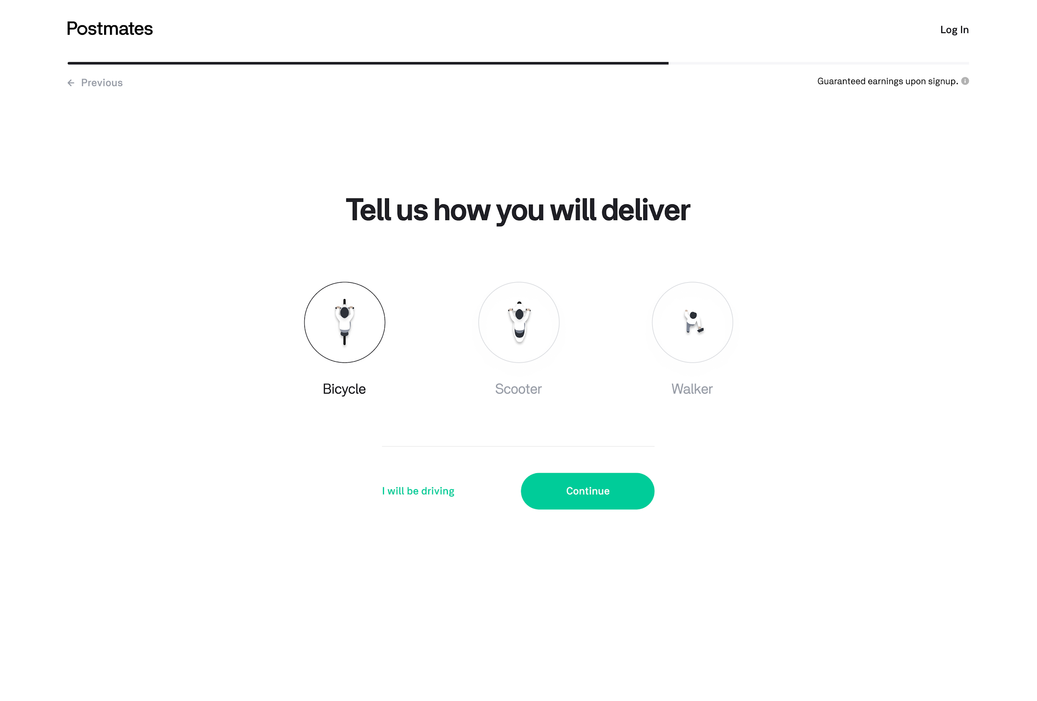  Error:  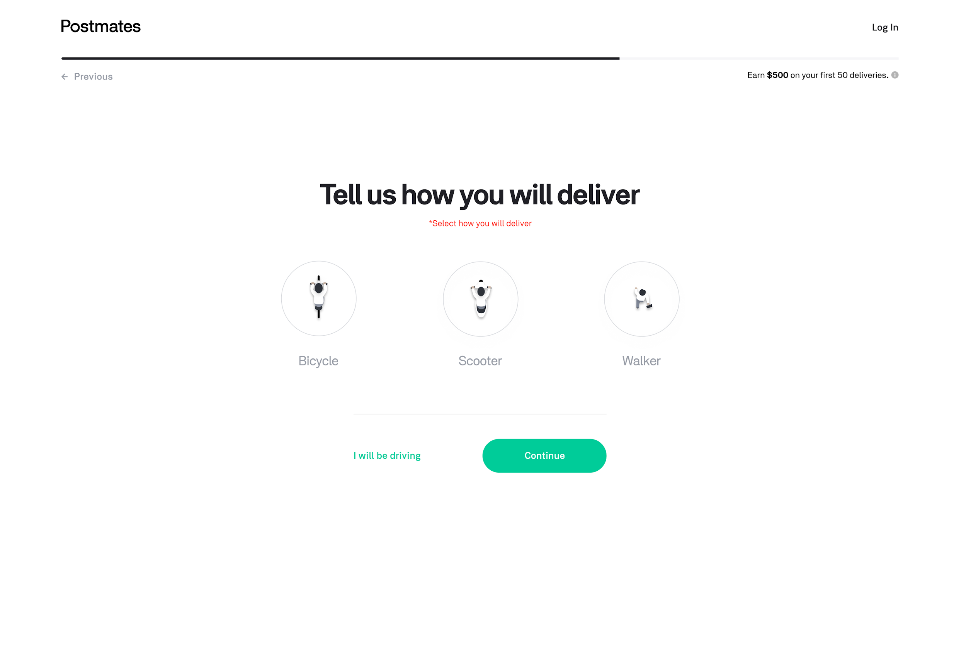
Verify Your Identity | Verify Your Identity  - If you are on the Verify Your Identity screen  - There is a form field for Social Security Number  - There should be form validation of only 9 numerical digits  - The fourth digit should prompt a dash after the third  - The sixth digit should prompt a dash after the fifth  - There is a form field for Date of Birth  - There should be form validation of only 6 numerical digits  - The third number should prompt a forward slash after the second  - The fifth number should prompt a forward slash after the fourth  - If you select “Continue”  - Your results are captured/stored and advance to the next screen: “Add Profile Photo”  - If you select “Previous”  - If you had any data entered into the fields, your results will not be captured and a browser-level warning message will appear about advancing without saving changes. If confirmed, you will go to the “Confirm Where You Will Deliver” screen  - If you had no data, you will be directed to the “Confirm Where You Will Deliver” screen  Error States  - If you did not enter 9 numerical digits for the Social Security number, then an error message will appear that says “Please enter a valid SSN”  - If you did not enter 6 numerical digits for the Date of Birth, then an error message will appear that says “Please enter a valid DOB (MM/DD/YY)” | 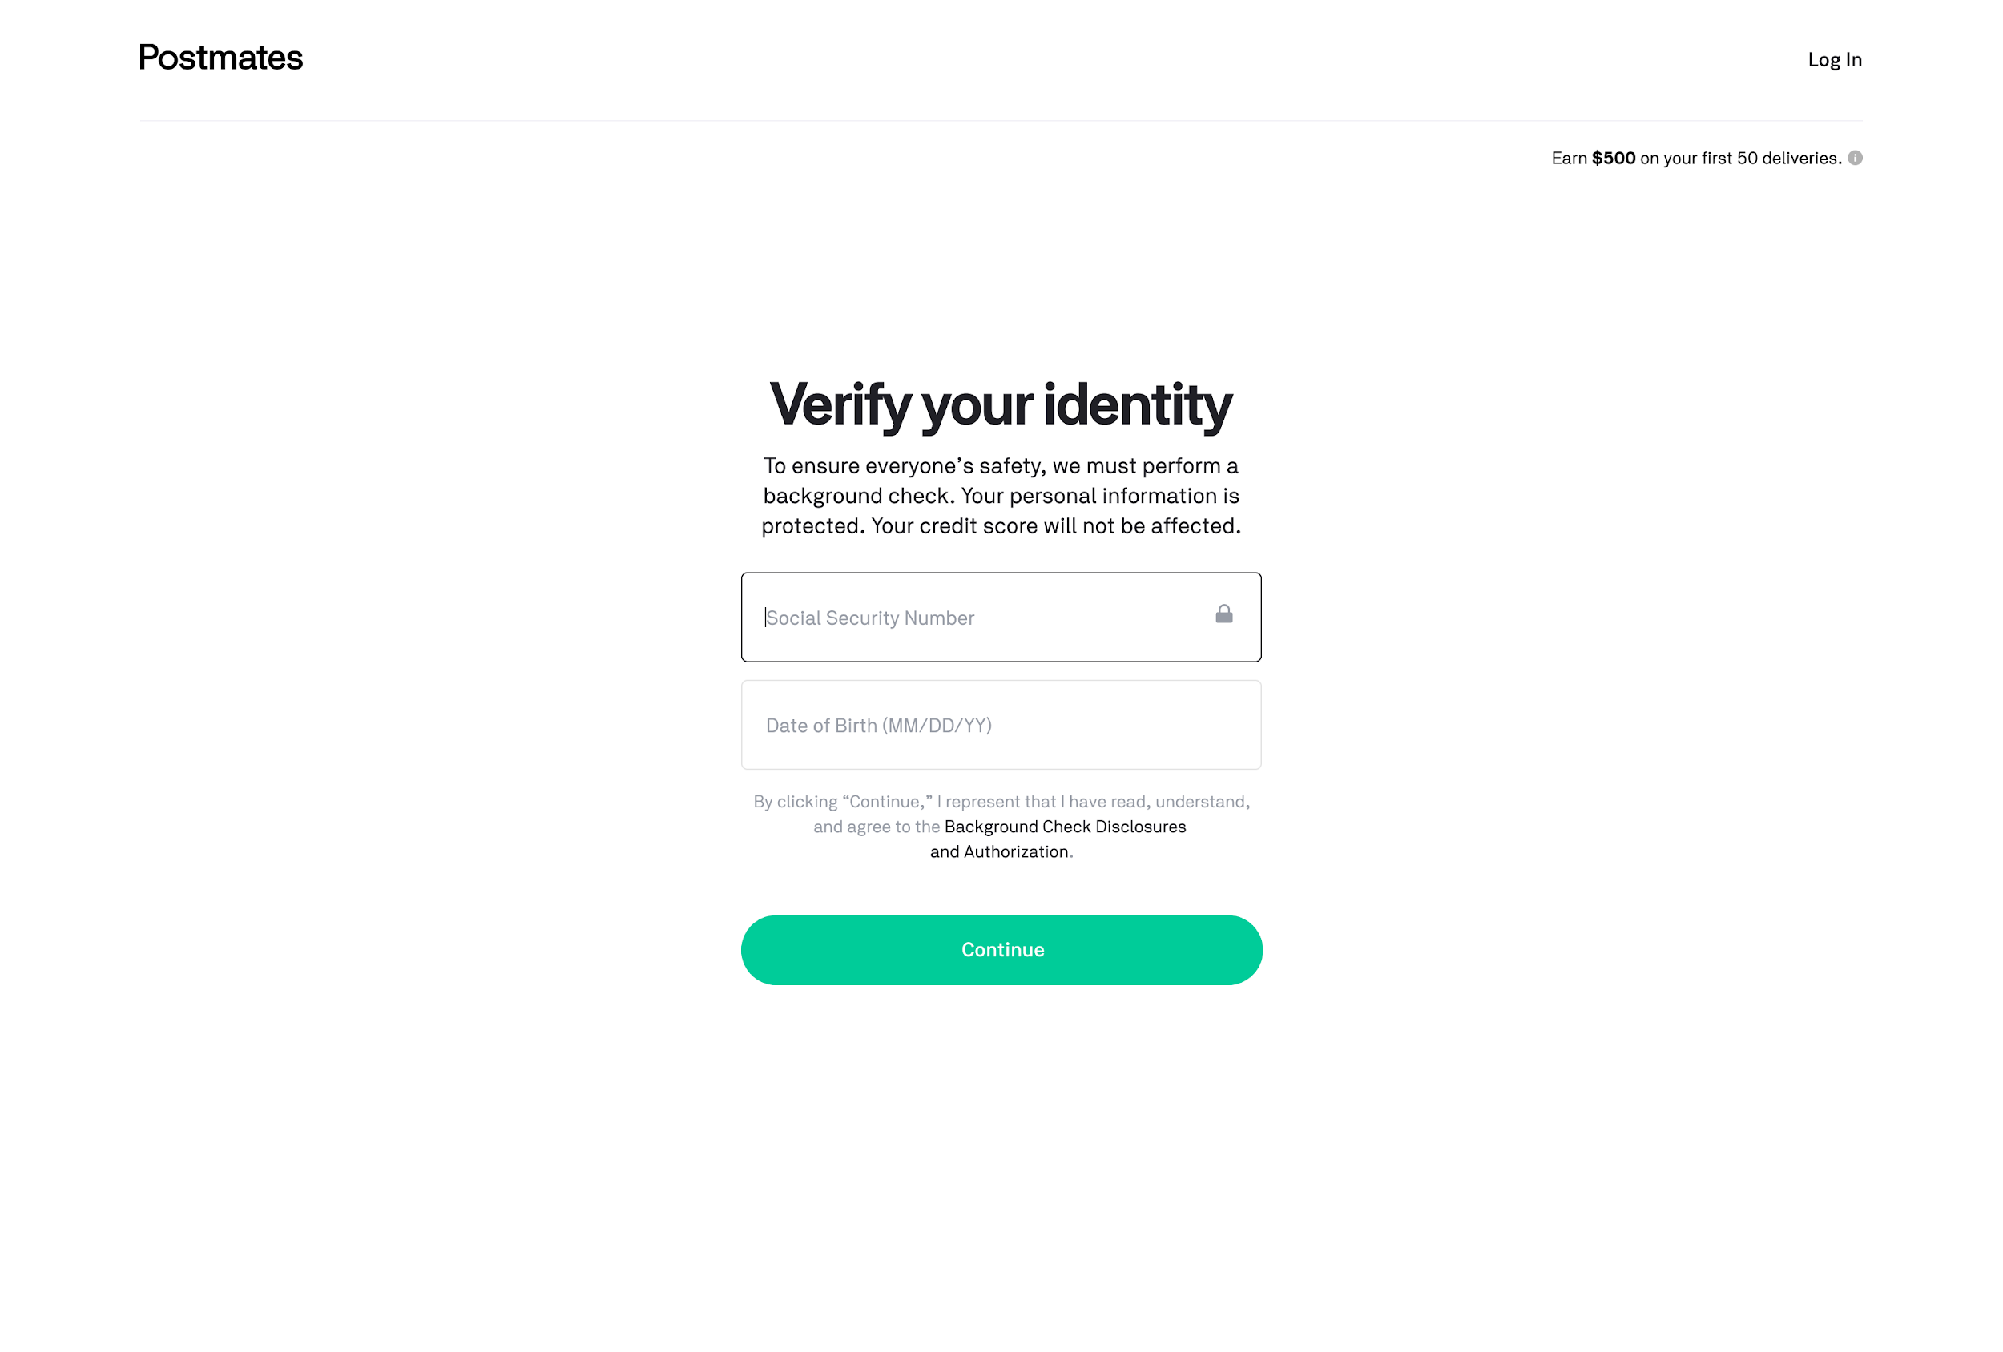
Add Profile Photo | Add Profile Photo  - If you are on the profile photo screen  - Upon hover (state) of avatar button, entire area darkens, and the outside border expands  - Clicking “Upload” / the entire avatar profile button should prompt a menu to  - Browse files  - Prompts search window native to your computer  - A photo should then be selected/taken  - Clicking outside menu makes it disappear and you are back to default state  - If a photo has been selected that meets the above requirements  - Uploaded image replaces button, the editor controls appear below (see more info on Edit your image on row below)  - If you select “Previous”  - You will be directed to the “Verify Your Identity” screen  Error States  - If you select Continue without having a photo attached  a red error circle appears around the perimeter of the Upload profile button. | Default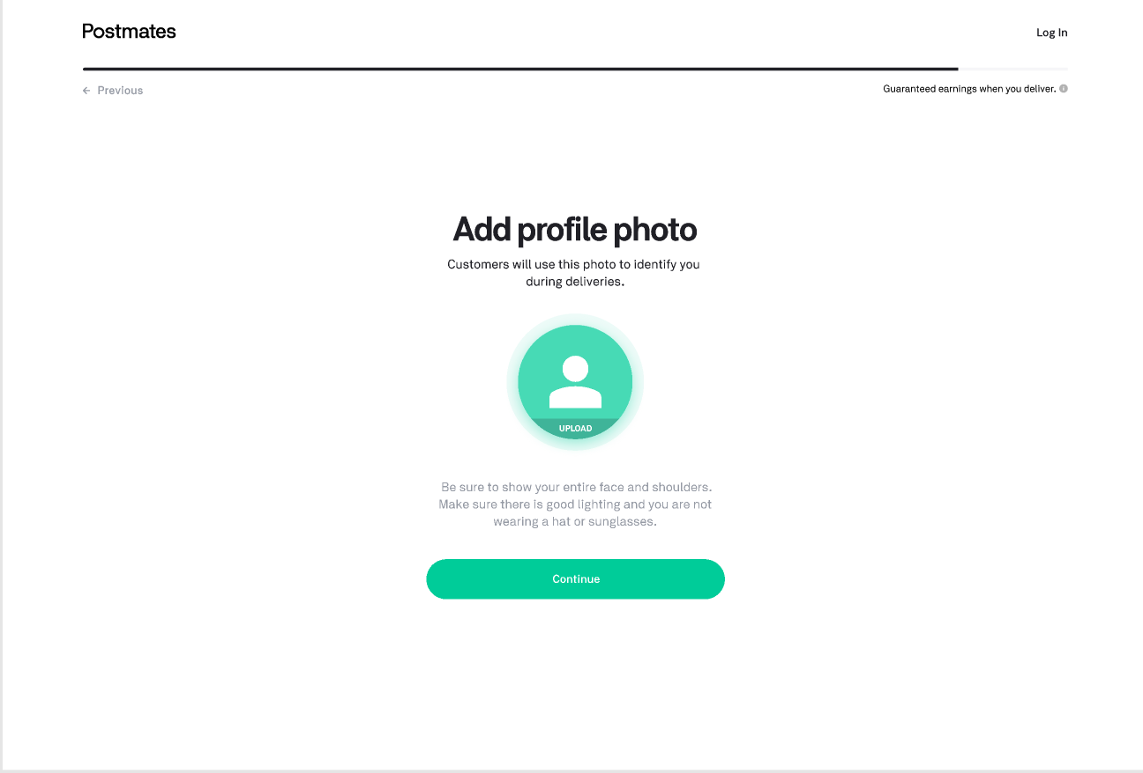  Hover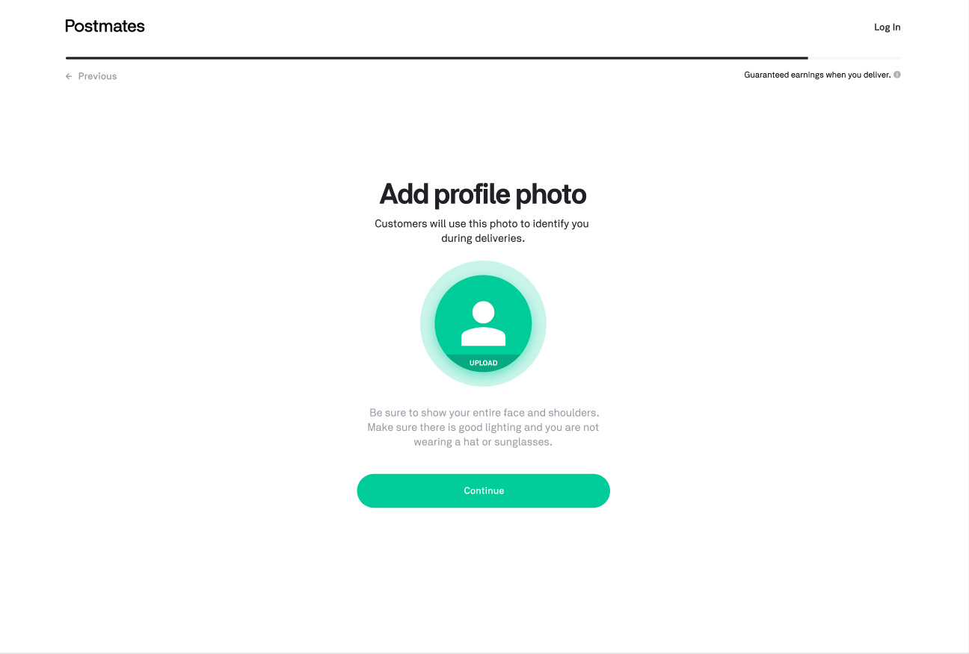  Clicked exposes menu  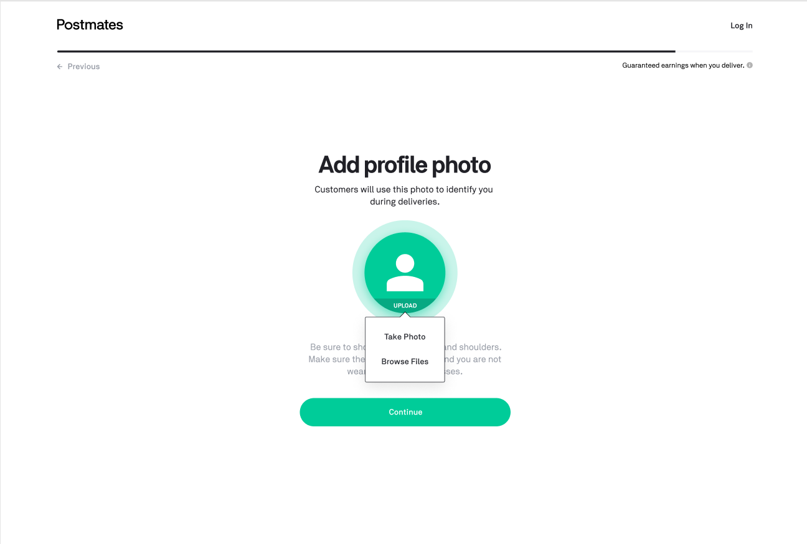  Error Default  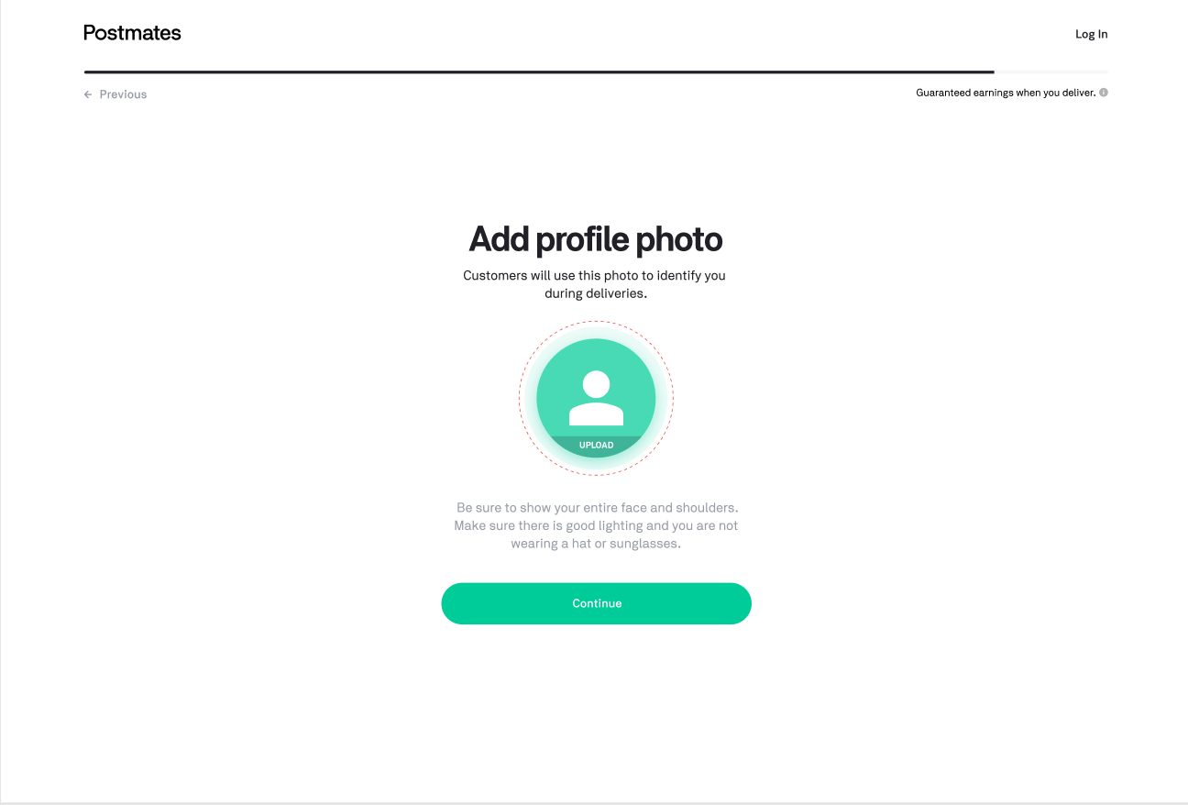  Error Hover state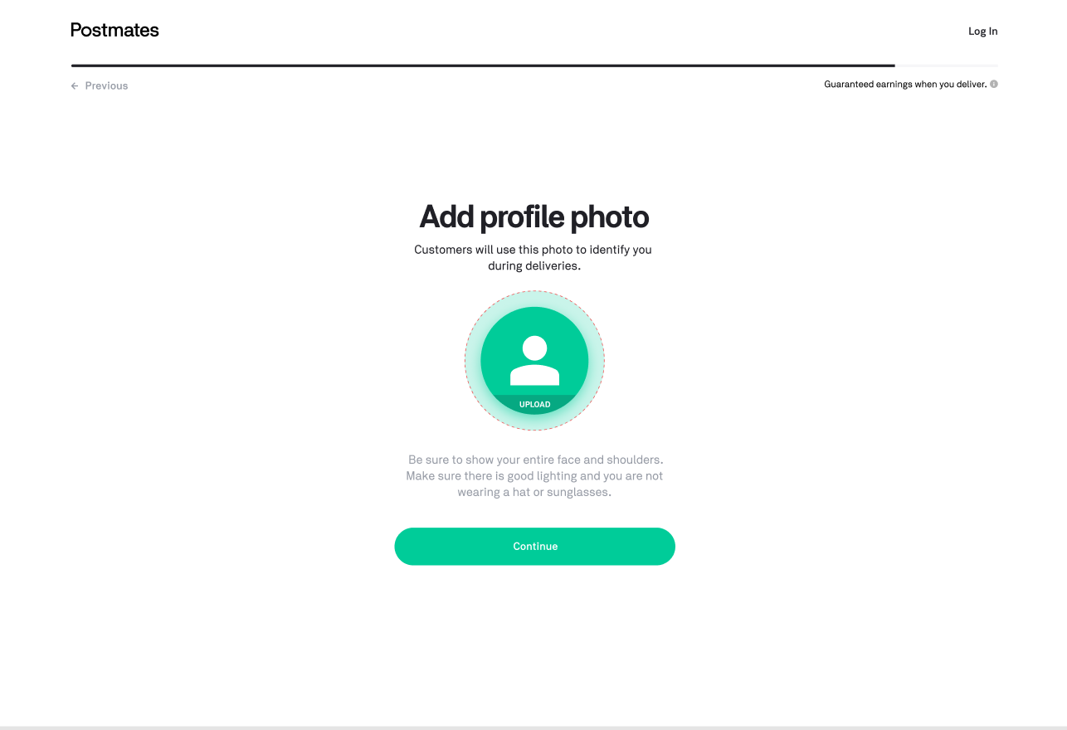
Edit Your Image | Editing your image  - After uploading image  - You should see the image you selected within a circle in the center of the screen  - The image will scale to fit within box, with anything outside the circle translucent  - There is a control slider beneath the circle in the center of the screen that zooms in on the image when adjusted to the right and minimizes it when adjusted to the left  - Clicking and dragging the image lets you pan it to center  - If you click the X button on top right, it will close and reset/reverting back to default add profile photo setting with button (and zoom controls disappear)  Error States  - N/A | 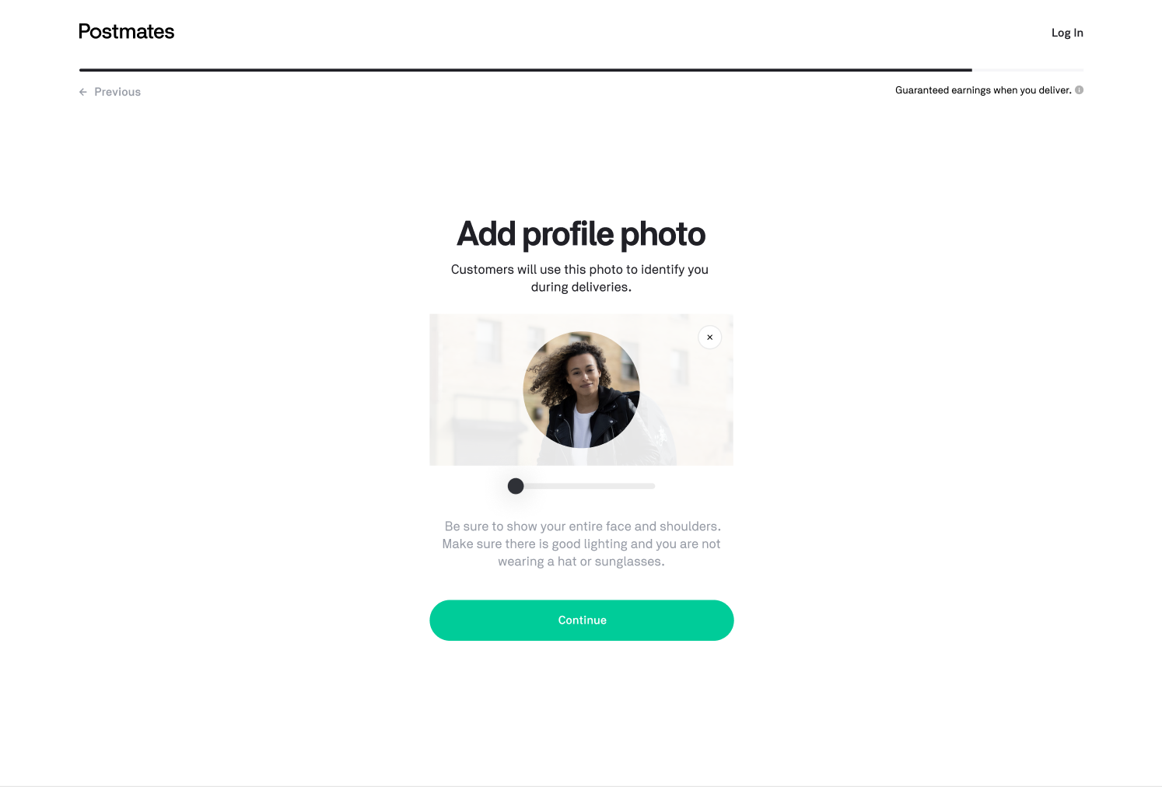
Pending State Dashboard | Application Status Bar  - User cannot go back and edit content  - Under Welcome message “Welcome to the Fleet, (First name)  - If user is in a cardless market, message appears “Once your account is approved, you can start delivering without your prepaid card.”  - If user is not in a cardless market, no messaging  - Above “Welcome Kit”  - There is a green check mark icon if the event Welcome Kit Order has fired off, which calls the Shopify API and generates a Welcome Kit shipment  - The word “Shipped” is indicated beneath “Welcome Kit”  - Subcopy states “Arrives in 1-3 business days”  - There is a clock icon if the event did not fire off  - Above “Photo Verification”  - There is a green check mark icon if the selfie has been approved  - The word “Approved” is beneath “Photo Verification”  - There is a clock icon if the selfie photo is still being approved by our external agency (webhook is sent when approved)  - The word “In Progress” is indicated beneath “Photo Verification”  - There is a triangular hazard icon if the selfie was rejected.  - The status “Action Required” should appear beneath “Photo Verification”  - The subtext beneath “Re-Upload” acting as a link  - Selecting “Re-upload” should link back to the “Add profile photo” Sign up step.  - After successful photo upload, “Continue” button brings them back to status page  - I would think, if you are re-uploading, There shouldn’t be a progression loader, Previous button should bring back to Account status page, And the top nav will show “  - Above “Background Check”  - There is a green check mark icon if the background check’s webhook returns report.completed has passed  - The word “Completed” is beneath “Background Check”  - There is a clock icon if the background check’s webhook is returned with either of these statuses report.resumed, report.upgraded, report.pre_adverse_action or report.disputed  - The word “In Progress” is indicated beneath “Background Check”  - Subcopy states “Takes 1-3 business days”  - There is a triangular hazard icon if the background check’s webhook returns report.suspended, meaning it requires additional information  - The word “Action Required” is indicated beneath “Background Check”  - The subtext beneath “Action Required” should say “Check your email for next steps”  Download Now  - A widget appears in the center of the screen with a field to enter in a phone number  - The field should be pre-populated with the user’s phone number  - Selecting the green button w/ an arrow sends a text message to the phone number with a link to download the app  Top Questions  - There will be 3 key questions (shown as headers) that will be asked during signup and a “+” icon to the right of it  - When selecting the “+” icon, text will expand beneath the header (shown as a body)  - There will also be a link to the help article this blurb is referencing  - Article 1  - Article 2  - Article 3  Error States  - N/A | 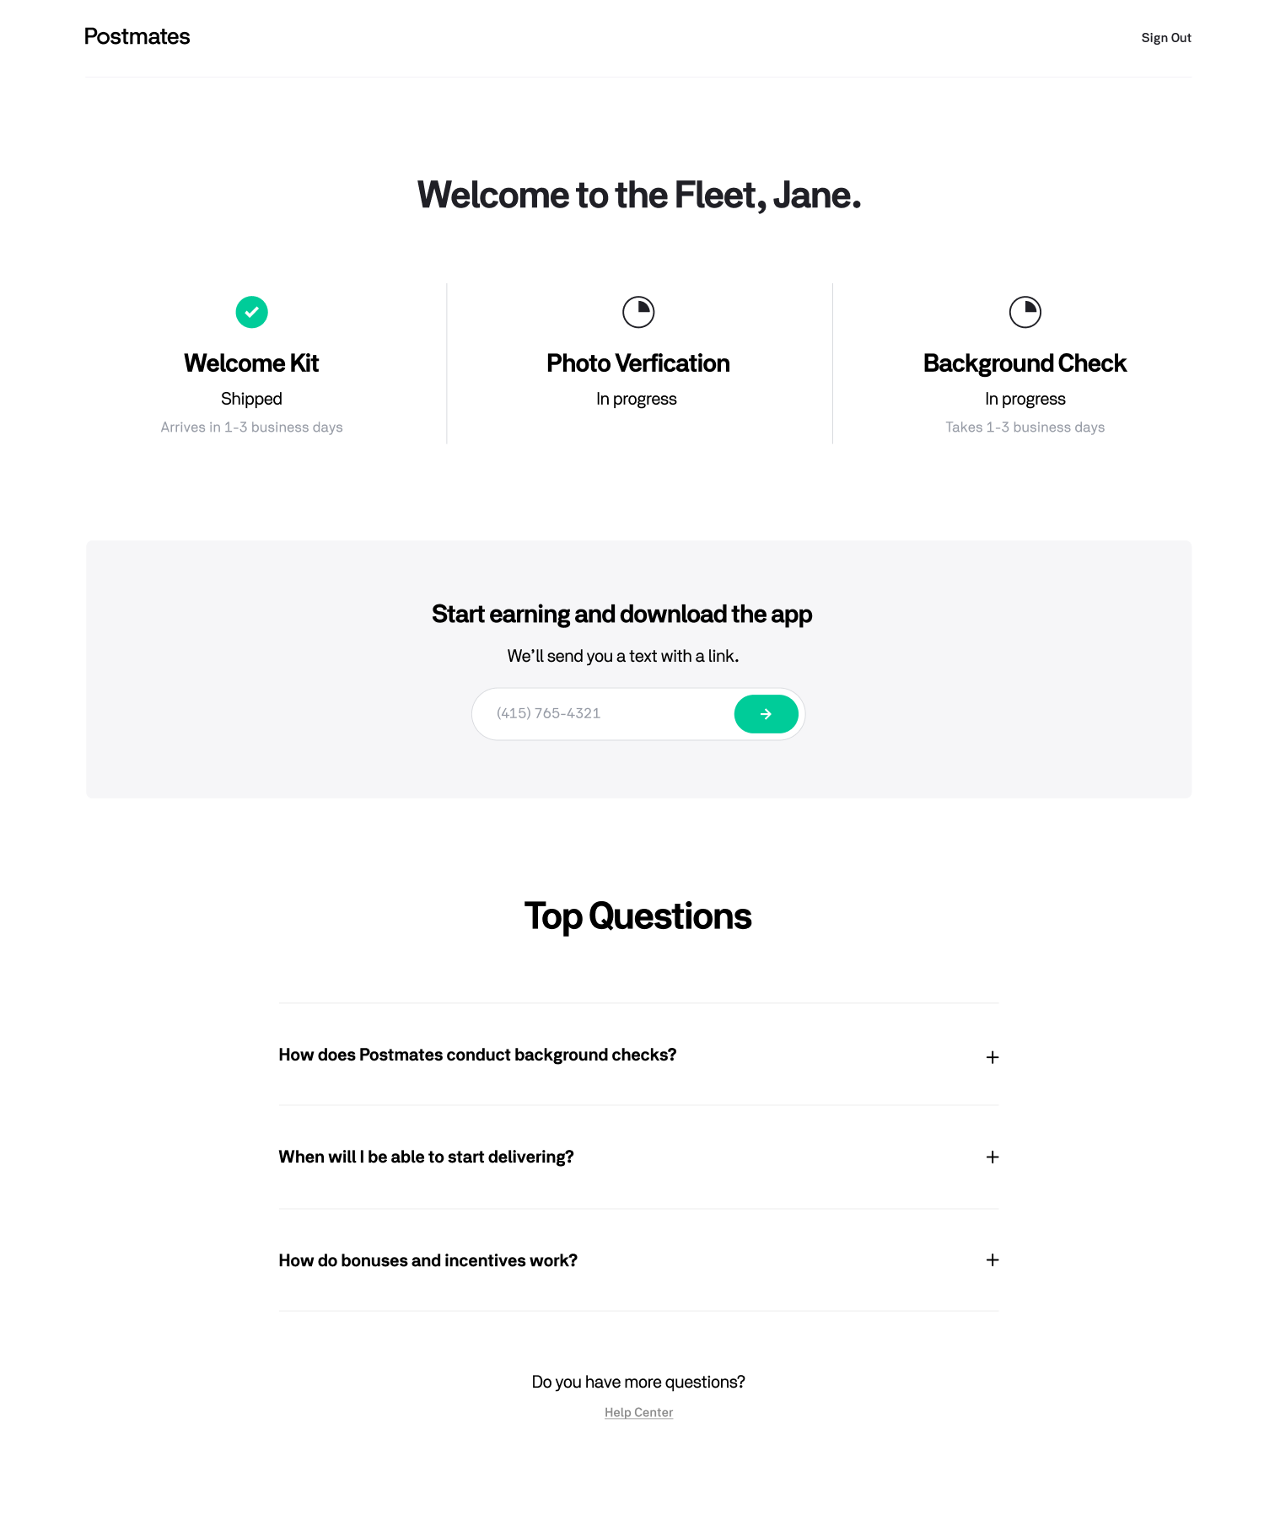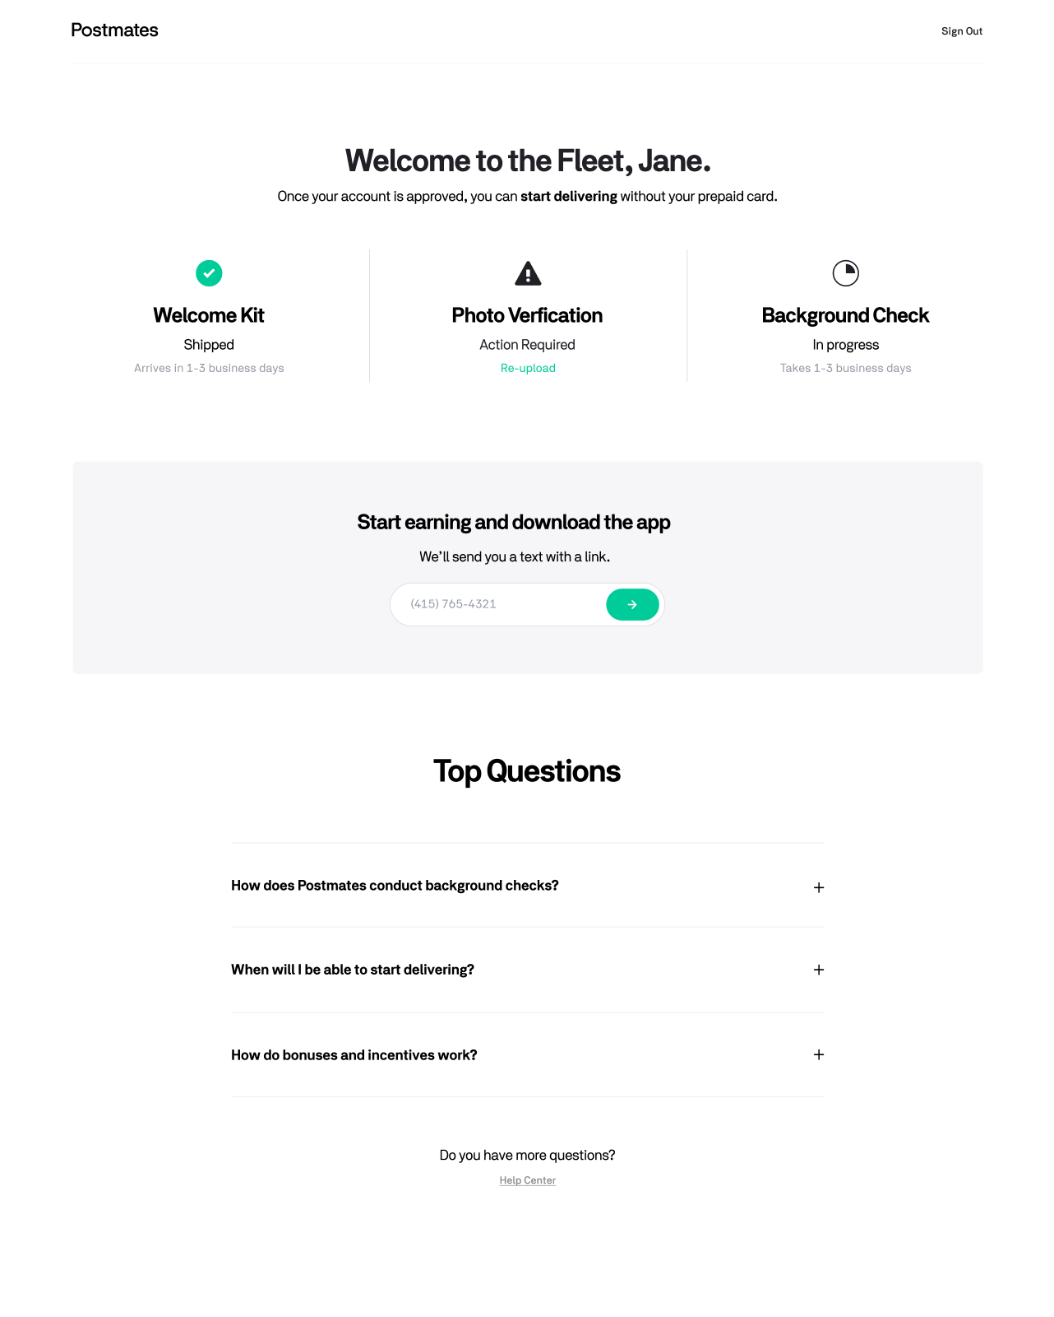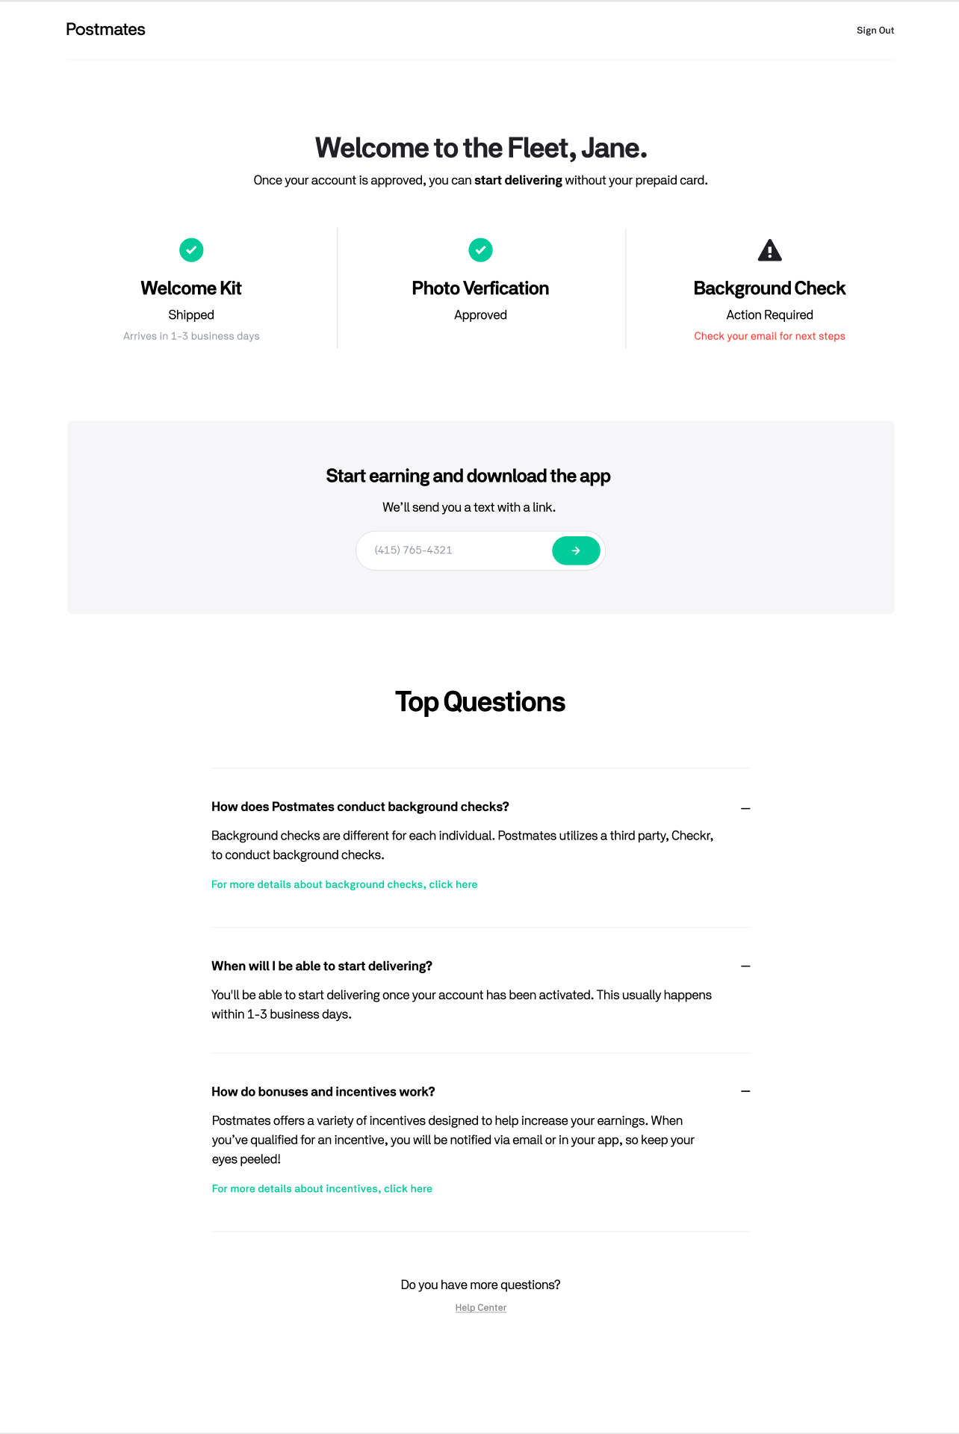  Re-upload:  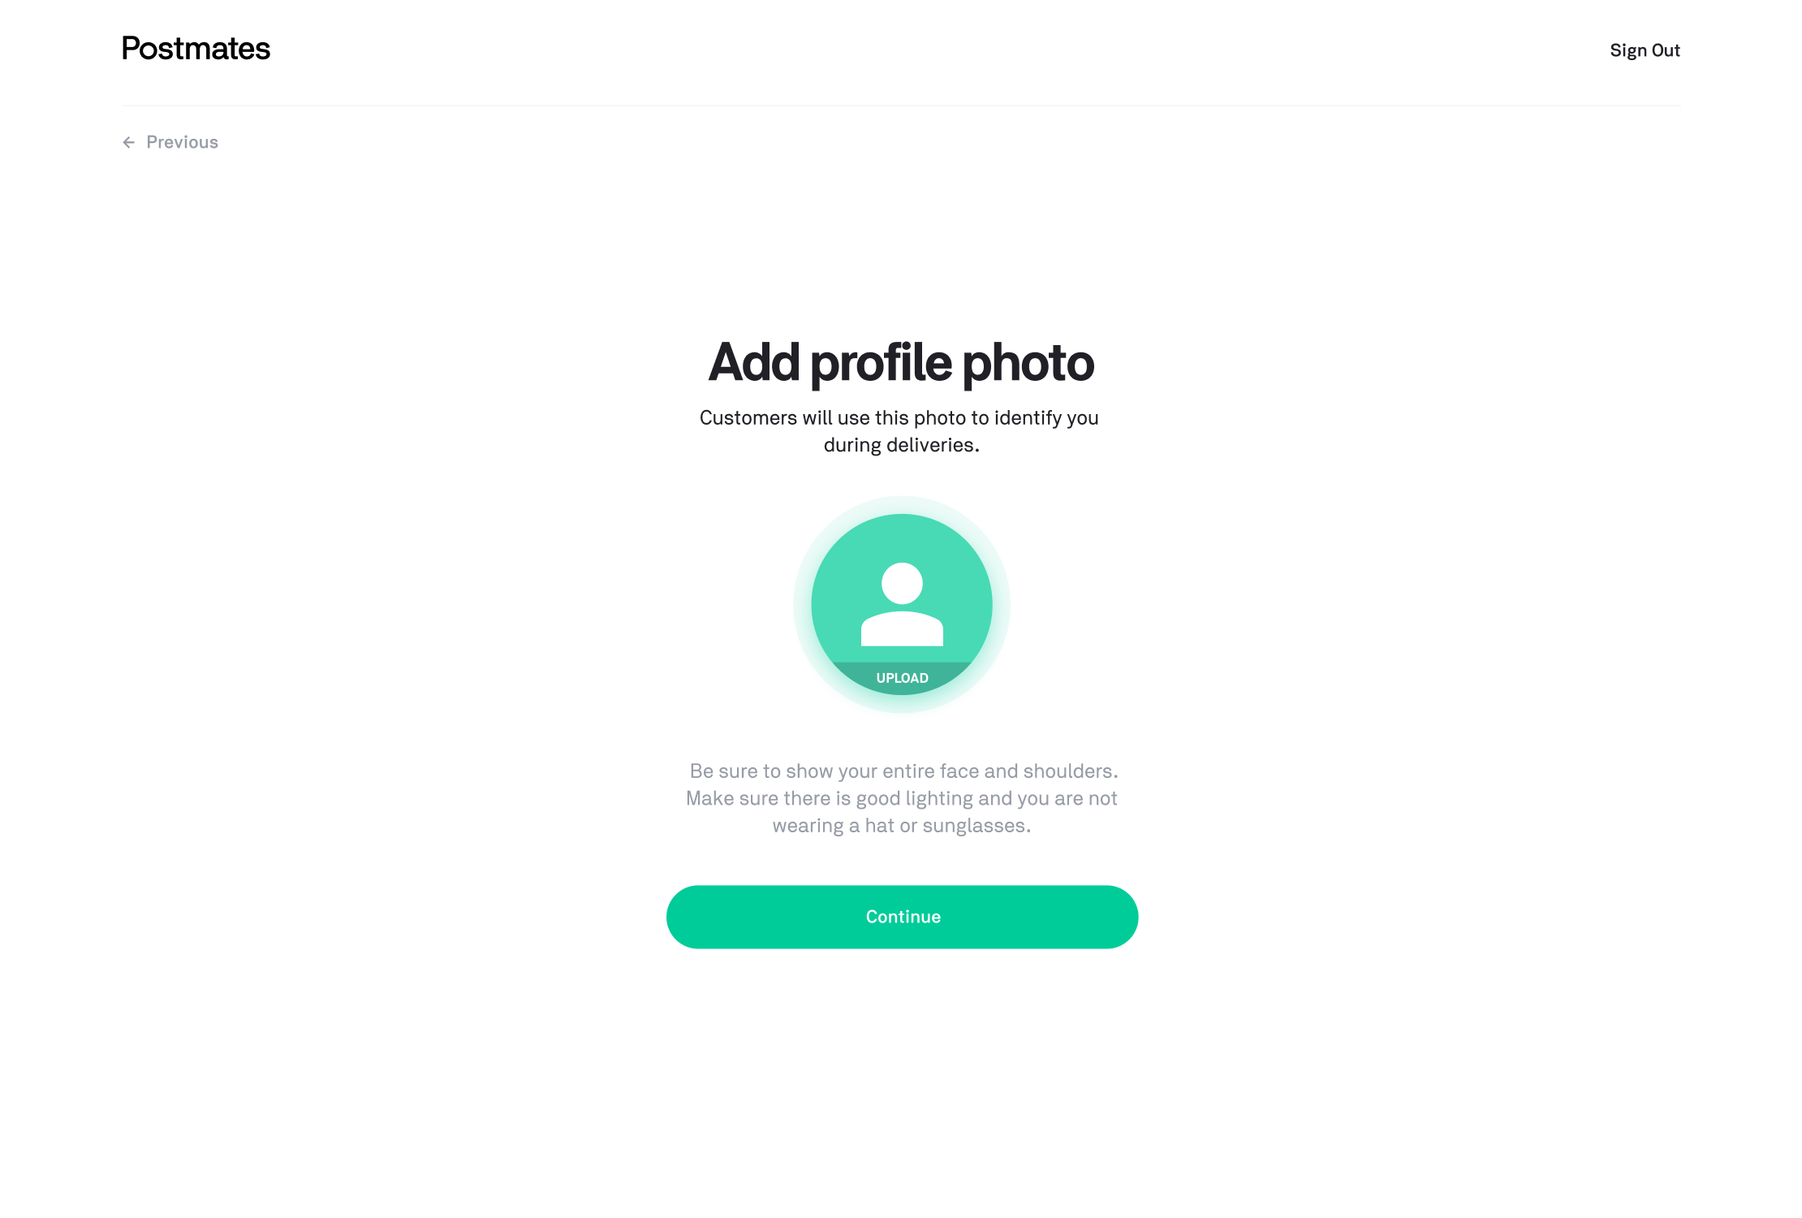

Add Event Tracking (FLEET-18207)
- Add these net new events
  - Event: Signup Market Incentive Glyph Selected
    - Property: Selected → (When glyph is clicked on, surfacing modal)
    - Property: Dismissed → (When “Got it” is selected on modal)
  - Event: TBD
- All other events should map to an existing event

Server

TBD (ISSUE-###)
- …

Migration of Applicants in Pseudo-States (ISSUE-###)
Our approach will be to allow two concurrent funnels to exist. The old funnel will have 28d to dry out before we turn it off and force those applicants onto the new funnel.

- TBD

Support

Update relevant support articles for Web Signup V3.0
- Update “How do I become a Postmate?”
- …

Analysis

Analyst DRI: Mikaela Klein
Hypothesis | Our hypothesis is that by reducing the number of stages in our onboarding funnel and optimizing our usability, we can convert at least 5% more applicants over a 7d conversion.
Treatment & Control Experience | Control - Applicants with the current onboarding experience  Treatment - Applicants with the new onboarding experience
Population Criteria or Sample Size | - Must reach YYYYYYY applicants for the experiment group to be statistically significant  - Evenly distributed geographic span of applicants in the US  - Paid and Unpaid channels to be equally split
Test Duration | X days
Success Metric | See Success Metrics
Second Order Metrics | See Success Metrics
Test Timeline | In order for the impact of the this test to be statistically significant, it will run for X days in order to create an experiment cohorts of YYYYYYY applicants that includes a 50/50 split of test and control groups.
Tracking/Implementation Details | We will have user properties associated w/  Bucket:  - A (Control): {insert_user_property}  - B (Test): {insert_user_property}
Methodology | - TBD

Appendix

Current/New Process Side-By-Side

Current | New
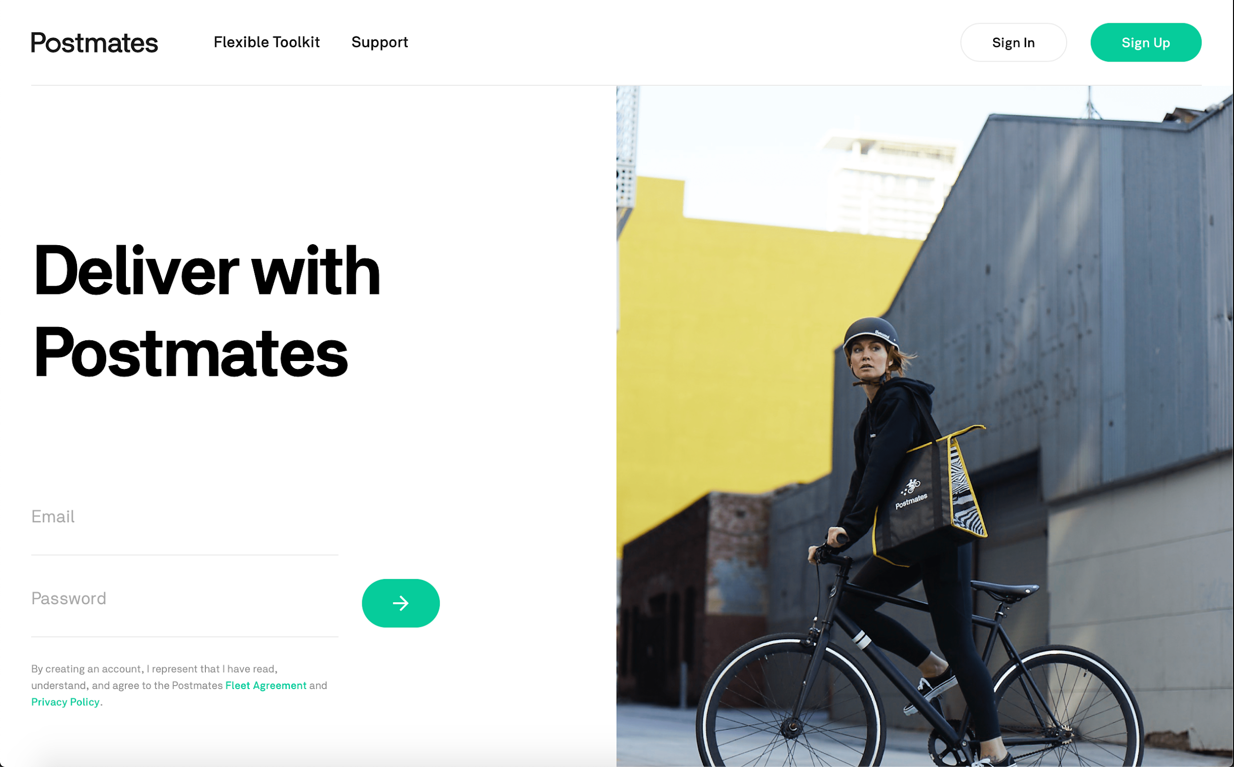
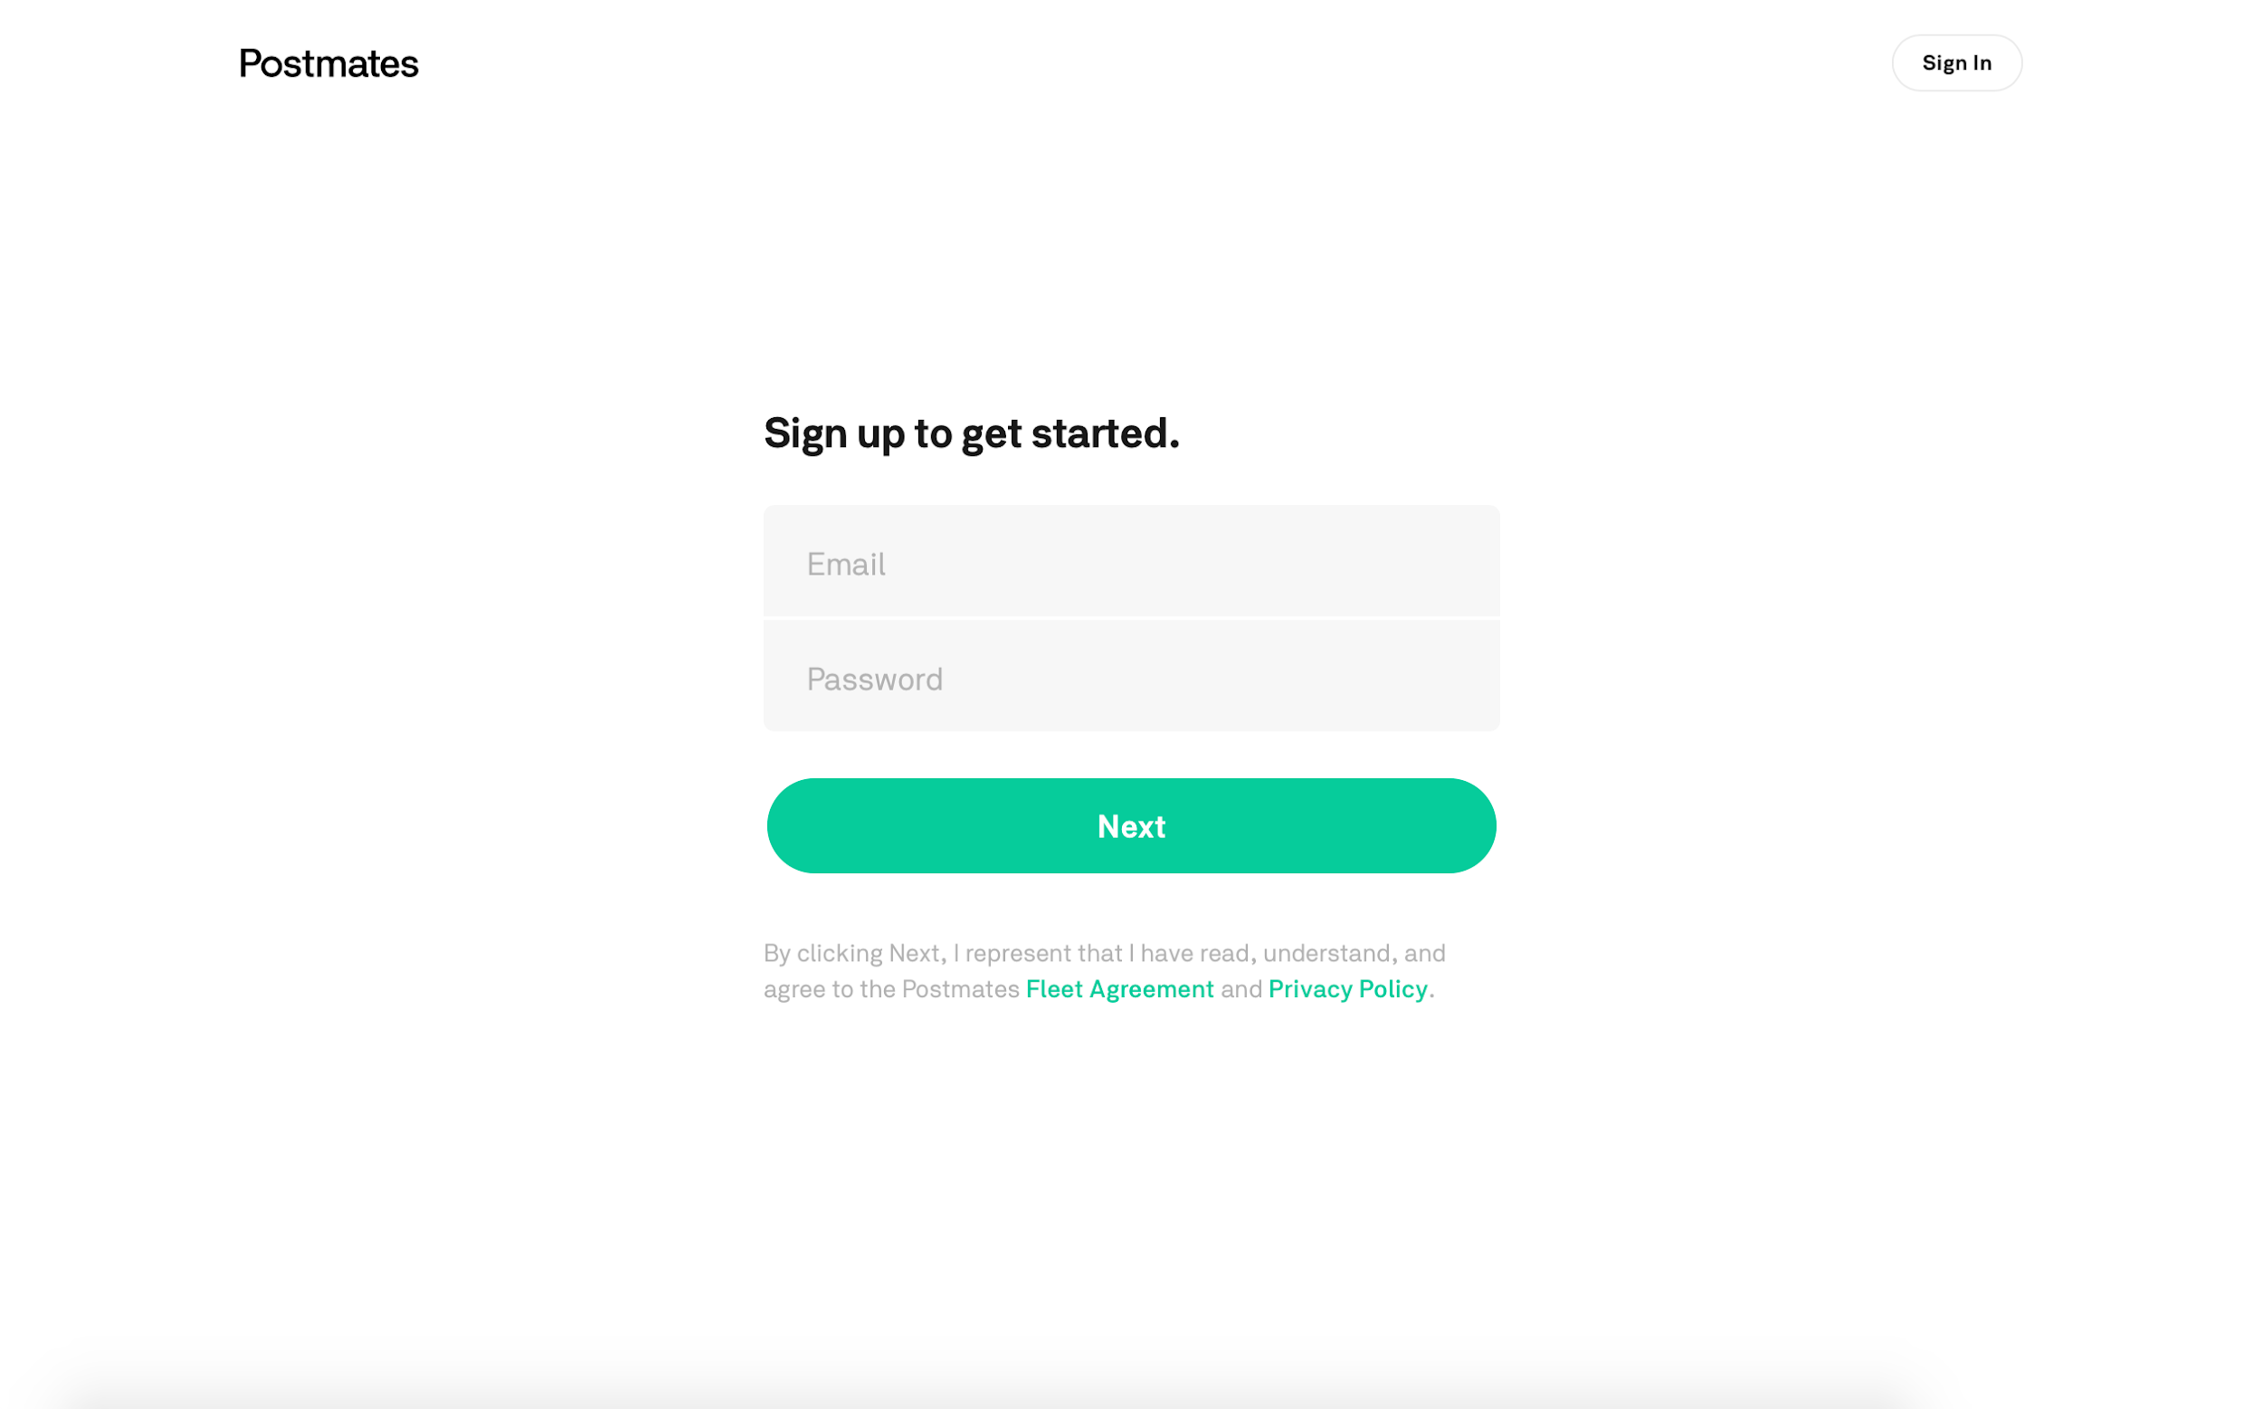
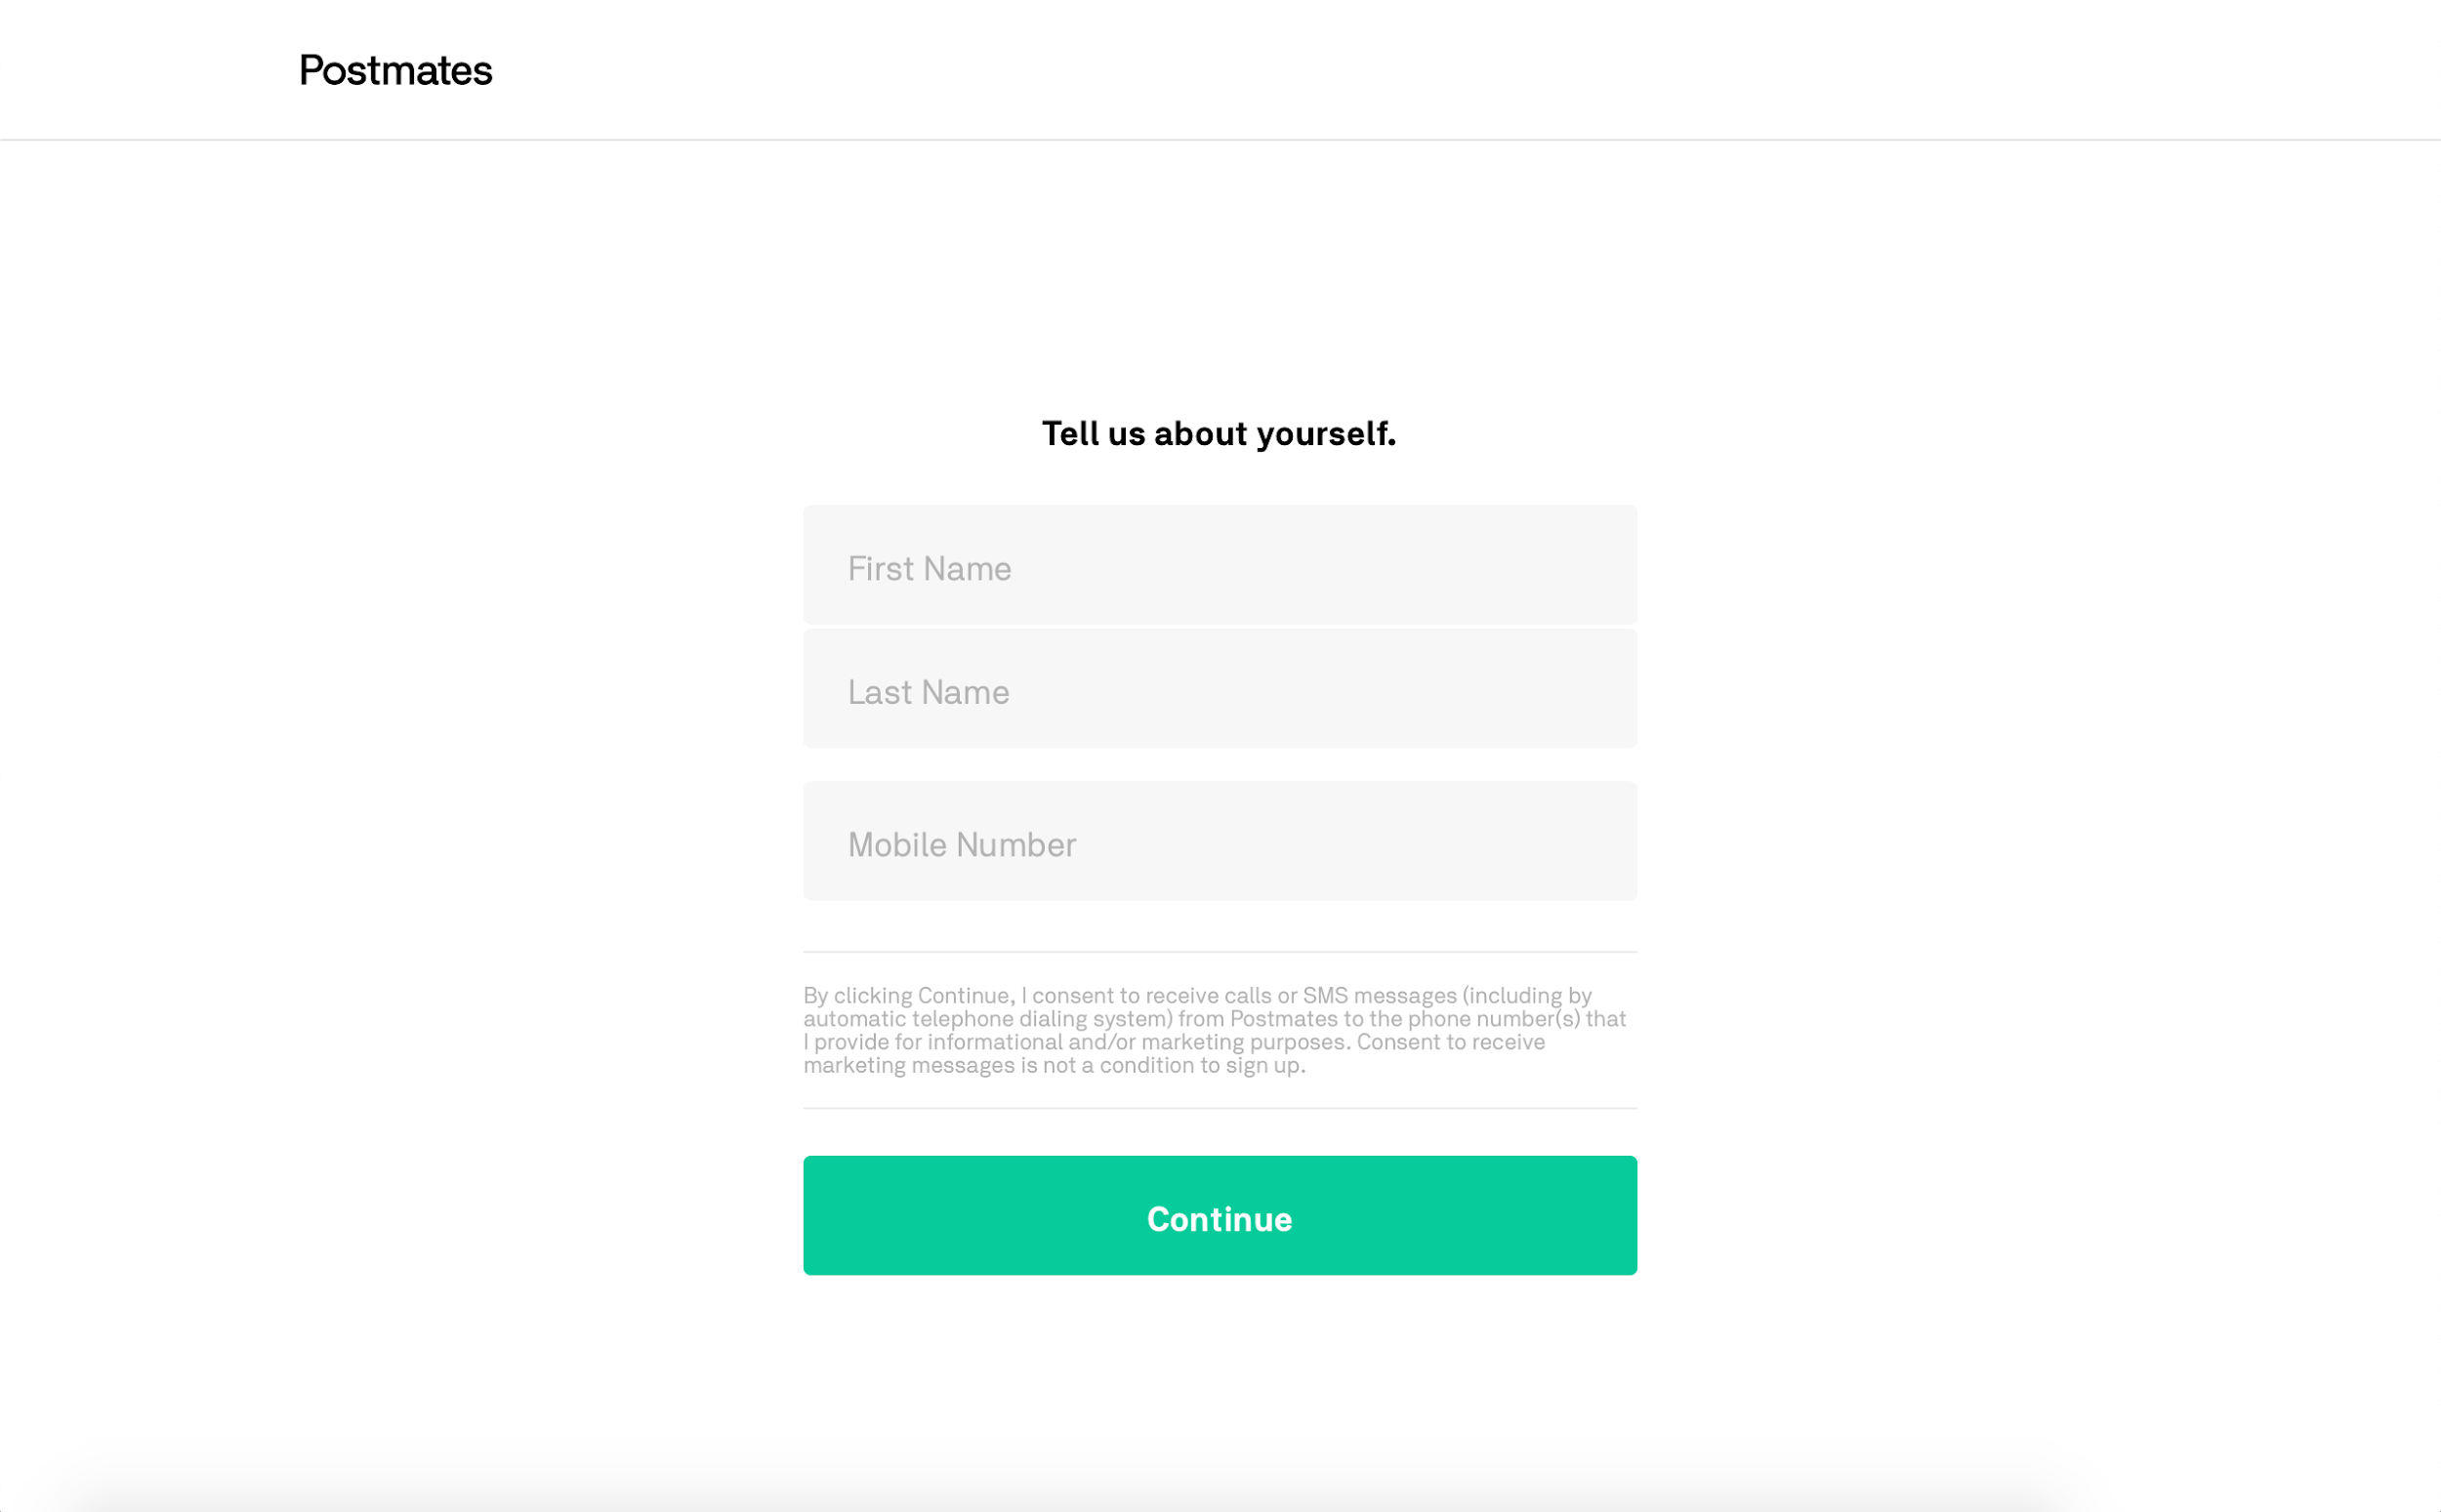
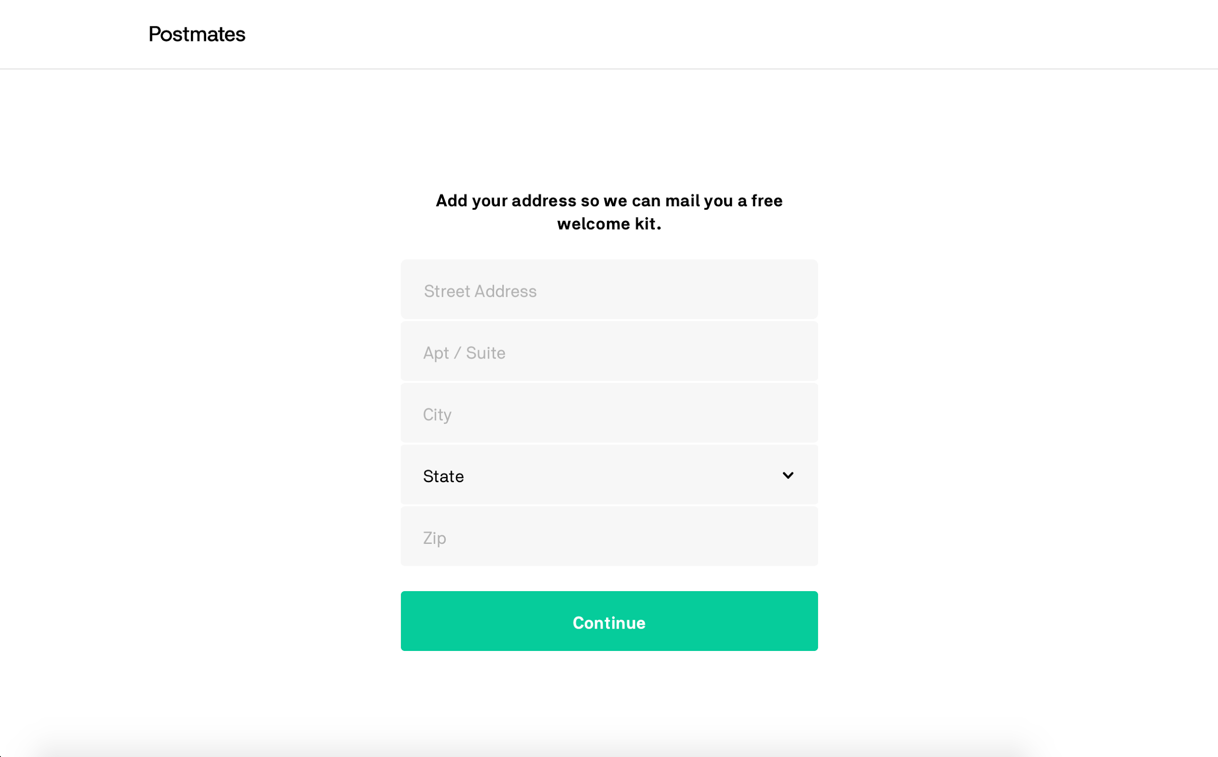 | 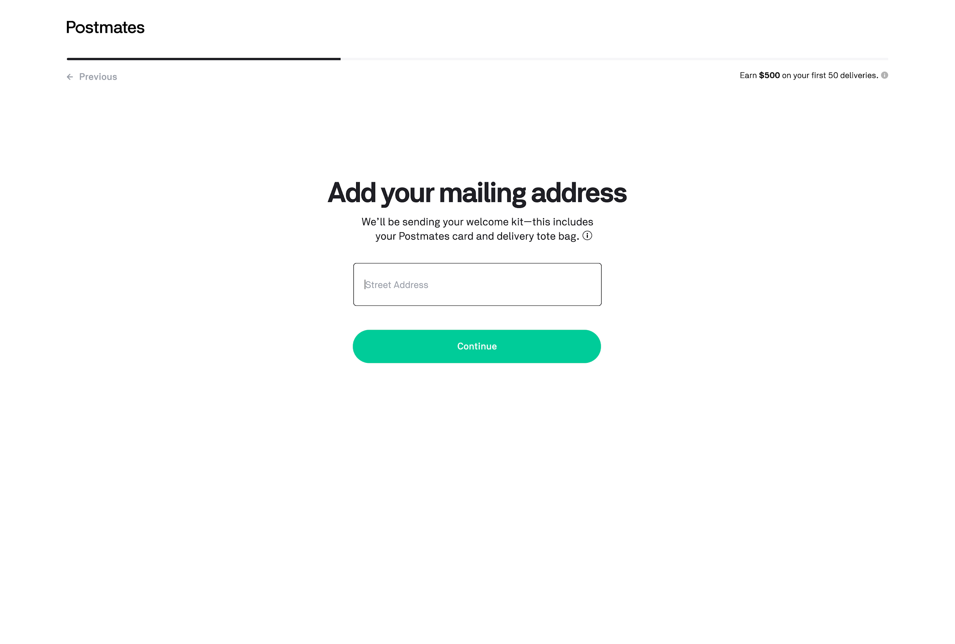
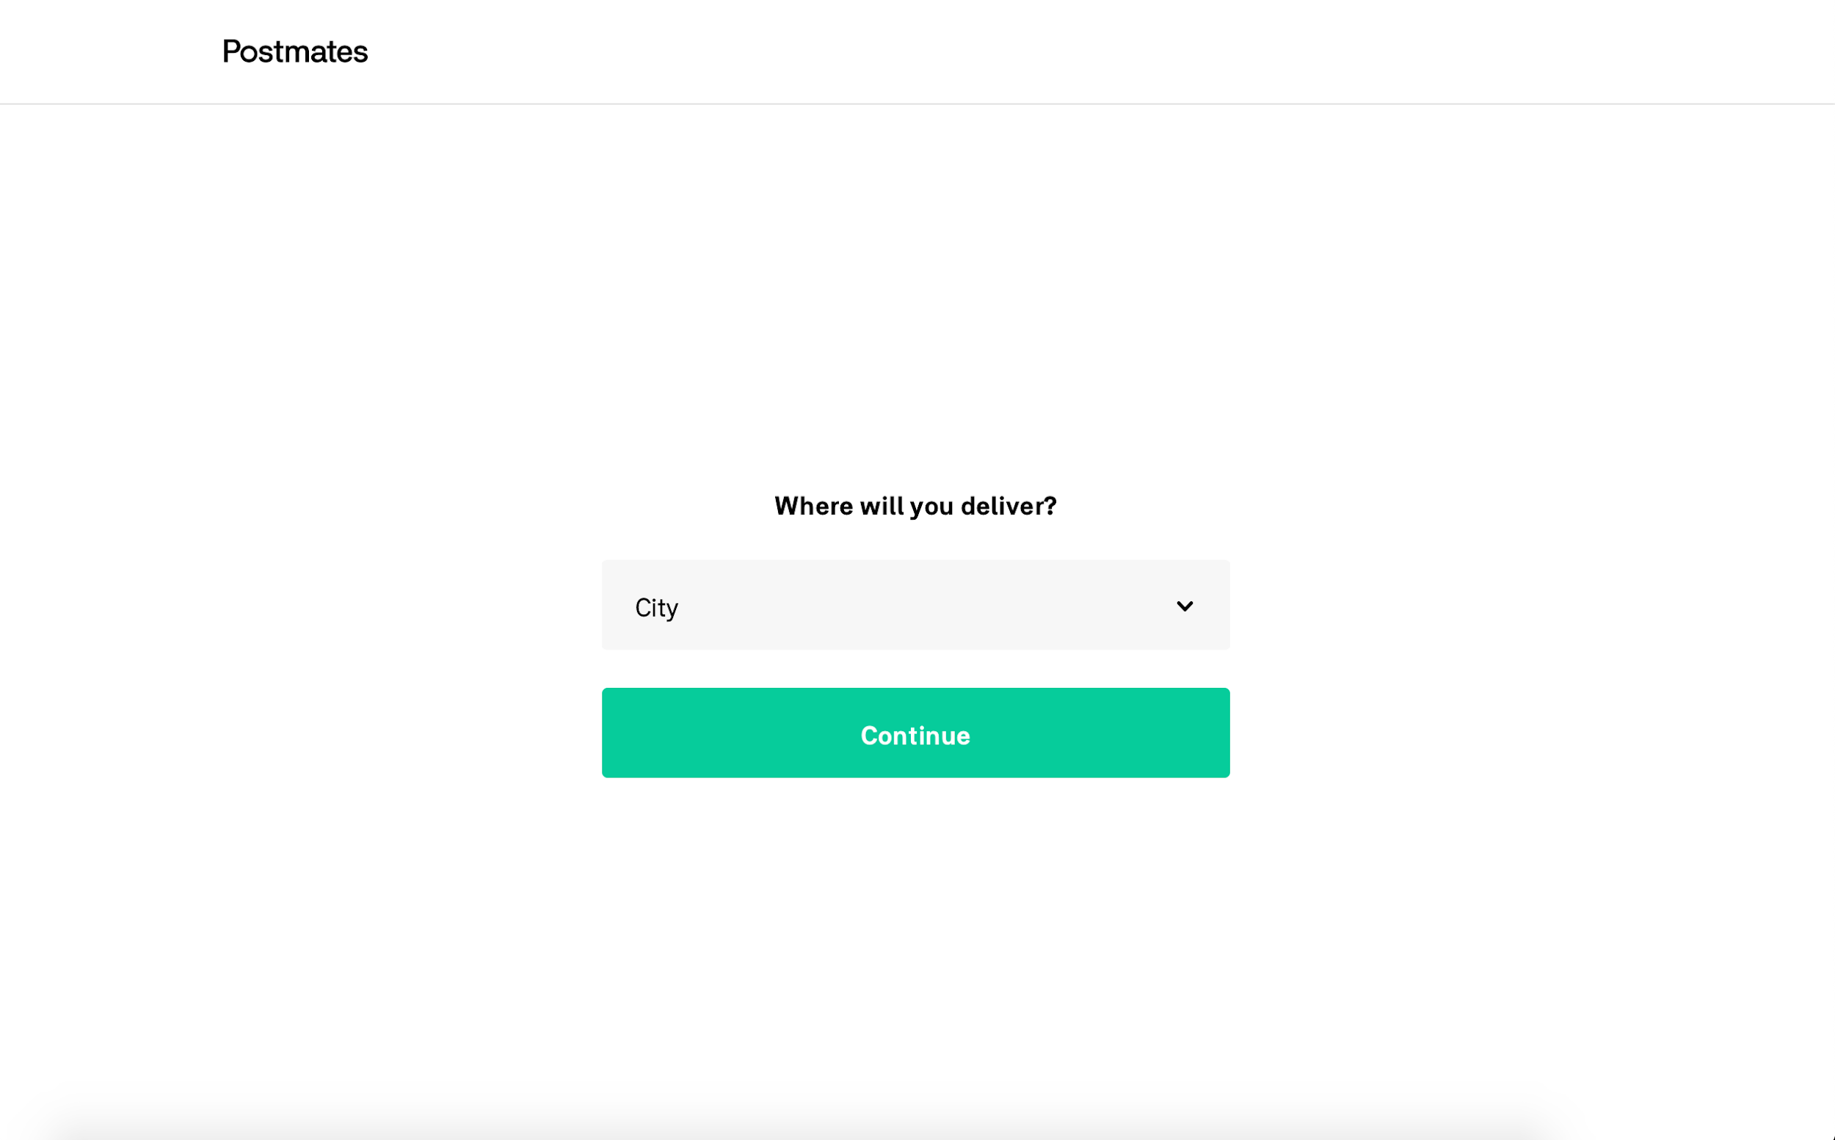 | This is visible 4 rows below.
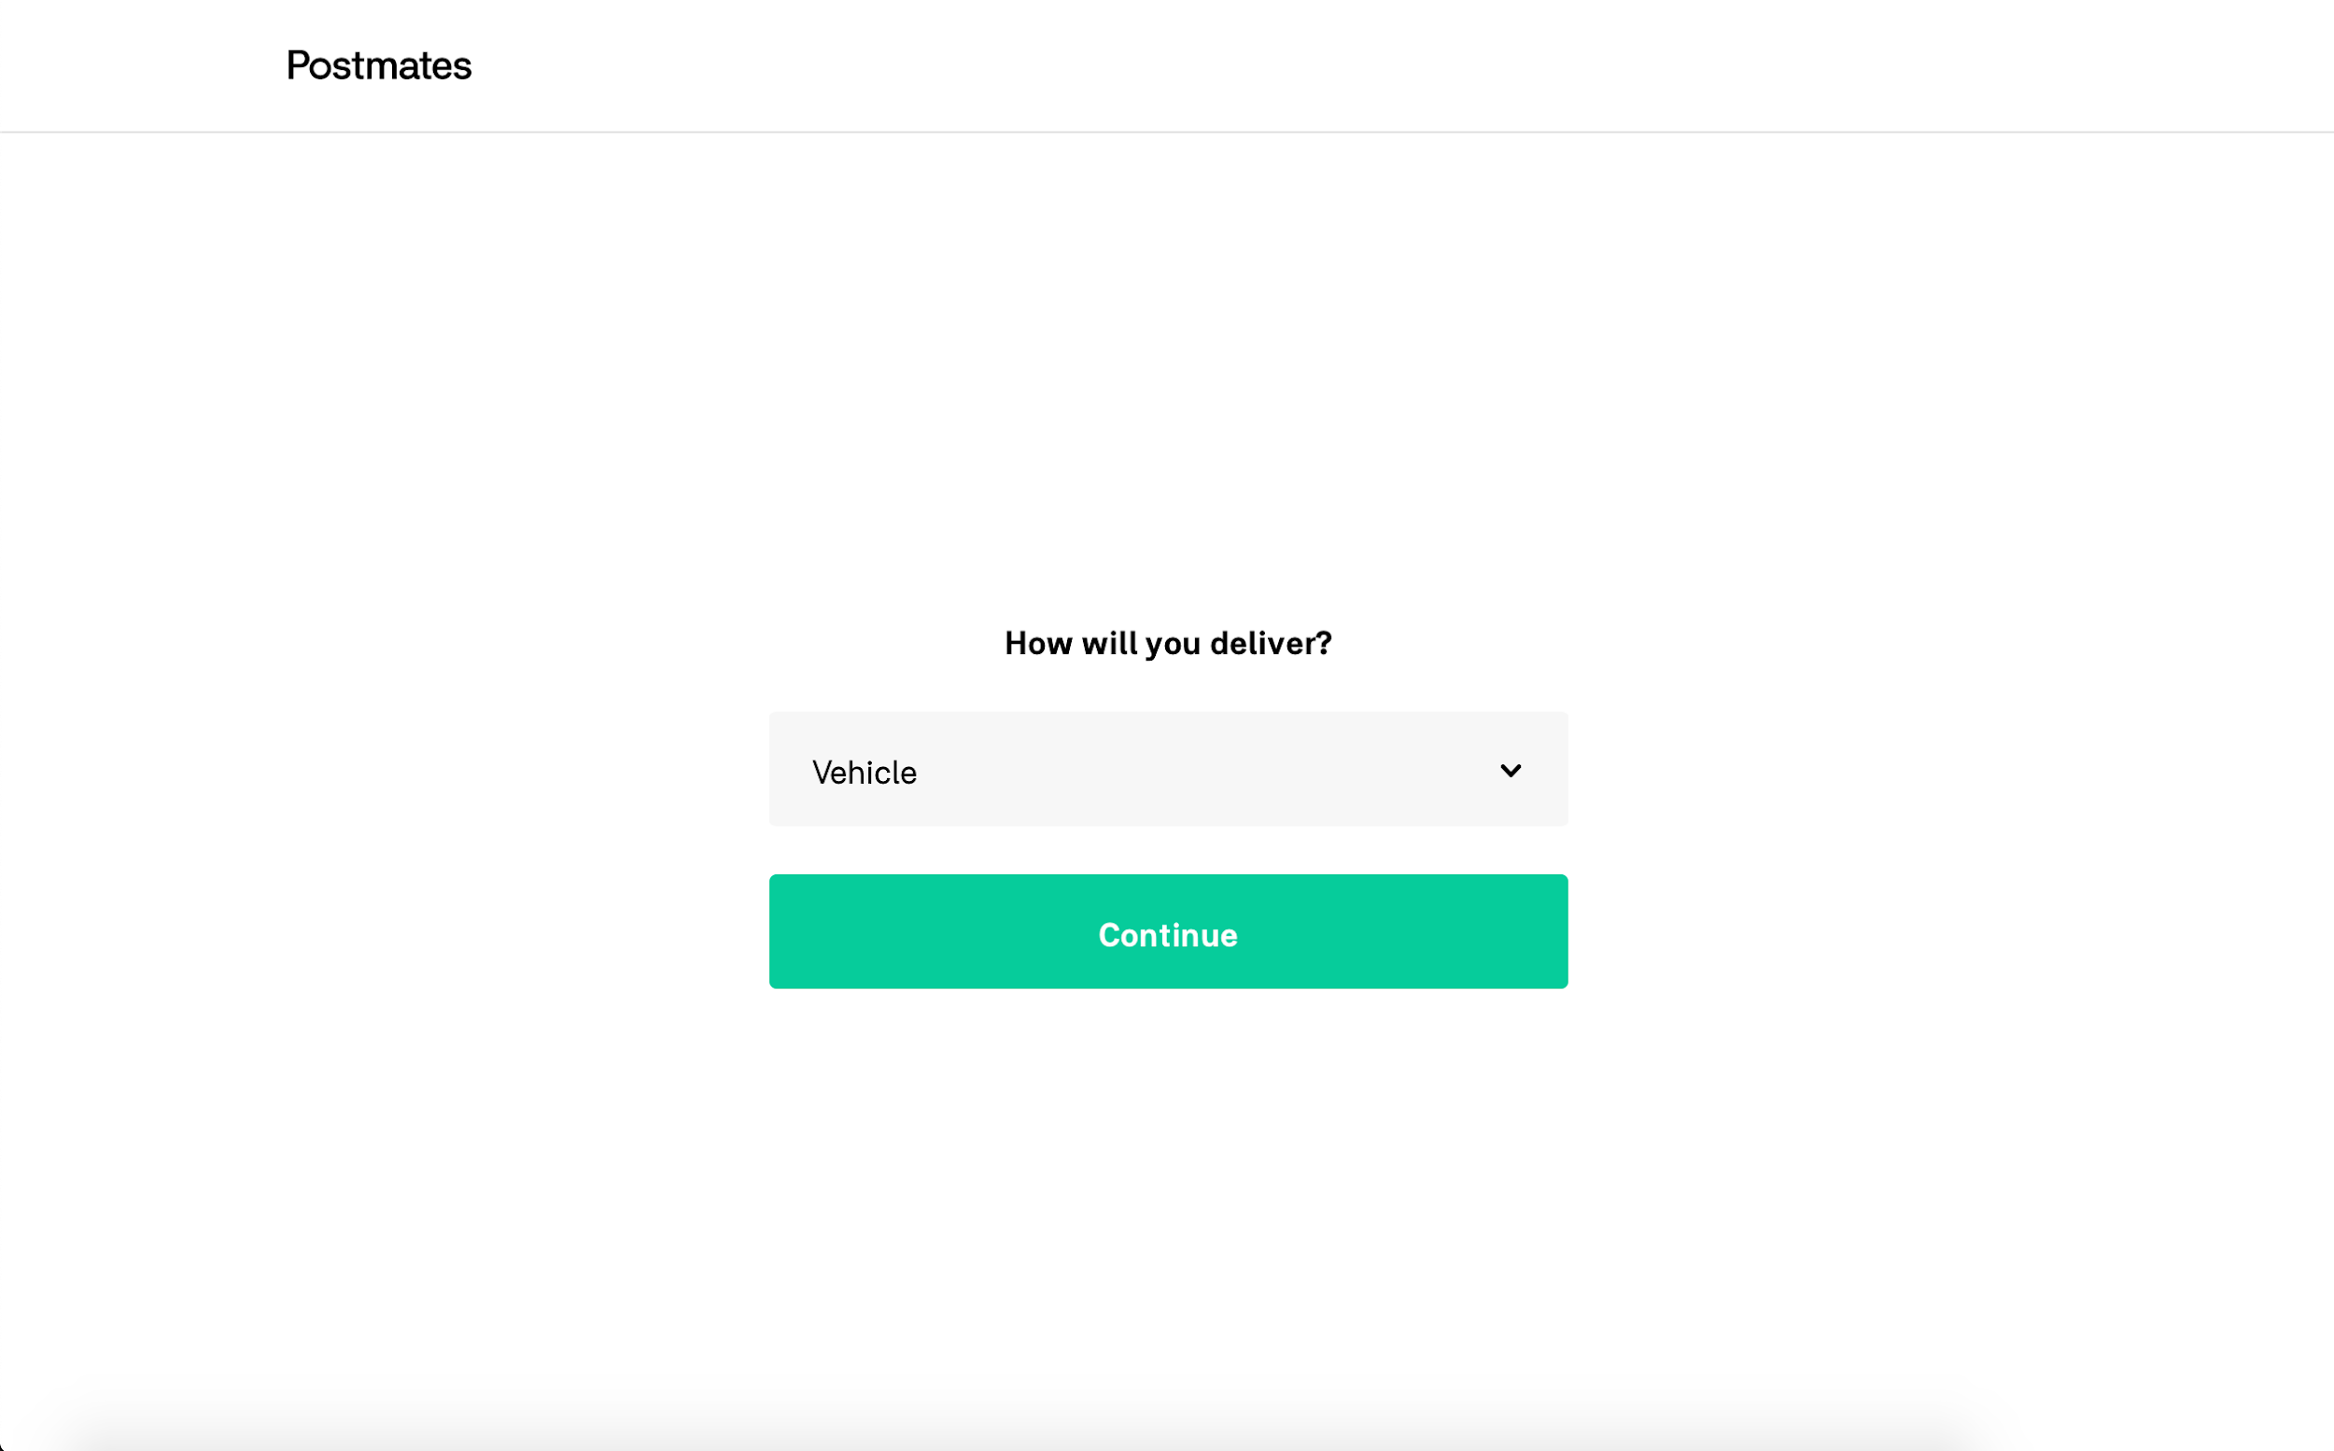 | This is visible 2 rows below.
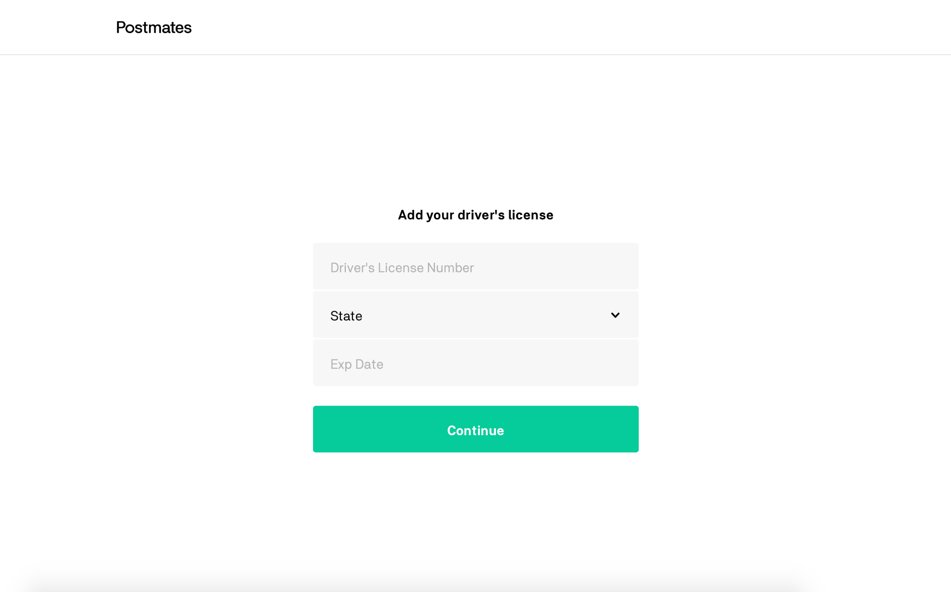 | 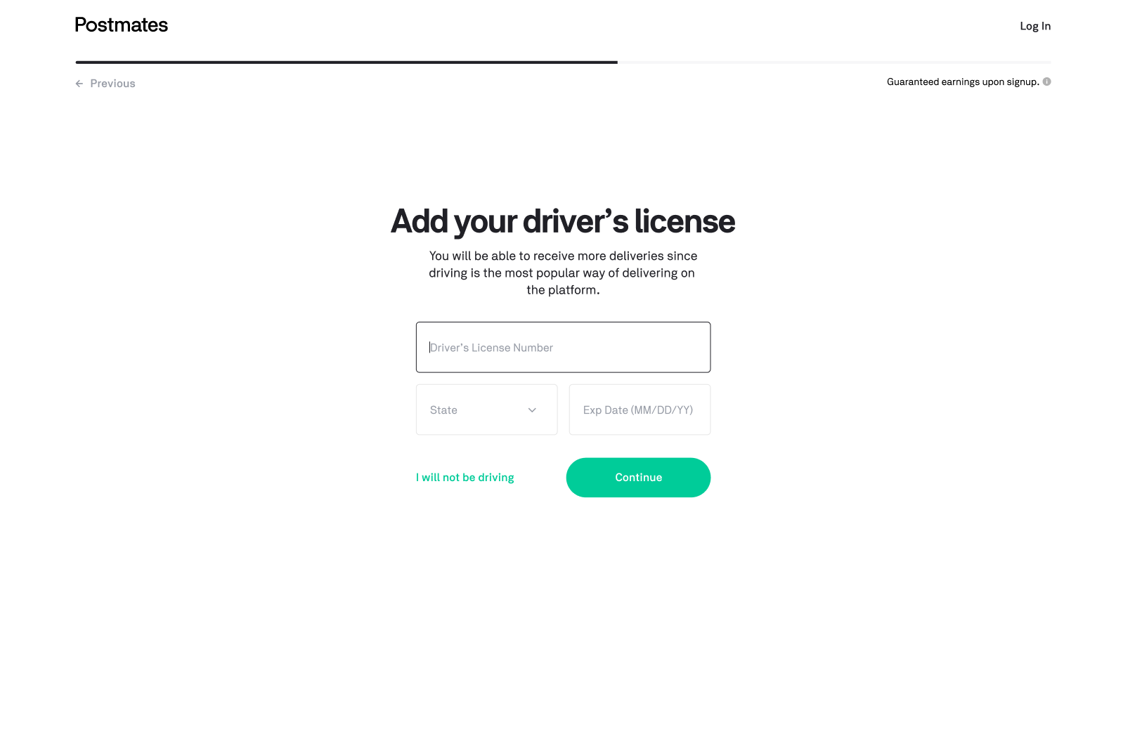
This is visible 2 rows above. | 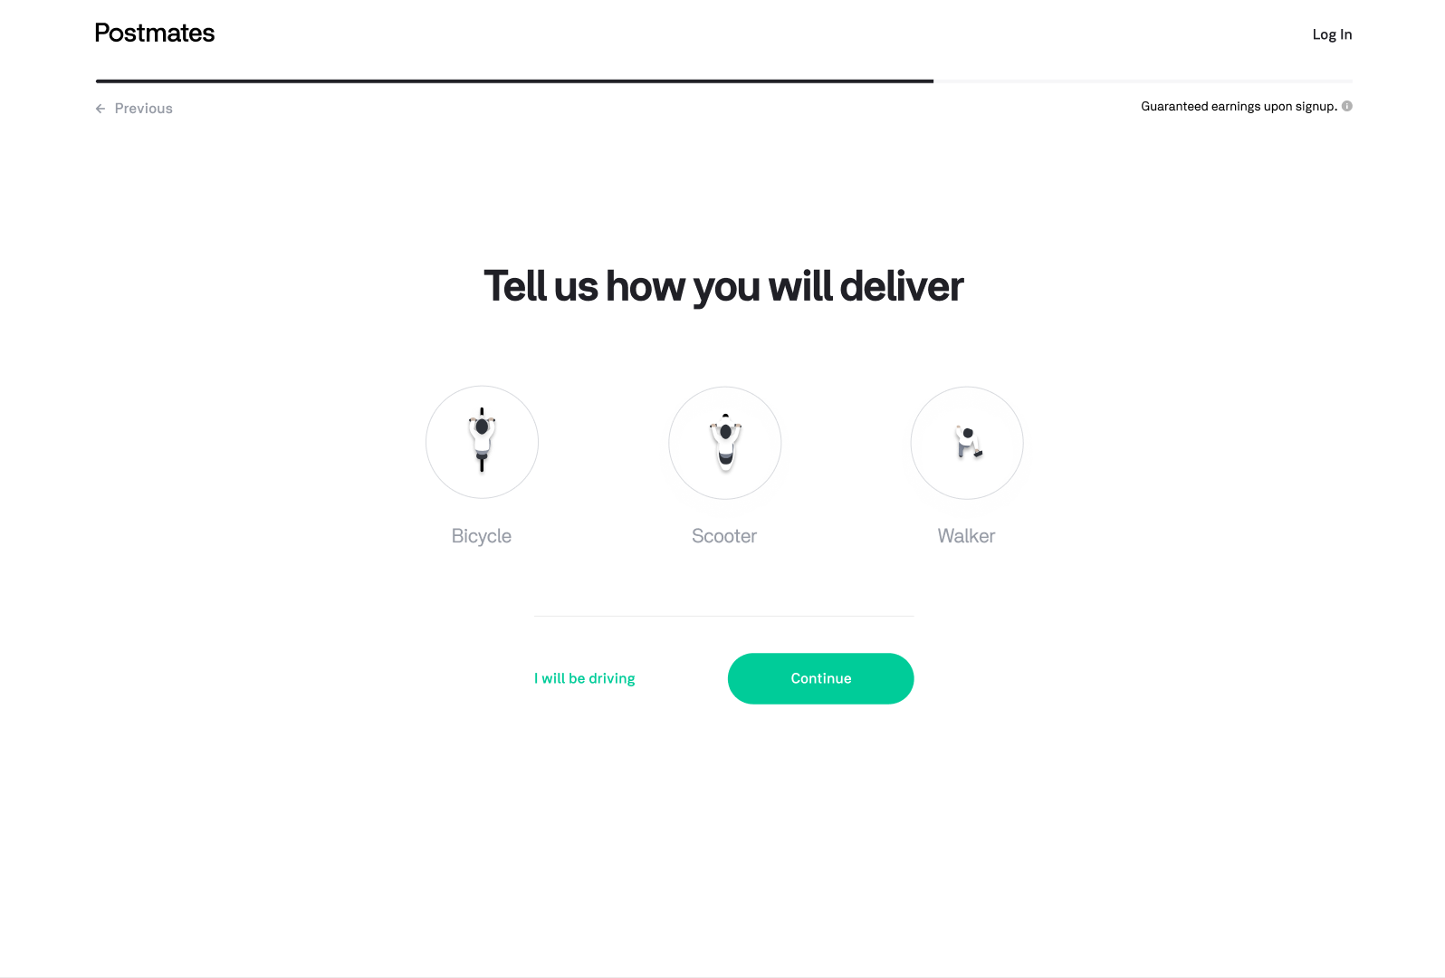
This is visible 4 rows above. | 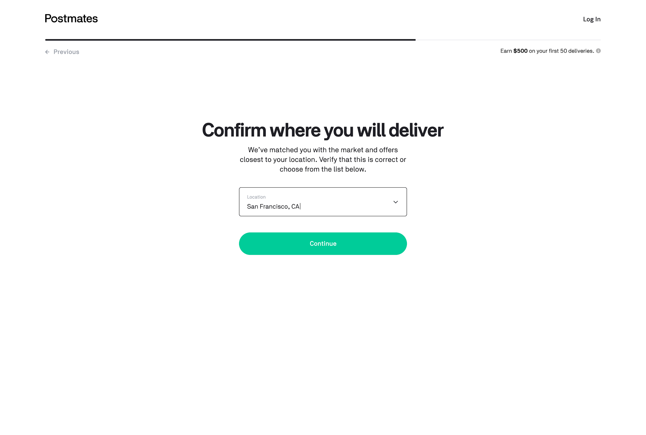
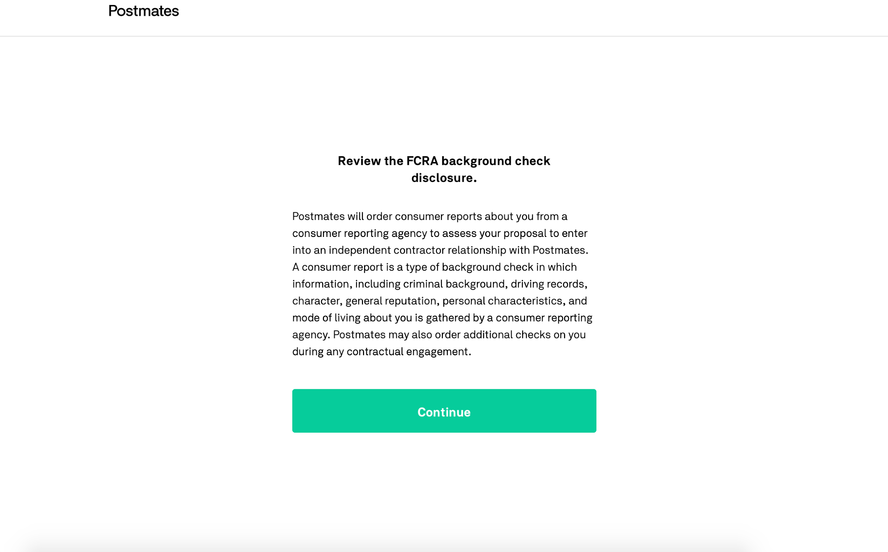
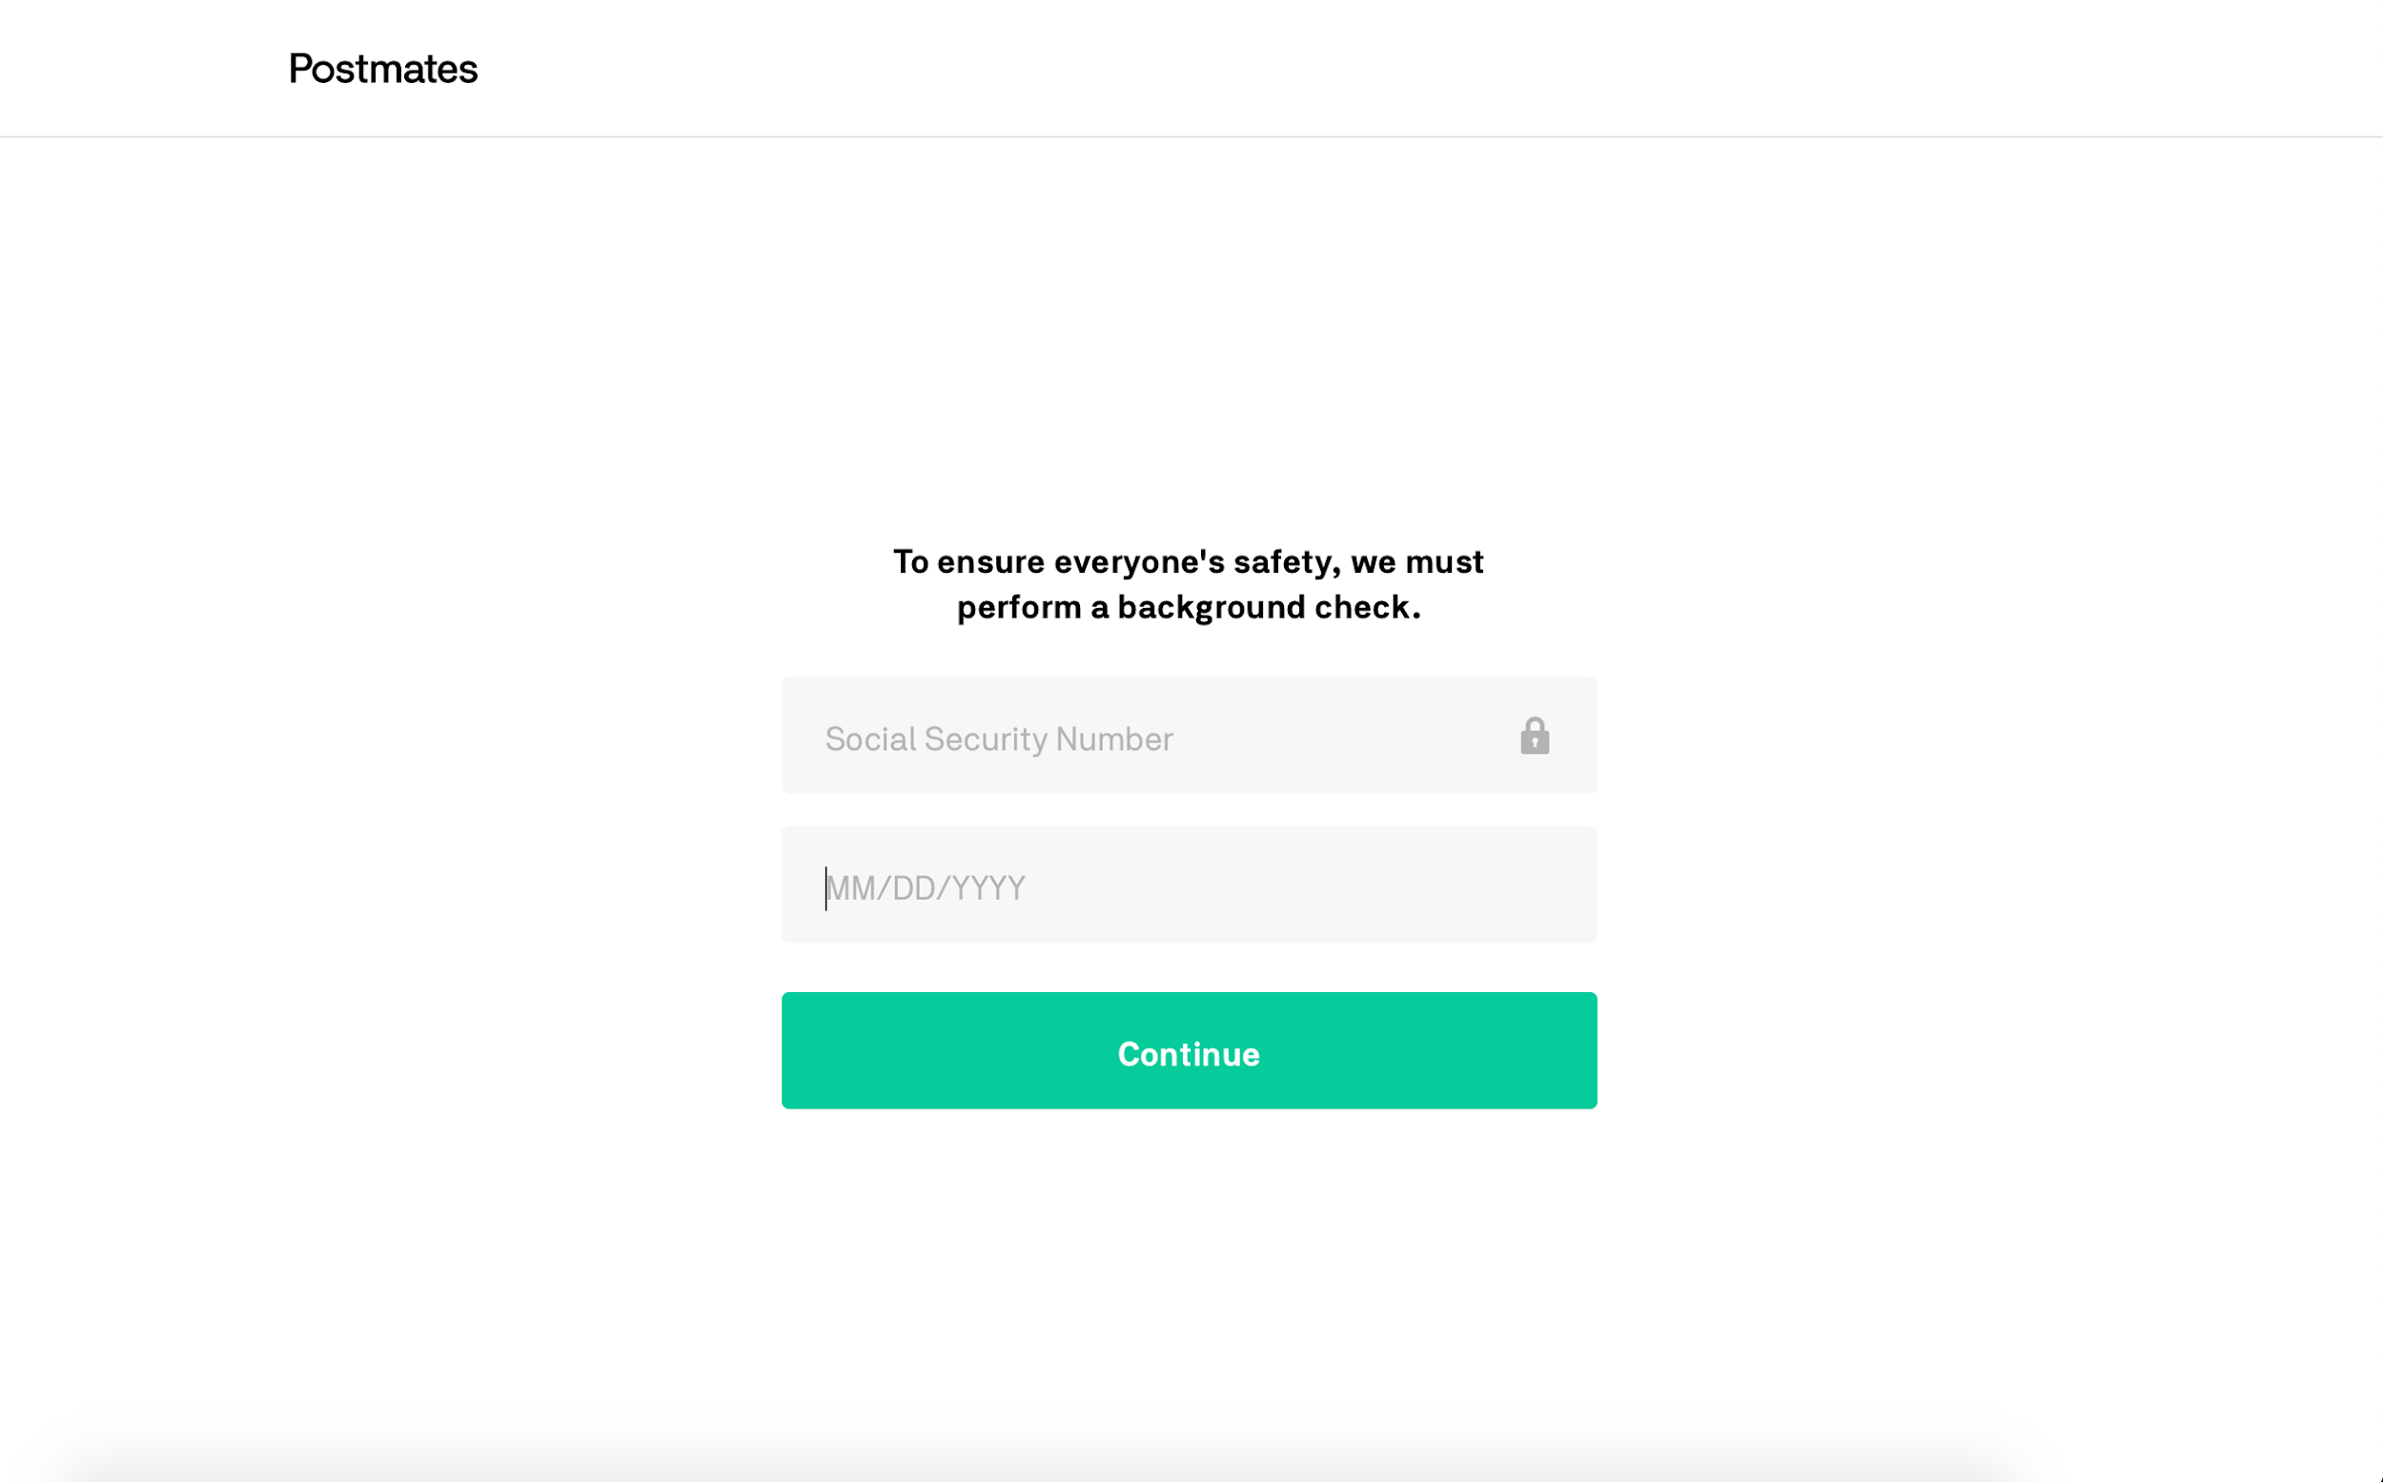
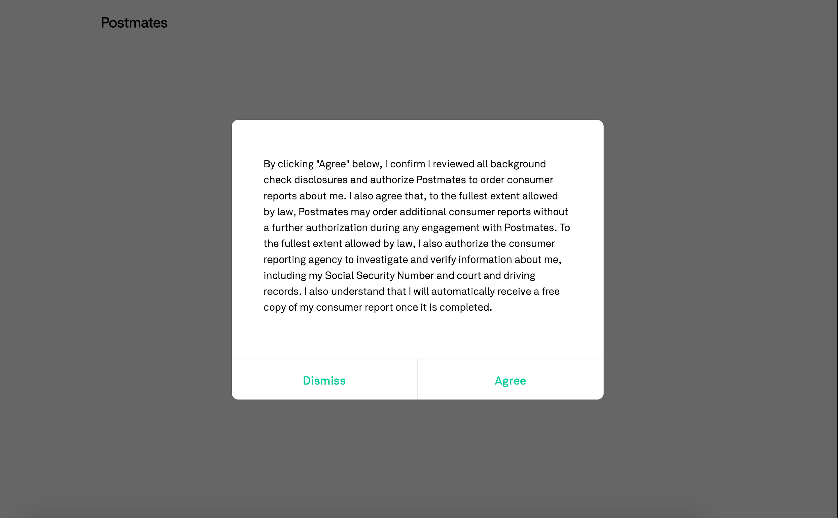
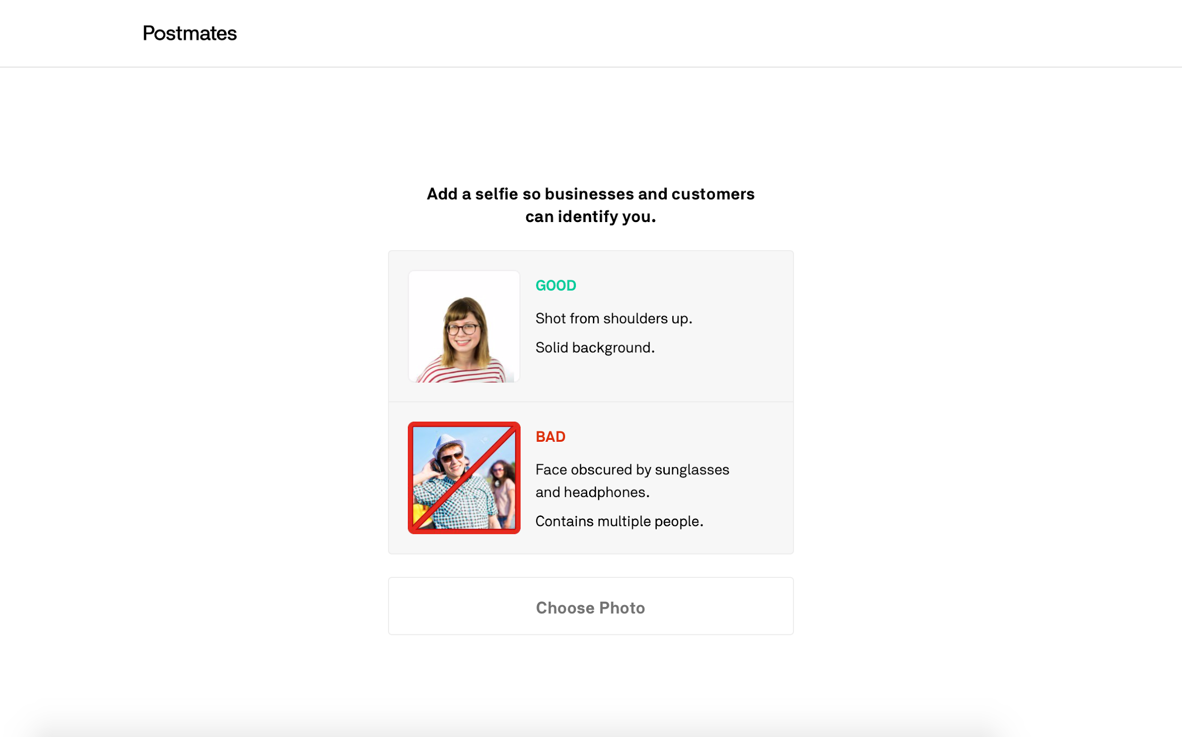
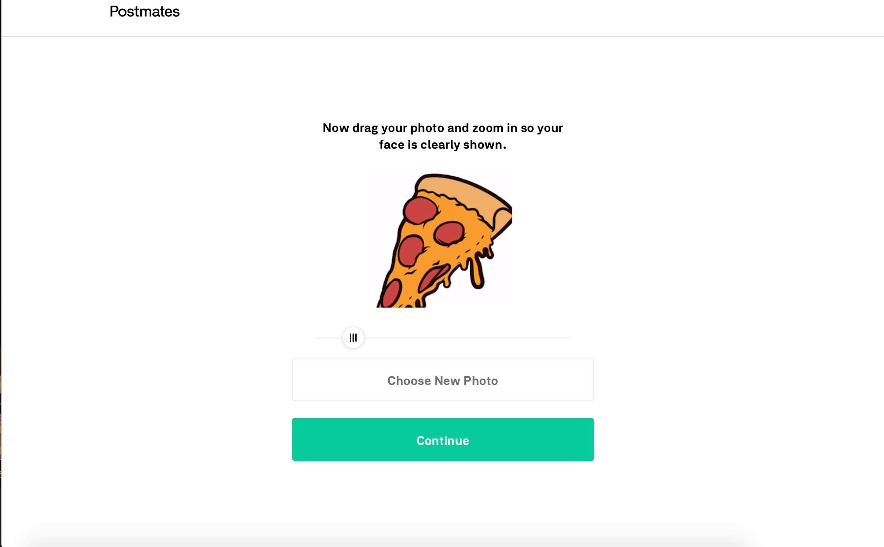
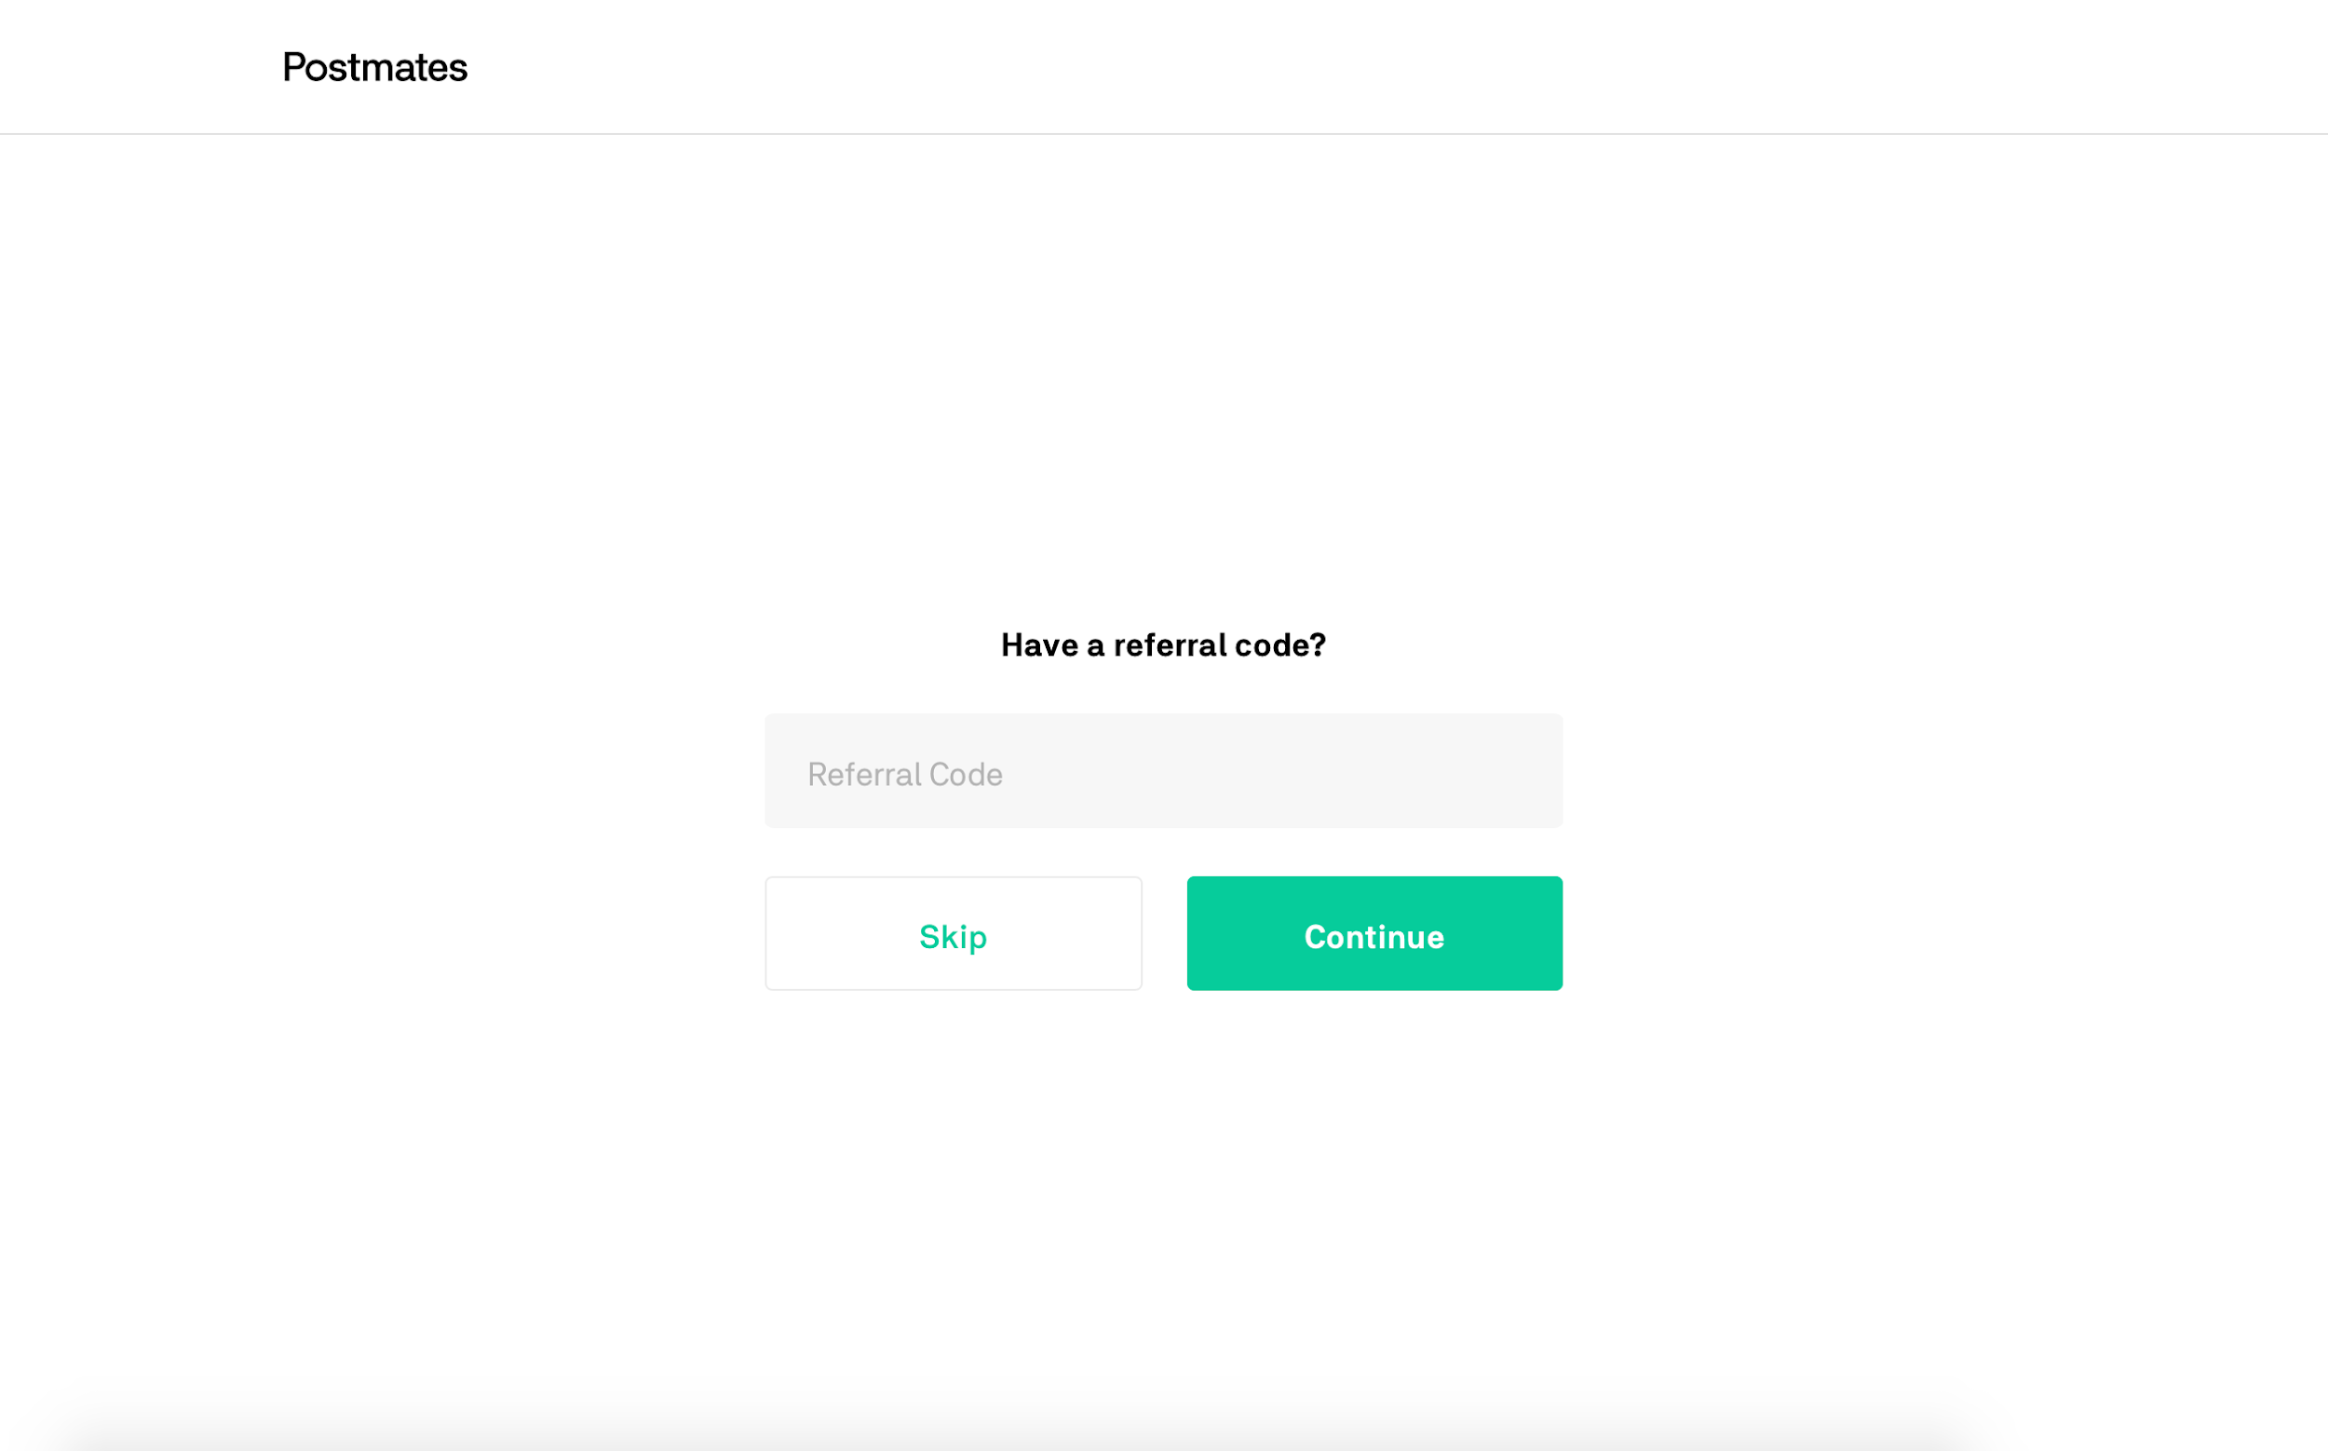 | This is visible 15 rows above.
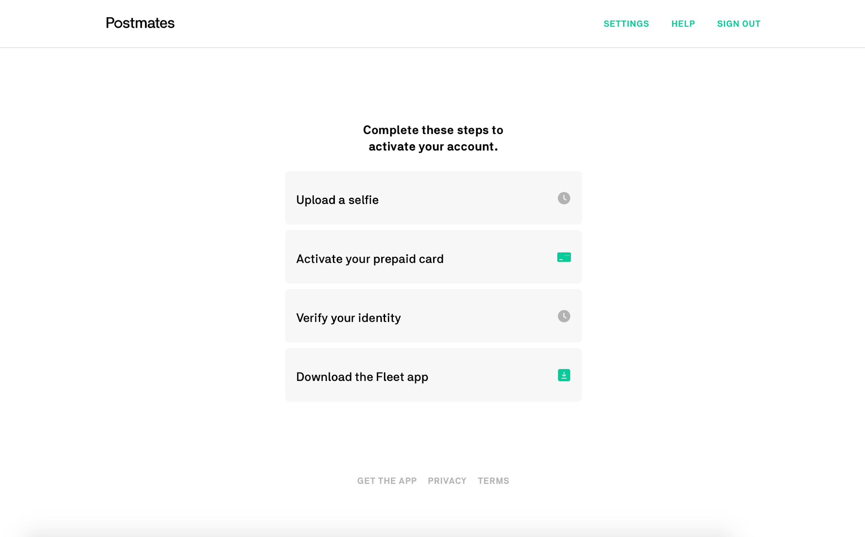 | 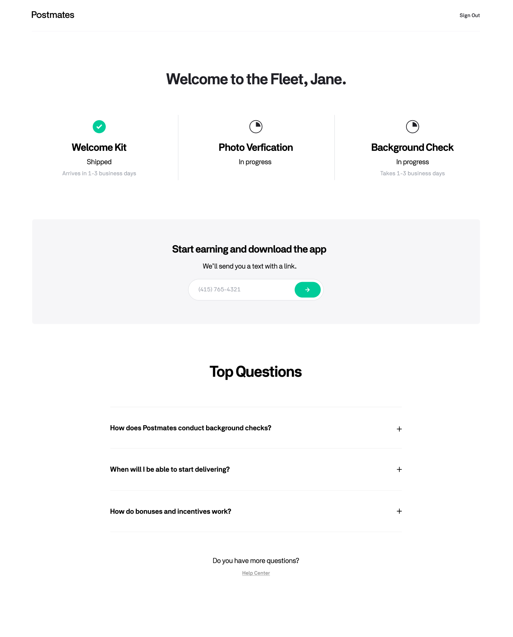

Notes
[AS] = Ahmad Saffi, Fleet PM
[DS] = David Shao, Fleet Server Engineer
[EP] = Emmanuel Pozo, Fleet PM
[KC] = Keith Chapman, Legal
[KM] = Kevin Marano, Fleet Ops
[LB] = Lalit Bhagwat, Fleet Server Engineer
[MG] = Melissa Gamo, Fleet Design
[MK] = Mikaela Klein, Fleet Analytics
[PC] = Portia Chan, Operations Strategy Product Analyst
[RF] = Ryan Fitzpatrick, Fleet Web Development
Question | Answer
Where can we reference the market-specific incentive bonus stats to be dynamically generated at the navigation bar? (see 2nd row in Web Reqs) | [MK]
Where can we pull the written details explaining the market incentive bonus? I imagine this is the same content we are using for Braze newscards. | [MK]
What will the loading screen look like in-between screens? | [MG] We will keep the same loading state.
What are some of the reasons/error states where a photo might not be uploaded successfully? | [AS] It’s pretty binary, look at the answer below. But some reasons a photo can fail to take upon initial submission is because it doesn’t meet the following requirements.  - 320x320 pixel minimum  - 4MB max size  - JPEG/PNG formats only  However once those are submitted successfully, they can be rejected because they are too blurry or do not meet the standards we set. Regardless of the reason, Support will send the email below and we won’t know the reason.  [RF]
How long does Photo verification take? Is it only pass/fail (need to re-upload) or are there other statuses? | [AS] It’s pass/fail. Pass advances you, while fail sends you an email as shown below.  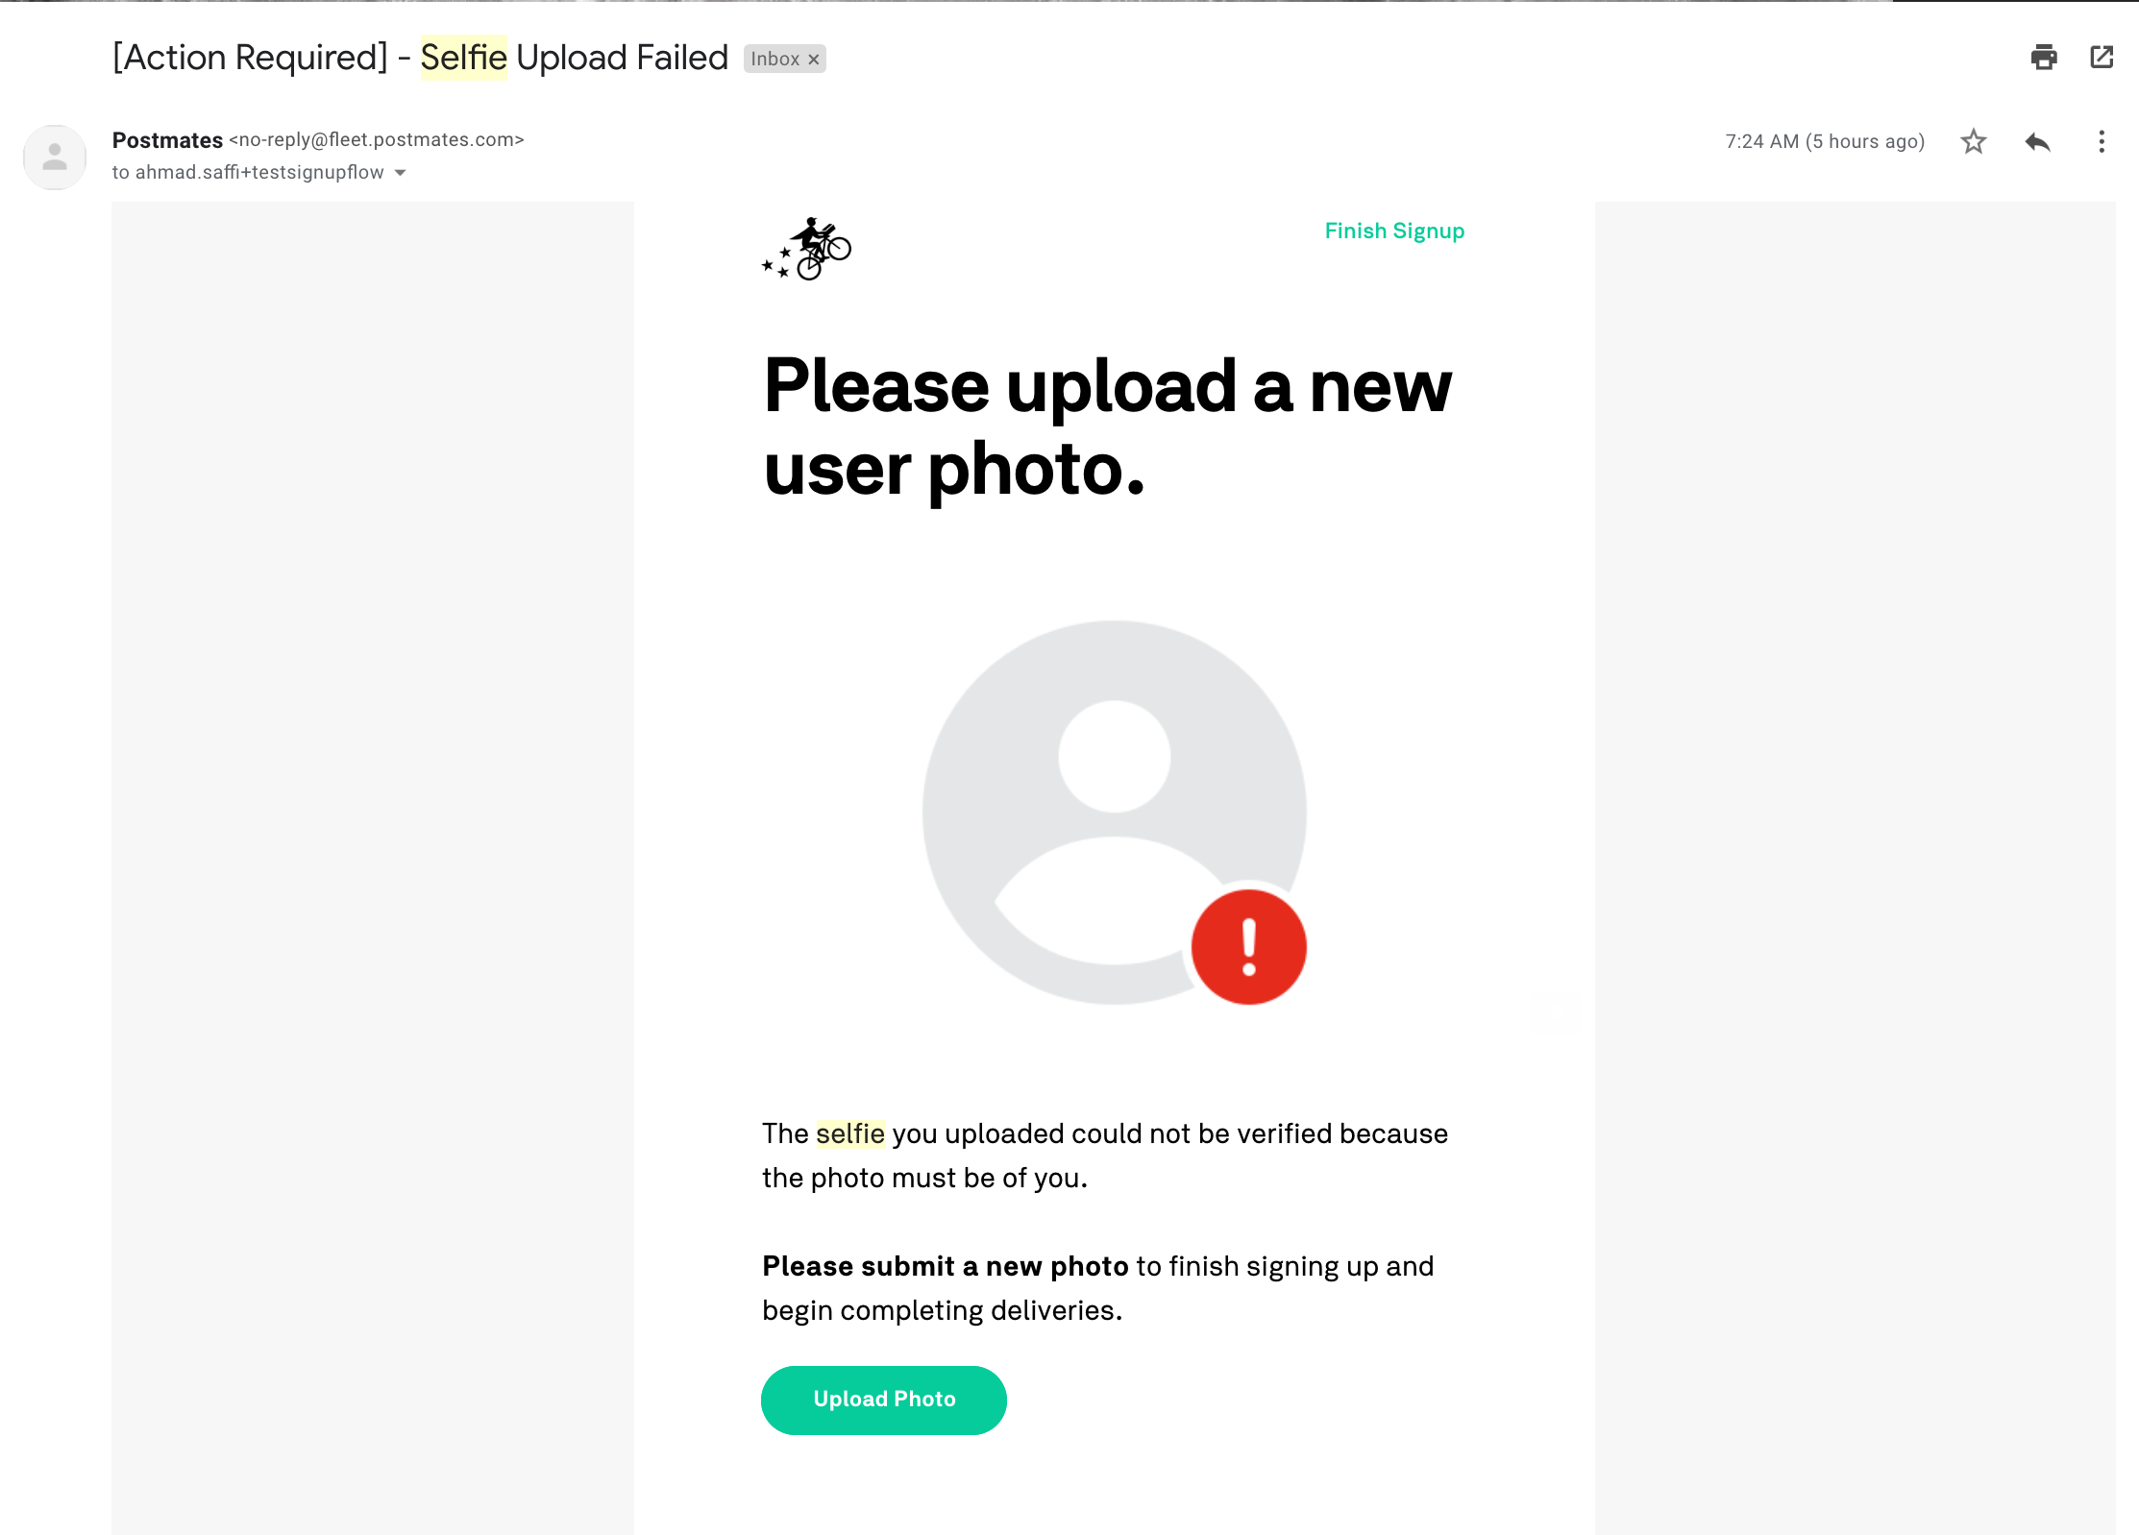  [KM] Between 3-10 mins, depending on time of day. `Selfie_Approved` is an event, so it would never be pending at this point.  It shouldn't really ever be more than 15 mins, unless there's a Chartio or Godmode outage  There are couple different reasons:  1) It could have been flagged for fraud (ie they've approved the same image before)  2) It was on Staging. We don't review those
Which API are we using to search for addresses as the user types theirs in? Google Maps API? | [RF] Google Maps API
Do we allow shipment of Welcome Kits to P.O. Boxes? | [KM] No
How long do Welcome Kits take to arrive? | [AS] 1-3 days on average.  [KM] 2-3 business days (1-3 is fine to communicate). If selfie approved is after 4:00pm PDT, it will 100% take one day to just fulfill the order  Shipping usually takes 1-3 days. It can be longer, but this is becoming less likely as we have multiple warehouses.
Are we legally allowed to consolidate the background check disclosure consents? We sent this out to Keith on 09.24.19 to see what our outside legal has to say. | [KC]
If we make changes to the sequencing of our onboarding funnel, how will that impact our metrics? | [AS] We will have to have two separate funnels so long as this exists and have a clear separation. That is, until we fully reconcile the two when native mobile’s onboarding is changed as well.
Do we have any solutions other than our Regex library to validate driver’s license numbers? | [RF] After briefly looking, there doesn't seem to be a very well maintained drivers license number validation library for javascript or python. I think our answer is to use our current regex in python.  The validation ultimately needs to be done by postal and making requests to a 3rd party service on each applicant is not viable.  One solution outside of this scope would be an be an ID scanner. https://microblink.com/products/blinkid
What’s the impact of not having the USPS Street Address Checker? | [KM] We have 200-300 welcome kit weekly orders with un-shippable shipping addresses. I manually email then to order a replacement prepaid card since we don't have USPS validation at the point of address collection.
Does the Google Maps API's search results already restrict search results to US addresses in the API call? If not, can we do that on the API call itself? (Assuming we still are using that in conjunction w/ the USPS API) | [RF]
If you choose a scooter, do you need to provide your driver’s license information? | [KM] Yes, required DL for all motorized vehicles
How will we assign the user a market when they submit their mailing address information? | [RF]
If you are a walker, do you need a background check? What are the background checks run on each vehicle type? | [KM]  Walker/Biker – Background Check Only  Motor Vehicle – MVR Check & Background Check
Is there a rate limit that is set by the USPS API? What’s our plan when the service is down? How do we handle failure? | [DS]  [LB]
When ECT confirms the selfie, does an event fire off, or a webhook is sent? | [EP] An event called ‘Selfie Approved’
Can we get more information on welcome kit shipment statuses? | [KM] Welcome Kit is shipped once other criteria in the checklist are complete (ie application & selfie approved). Seeing this section isn't required until those items are complete. It was most likely added to reduce FS tickets as couriers are wondering where welcome kits are (as we say we're shipping them kits during onboarding).  I'm not 100% if "Shipped" is displayed after then Shopify event "Order Created" or "Order Shipped". Would be best to display the USPS delivery ETA if possible.
How is it tagged as a ticket and how would you define "weekly contact rate for background check FS tickets"? | [PC] Here are the list of issue types that are background check related:  - fs_risk_bgc_status  - fs_signup_bgc_issue_duplicate_account  - fs_onboarding_post_aa  - fs_onboarding_pre_aa  - fs_signup_bgc_update_request  - fs_signup_bgc_rerun_check  - fs_signup_bgc_info_incorrect  - fs_signup_bgc_check_not_created  - fs_signup_bgc_status_mismatch  - fs_signup_bgc_check_dispute  - fs_signup_bgc_checkr_info_request  - fs_signup_bgc_check_request_to_unsuspend  - fs_signup_bgc_id_provided  In terms of contact rate, it is (ticket volume) / (completed jobs).
Is the rationale behind reducing background check FS tickets that people just don't know the status of their background check and by making it more clear, we will reduce tickets pertaining to background check status? | [AS] Yes, it's pointed to the statuses we receive from Checkr. It's a placeholder until I can actually look at the Checkr ETA feature, which would have a greater impact. But if I can't get to it by Monday I'll have to table it as a fast follow.

Meeting Minutes

Date | Notes
09.26.19 | Attendees: Ahmad, Melissa, EP, Onur, Ulf, David, Lalit, Mikaela  - The referral is hard to show in the stages after the referral and before the user specifies their market.  - Check the rate limit that is set by the USPS API  - What’s our plan when the service is down? How do we handle failure?  - For the mailing address, when you are typing ahead and select an address, it should display all those fields with the information already populated.  - As a fast follow to V3, we can explore removing the vehicle option (since it isn’t 100% necessary for onboarding).  - The market search option should be controlling the radial search option from the backend, not the frontend. Frontend would have to store that information somewhere and it becomes more cumbersome. On top of that, if the client does the work, both native mobile clients will have to develop their own logic.  - The type-ahead option for mobile responsive web needs to be optimized for mobile (we’ve had some difficulties with this in the past)  - We should look into Checkr’s ETA feature  - We could consider not displaying the picture requirements since the client will be clipping and controlling the format of it  - Logic for accepting the photo should be that we will accept anything -- better to not allow the user to churn; instead we can capture the photo and let the ECT team reject it later. They’ll ask for a followup through email after they have already completed their steps.  - For every stage of the funnel, we should add a page ID so we know where the user is the farthest in their onboarding when switching devices or coming back to their onboarding funnel later.  - We can consider adding photo taking directly through the computer so long as we request photo access from their computer.  - We do not necessarily need to keep the web and native mobile in sync -- the native mobile onboarding funnel can be the old one while the web can have this newly optimized one. We will have to be okay with using two separate funnels concurrently.

